Blindata Release Note 2.8.5 

17 March 2006

Bug Fixes and Enhancements

970. General Error Message

This message ‘A call to an OS function’ kept appearing if you didn’t key anything in for a few minutes. Fixed.

972. Timeout Errors

Timeout errors were occurring in order entry when users were going into stock item records on a frequent basis. Fixed.

977. Fitters Sheet / Sales Leads > Sales Lead Amend

This screen has been tidied up.

978. Fitters Sheet / Sales Leads > Convert to Quotation/Order

When you convert a sales lead to a quotation, a message appeared if a postcode did not have a fitter set up against it. This validation is now not done when converting to a quotation.

979. Fitters Sheet / Sales Leads > Convert to Quotation/Order

After you convert a sales lead to a quotation or an order, the diary refresheed back to the current date. It now stays on the date that the sales lead was on.

980. Fitters Sheet / Sales Leads > Convert to Quotation/Order

When you converted a sales lead to a quotation or an order, the measurement defaulted to ‘Imperial’, even when the default in the customer record is ‘Metric’. Fixed.

981. Fitters Sheet / Sales Leads > Convert to Quotation/Order

When you converted a sales lead to a quotation, the proforma default was not picked up from the customer record. Fixed.

982. Order Processing > Quotation > Create Order

After you converted a quotation that has been created from a sales lead to an order, the sales lead number disappeared from the quotation enquiry screen. Fixed.

984. Invoice – Laser print 11 Lines

The option price field was displaying more than 2 decimal places. Fixed.

New Work and Customer Requests

123. Roller/Pleated Fabric Optimisation Calculation

We now have a more sophisticated way of calculating fabric usage for roller and pleated fabric. Roller fabric is bought in rolls which are approximately 2000mm wide, pleated fabric is also bought in width amounts. Previously we had no good method of calculating the actual amount of fabric that was required when making a number of blinds that used the same fabric. Here is an example of the problem:

An order is placed for four roller blinds, all using the same fabric. The fabric is turnable (calculator = ‘width or drop’) and is 2000mm wide (roll width = 2000).

The blinds are the following manufacturing sizes:

800 x 1200
900 x 1200
1300 x 1400
1350 x 1650

The calculator field is set up so that 250mm is added to the drop of each blind. The fabric measurements required are therefore:

A: 800 x 1450
B: 900 x 1450
C :1300 x 1650
D: 1350 x 1900

The most efficient way to cut them from the fabric roll is like this:

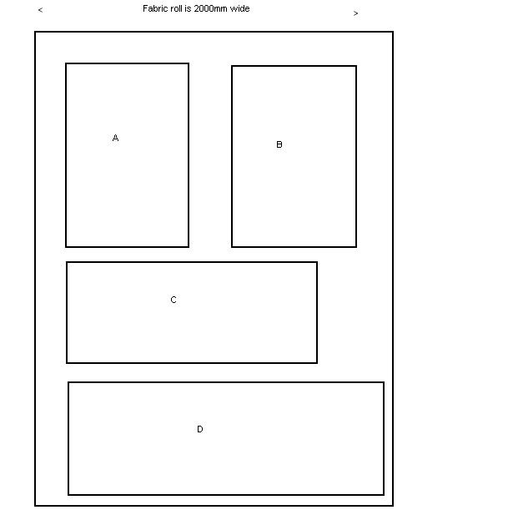

This is not to scale and also the fabrics would be cut very closely together. The amount of fabric required from the roll will therefore be 1200 + 1300 +1350 = 3.85m.

Previously the program worked it out as 800 + 900 + 1300 + 1350 = 4.35m.

There is a new field in the stock item record, called ‘Fabric Optimise, which is held in Stock Setup > Stock Items > Regular PO Options. This field must be ticked before the fabric can be optimised.

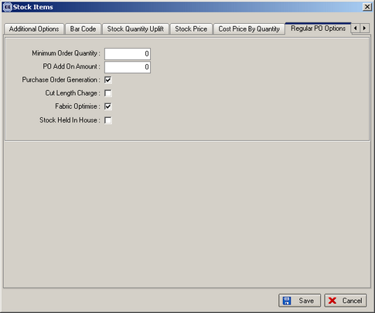

We now have a new routine, called ‘Fabric Optimisation’. We have added a new menu item - Stock Setup – Fabric Optimisation (we also added a corresponding Permission for this menu item). When you select it, you will see a form, where you need to input parameters required to select the orders which should be optimized.

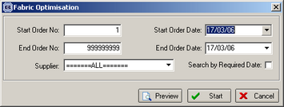

There is “Preview” button on this form. When you click it, you will see a form with a scheme of cutting the material. We also added a new field – “Optimized” to the Blind Details tab of the order editing form, to show if the order detail has been optimized.

We have also developed the logic to cancel the optimization.

- When you recalculate the entire order using “Recalc” button on the order editing form, it cancels the optimisation. When you recalculate an individual order detail, optimisation is cancelled, but only if this order detail has been previously optimised.
- The optimisation is also cancelled when optimised order details are being copied or deleted.
- When you edit an optimized order detail, the optimisation is cancelled if you change the blind size or Fabric.

Please note – the optimisation of all order details is being cancelled. The user can optimise them again after completing changes.

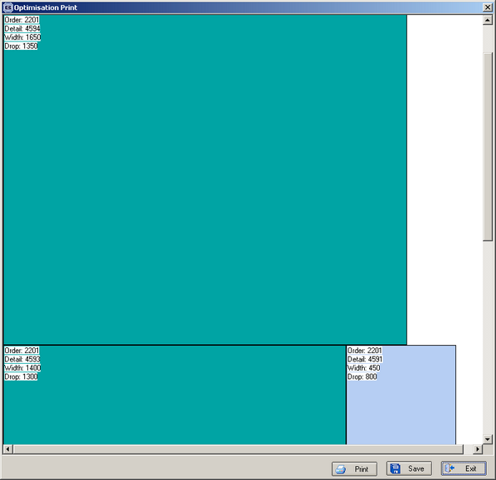

211. Order Processing > Delivery Docket Batch Print

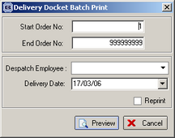

This form has been improved so it has a reprint button and also a choice for entering a despatch employee.

If reprint is not ticked, then the program will print delivery dockets for all orders that have status = Order Manufactured. The status of these orders then changes to Despatched. The report layout is the same as the individual delivery docket print.

If reprint is clicked, then the reprint can be done for the range of order numbers entered. An order with a status less than Despatched (ie order entered, order printed, work in progress, order manufactured) cannot be reprinted.

