Blindata Release Note 2.8.3/4 

13 March 2006

Bug Fixes and Enhancements

965. Order Processing > Orders > Detail Line Entry

If you enter a second detail line, the ‘Measure To’ now defaults to the Measure To entered in the first detail line.

966. Invoice – Bespoke 2 (Regular and Batched)

If an order is entered for a blind type with a different VAT code, the invoice printed incorrect figures in two different places. Fixed.

At the bottom of the invoice, it was displaying the VAT code for the customer – it is now the VAT code for the blind type.

967. Administration > Company Details

When you update the company name, an error message appeared when you tried to save the record (but it did save). Fixed.

968. Administration > System Tables > Employees

When you enter an employee, it now default to fitter, rep and despatch all true, and all others to false. All amounts default to zero. Previously you had to enter each manually.

969. Blind Details > Blind Type Options > Link Options

An error occurred if you did not fill in all three choices. Fixed.

971. Blind Details > Blind Types > Duplicate

If you tried to duplicate a blind that has a different related blind type from the actual blind type (and had already been duplicated itself), the record did not save properly. Fixed.

New Work and Customer Requests

198. Order Processing > Orders > Post Invoice

When we post an invoice, it now go through the same process as in ‘Post Invoice to Sage’. Firstly it is validated, then a validation report printed and then the posting done. The user is prompted at each stage as follows:

‘Validation successful – print report?’ (if yes, print report, if no, just post invoice).

‘Validation unsuccessful’ – give reason why and then exit routine.

210. Automated Backup

It is now possible to carry out an automated backup of the Blindata database. The settings can be found in Administration > Parameters > Backup.

You can specify the name of the backup file, the periodicity of the backup in days, and the start time of the backup operation.

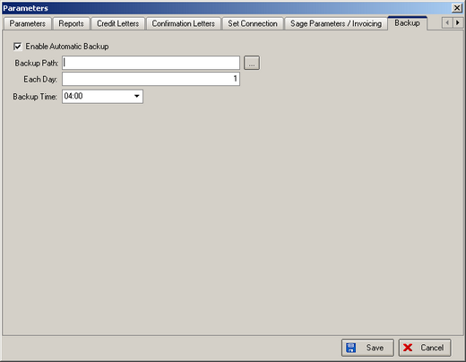

The automated backup functionality will only work properly if SQLSERVERAGENT service is running on the server, otherwise the automated backup task will not be started.

212. Batch Manufacture

There is a new parameter called ‘Batch Manufacture’ in Administration > Parameters. This controls the display of a new button on the Order Amend Enquiry form, called ‘Batch Manufacture’. The default setting of the new parameter will be = false. If set to true, the button ‘Batch Manufacture’ will be displayed on the Order Amend Enquiry form.

The purpose of the ‘Batch Manufacture’ button is to change all orders that have been printed out to status = Order Manufactured. There is a slight complication to this if ‘Enable WIP Status’ = true. The logic is as follows:

If ‘Enable WIP Status’ = false, user clicks ‘Batch Manufacture’ button and the following message will appear – ‘You are about to change all orders that have been printed to status = Order Manufactured. Do you want to continue?’. If yes, all orders with status = Order Printed get changed to Order Manufactured.

If ‘Enable WIP Status’ = true, user clicks ‘Batch Manufacture’ button and the following message will appear – ‘You are about to change all work in progress orders to status = Order Manufactured. Do you want to continue?’. If yes, all orders with status = Work in Progress get changed to Order Manufactured.

