Blindata Release Note 2.8.0 

28 February 2006

Bug Fixes and Enhancements

941. Administration > System Tables > Wood Sizes

The ‘Width In Inch’ field now says ‘Imperial Width’ and displays sizes to 3 decimal places.

942. Reports > Sales Analysis > Sales Analysis by Category

This report was giving incorrect figures, and has been fixed.

943. Velux Codes on All Invoices

Velux Codes now print on the detail line in all invoices if blind type = Velux.

950. Reports > Credit Letters > Statement

The salutation (Mr/Mrs etc) was missing on the statement. Fixed.

951. Works Order A4 Individual

The telephone number from the order record and the customer account code now print on this works order.

952. Delivery Docket – Laser Print Individual

The delivery docket was printing the wrong number of pages if quantities of blinds are > 1 on a detail line. Fixed.

953. Reports > Sales Analysis > Sales Analysis by Category

All sales value, cost and profit figures now display to 2 decimal places.

954. Bespoke Works Order report

This was producing the wrong number of detail lines on the report if a quantity is > 1. Fixed.

955. Stock Setup > Stock Items > Product Blind Types

We noticed a problem that was occurring on quite a few PCs. When you tried to add or change a product blind type record, the record did not get saved, either by pressing the up or down arrow or ‘Save’. This only seemed to happen on some PCs and only happens with this form. All other forms seemed to save ok. Fixed, we think.

New Work and Customer Requests

27. New Work Order Layout

There is a new works order layout called ‘Bespoke Works Order.pdf’.

190. Order Processing > Production Documentation

Three further amendments have been made on this form:

1. There is now an option to either run the batch print by the required date or the order date.
2. There is now an option to only print works order labels for Must Gos.
3. There is now an option to only print works order labels for Repairs.

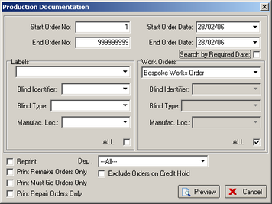

193. Proforma / Quotation Text

Previously the same text was printed on a quotation / proforma. We have split this into two fields, one for Quotation Text (existing field) and one for Proforma text (new field). The relevant field will print on the quotation / proforma, depending on whether proforma is true/false.

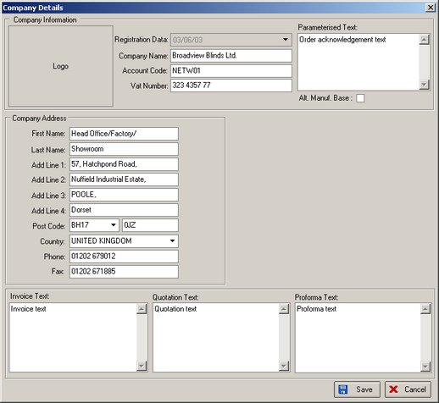

207. Quotation – Laser Print

‘Measure To’ and ‘Special Instructions’ now both appear on the quotation detail line, in the same place as they do on the invoice.

