Blindata Release Note 2.7.7 

17 February 2006

Bug Fixes and Enhancements

607. Invoice Bespoke 1 > Grouped VAT

There is a new function to calculate VAT by grouping the detail lines by VAT code and then calculating the VAT amount. Please note: this should not be used by Sage Line 50 users.

There is a new parameter in Administration > Parameters.

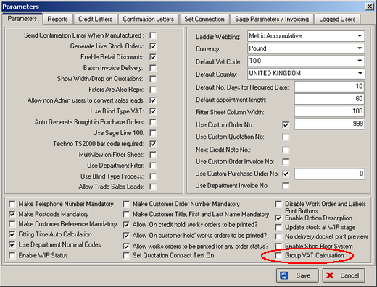

929. Invoice Laser Print (Letterhead)

We now show the Measurement field as well as Special Instructions.

930. Order Processing > Orders/Quotations

The minimum width is now being checked properly for imperial measurements.

931. Reports > Sale Lead Status Report

1. Numbers are now displayed properly to 2 decimal places.
2. The total % calculation is now correct.

932. Order Processing > Deleting Orders

When an order is deleted the orderstatus_id is updated to 7. The associated detailstatus_ids are now updated as well.

934. Invoice Bespoke 4

Velux Codes now print on the detail line if blind type = Velux.

935. Invoices on Invoice Hold Report

The company name was hardcoded into this report – fixed.

936. Deposits by Nominal Report

The department has been added to the top of the report, beneath ‘Order Date between…’.

938. Order Processing

The following error message now says ‘There is not enough stock to manufacture the order’ instead of ‘This is not enough items…’.

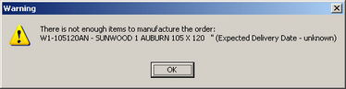

939. Financials > Post Invoice to Sage

The buttons at the bottom now go chronologically from left to right in this order: Run Validation, Print Audit Trail, Post Invoices, Line 50 Export File.

940. Order Processing > Box Blind Substitution

The minimum width rule is now being applied properly when substitute box blinds are used.

New Work and Customer Requests

191. Brackets For Blind Types

We can now hold the number of brackets against the blind type (in the blind type options form).

