Blindata Release Note 2.6.8/9 

24 January 2006

Bug Fixes and Enhancements

821. Postcodes (First Part)

We have imported all UK post codes (first part) into the system, plus a blank code. This means that it will be possible to lookup any post code (first part) or leave the field blank.

868. Fabrics

We have speeded up the way the fabrics table is accessed in Stock Setup > Stock Items.

878. Order Processing > Orders

We have changed the field description ‘Promised Date’ to ‘Cust. Promised Date’.

879. Order Processing > Quotations

Fittings now only apply to orders and are not enabled for quotes or credit notes.

880. Order Processing > Orders

If you enter a detail line for a fitting, it now appears in the correct order on the detail enquiry screen.

881. Reports > Outstanding Orders Report

This is now working properly if ‘Compression’ is selected. The customer reference field and fabric fields now match with the correct order numbers.

The compressed version groups the records by blind type and fabric. For example, if an order contained the following detail lines

Blind Type Fabric Quantity

89mm Vertical Blue 1
89mm Vertical Blue 1
89mm Vertical Red 1
Roller Green 1

The compressed version would show the records like this:

Blind Type Fabric Quantity

89mm Vertical Blue 2
89mm Vertical Red 1
Roller Green 1

882. Post Deposit and Balance Invoices to Sage

On the Sage screen, ‘Deposit paid’ now says ‘Deposit Invoice’ and ‘Balance paid’ says ‘Balance Invoice’ (see development #59).

884. Order Processing > Fitters Sheet / Sales Leads

We have moved the status down to below the details text.

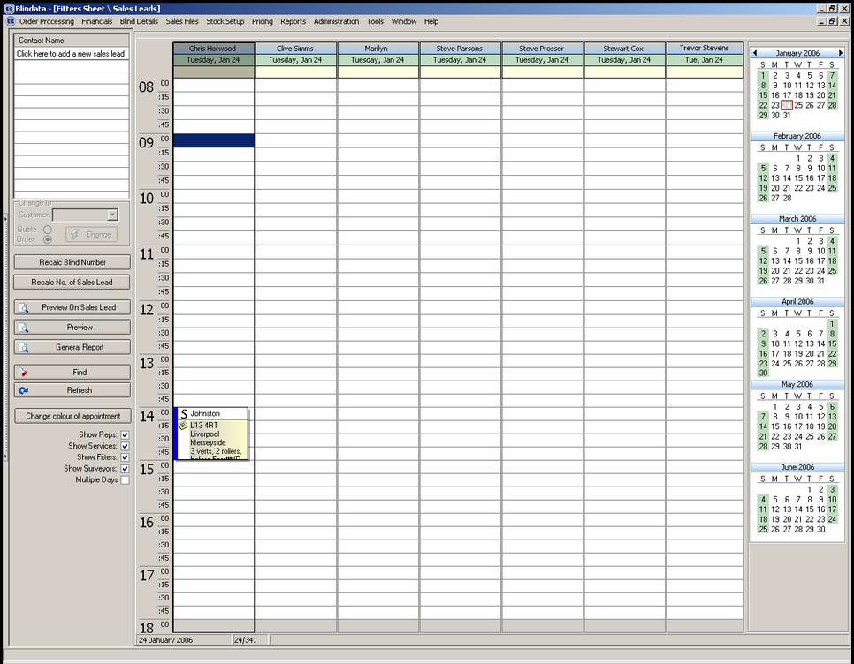

885. Stock Setup > Purchase Order Enquiry

The order of the columns (from left to right) is now PO No, Date, Supplier Name, Expected Delivery Date, Revised Delivery Date, Delivered, Posted, Type, PO Problem.

886. Order Processing > Orders > Create PO

When a bought in PO is generated from here, the lead time calculation is now handled in the same way it is in Stock Setup > Purchase Order Enquiry > Generate Bought In PO (see development #130).

889. Fitters Sheet / Sales Leads

A customer has requested that we show the whole of a last name on the diary screen. The only way to do this was to remove the appointment number and only show the Last Name of the sales lead on the first line.

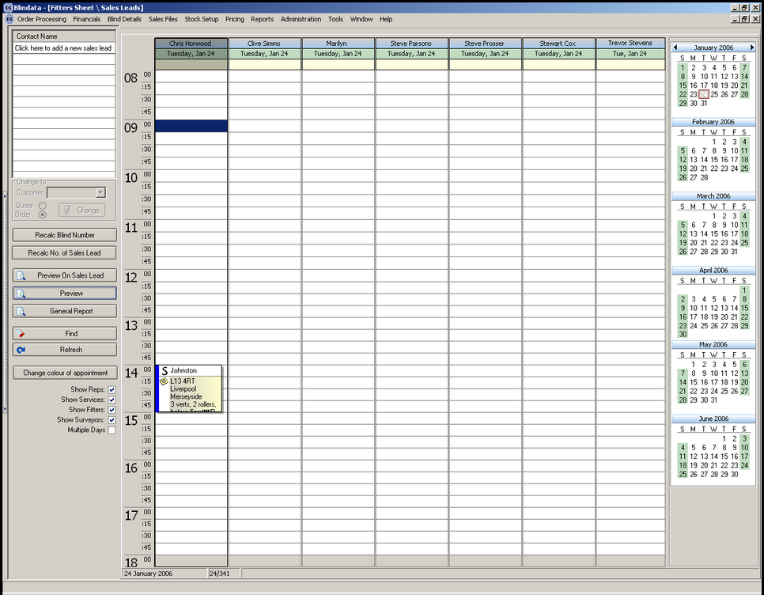

891. Order Processing > Orders

If you entered a fitting detail line and then try to enter a normal blind detail line, a minor error occurred. This is now fixed.

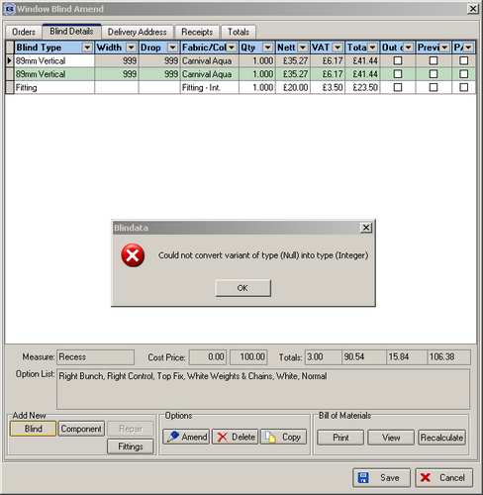

New Work and Customer Requests

59. Posting Deposits and Balances to Sage Line 50

In Administration > Parameters > Sage Parameters there is a new field called ‘Post Deposits and Balances to Sage’. If this is set to true, the parameter ‘Post Retail Invoices’ will be set automatically to false. If the parameter ‘Post Retail Invoices’ is changed to true, the parameter ‘Post Deposits and Balances to Sage’ will be set automatically to false.

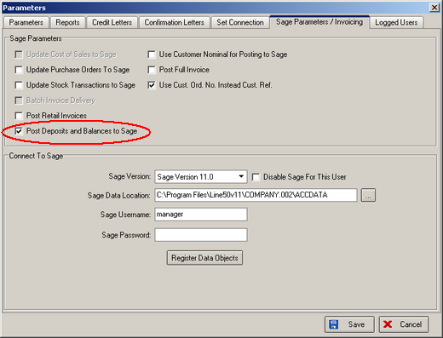

If this parameter is set to true, it means the system will be enabled for posting deposits and invoices to Sage. This will be done as follows:

When a deposit is entered, there will be an option to post the deposit to Sage. This will post the deposit amount as an invoice to Sage. The system checks to see if an account exists in Sage for this order – if not, it is created.

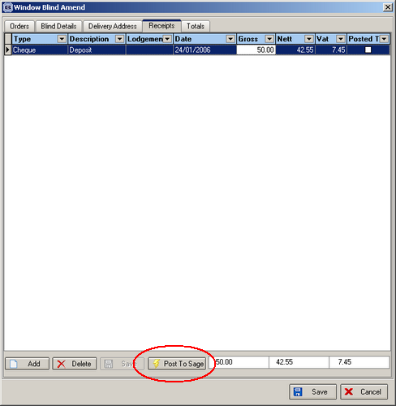

When the order status is changed to delivered, the system then posts the balance to Sage as an invoice amount.

Example:

An order (number 12345) is taken and the total value is £200.00 (actual amount).

A deposit is entered for £50.00.

An invoice for £50.00 is posted to Sage with the reference 12345/1.

The order is manufactured and delivered. An invoice is posted to Sage for £150.00 with reference 12345/2.

129. Multiple Invoice Addresses

It is now possible to hold multiple invoice addresses against customers.

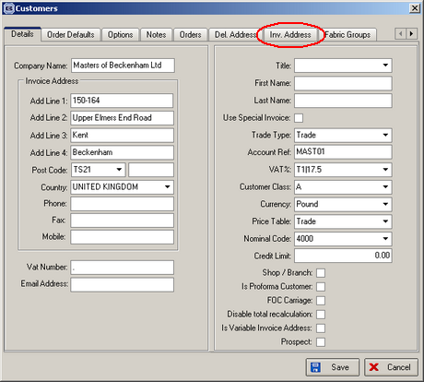

130. Purchase Order Enquiry

We are now able to record if there is a problem with a purchase order. There is a new table in Administration > System Tables called Purchase Order Problems. This will be installed with only have one field, which will be a text description. There will be a default record called ‘On Schedule’ and this will be used as the default when a purchase order is created. The user can then set up additional purchase order problem descriptions. It is possible to amend this new field in Stock Setup > Purchase Order Enquiry.

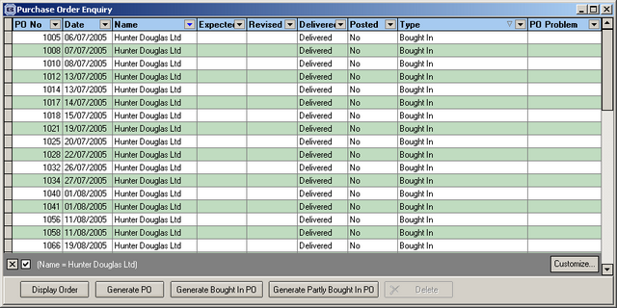

There is another new field called ‘Revised Delivery Date’, which can be edited in ‘Purchase Order Amend’ and is displayed on the purchase order enquiry screen.

We are also able to hold an expected delivery date for the blind to arrive from the supplier. This has been done for bought in blinds, partly bought in blinds and stock purchase orders.

The expected delivery date is calculated by looking at lead times and then adding the longest lead time to the current date to get the expected delivery date. Holidays and weekend days are taken into account (it is very similar to the way the required date is calculated in the sales order entry program). The expected delivery date is displayed on the purchase order enquiry screen, and it is possible to change it in the purchase order amend screen.

Bought In Blinds

We hold the lead time for a blind here:

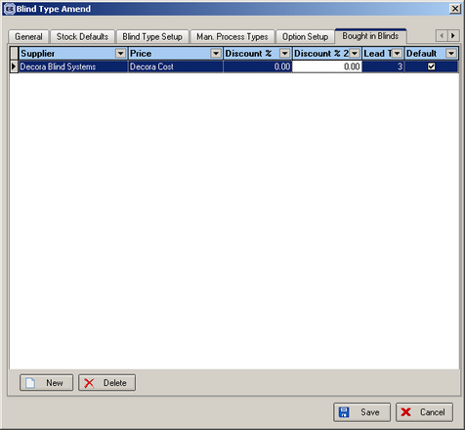

Regular / Partly Bought In

We hold the lead time here:
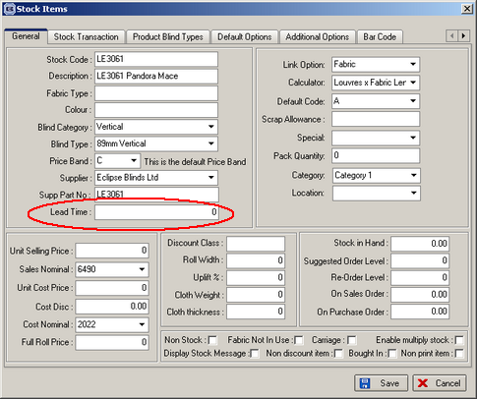

131. Purchase Order Enquiry > Bought In Purchase Order (Client 513)

It is now possible to enter cost price against a detail line in a purchase order. This is required because there may be no cost price in the cost price table or it is different from the one that has been selected.

132. Invoice on Hold (Client 513)

We have introduce the status of ‘Invoice on hold’ to Financials > Invoice Print and Post. An invoice can only be placed on hold if it has the status ‘Delivered’ or ‘Invoice Created’ or ‘Invoice Printed’. If the invoice is on hold then it cannot be posted to Sage Line 50.

This has the same functionality as putting an invoice on hold in Financials > Retail Balances. There are buttons for ‘Hold Invoice’ and ‘Clear Inv Hold’ on the Invoice print and post form.

135. Blind Details > Blind Types

There is a new field called ‘Valance Size Add On’ in the blind type form. This holds an integer (millimetres). If this field > 0, we now print ‘Valance Size’ on Works Order Label 1. The valance size is man width + valance size add on.

151. Supplier Discount for Bought In Blinds

Supplier discounts can now be held against the bought in supplier tab in the blind types form.

We now hold a discount % field and a discount 2 % here. These default to 0. When the cost price is selected in the order detail entry form, we calculate the cost price with discount applied. This will be:

Cost price = Cost price * (100 – discount %) / 100 * (100 – discount 2 %) / 100.

This means that the following fields are no longer required in the blind type general tab:

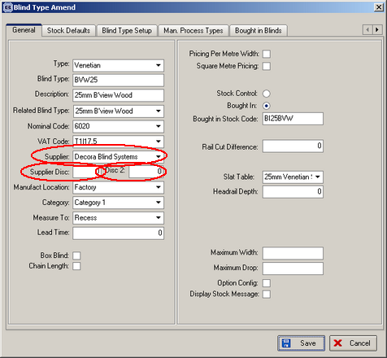

165. Department Invoice Number

It is now possible to have separate invoice numbers for each department. Instead of using the next invoice number in Administration > Parameters > Use Custom Order Invoice Number, we hold a next invoice number against each department record. These numbers start each department invoice number at 1.

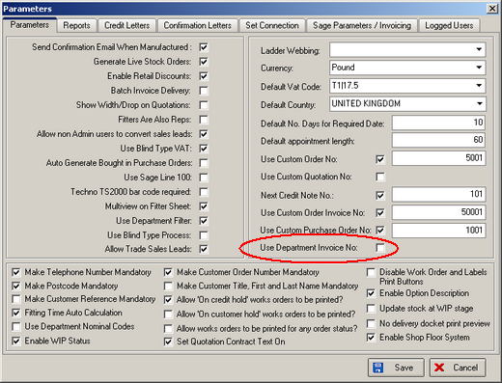

There is a new parameter called ‘Use Department Invoice Number’, which defaults to false.

167. Invoice Batch Print

There is a new option to choose which department when running invoice batch print. The default is ‘All’.

