Blindata Release Note 2.6.1 

23 December 2005

Bug Fixes and Enhancements

748. Works Order Portrait

All the rules regarding field displays and calculations in Works Order Label Blind Size now apply to this report. We no longer need the report ‘Works Order Portrait Imperial’ as the parameters for metric/imperial, entered/blind size are now used in Works Order Portrait.

755. Blind Details > Blind Types > Duplicate

There is now a button on the blind enquiry screen that allows you to duplicate a blind type record and all the related records (in the tabs: stock default, blind type setup, process types, options etc). A window opens up (similar to the stock item duplicate function) that allows the user to enter a new blind type code and description.

831. Reports > Financial Reports > Balances by Nominal Report
This report now select orders where despatch date is between start date and end date, not order date. There is a new criteria on the ‘Financial Reports’ screen for ‘Start Delivery Date’ and ‘End Delivery Date’.

The following criteria are being used for this report:

- The order should have “date delivery” between ‘Start Delivery Date’ and ‘End Delivery Date’ specified by the user.
- There should be at least one order detail in the order.
- The order status should be = Despatched, Invoice Created, Invoice printed or Invoice Posted.
- The order should have payment(s), which does not have ‘Deposit’ parameter (System Table > Receipt Description).

834. Blind Details > Blind Types

The ‘option setup’ tab now appears on the screen without having to click on the right hand arrow.

835. Blind Details > Blind Types

If a blind type was set to bought in = true, the program asks for a bought in stock code. This is no longer required and has been removed.

836. Blind Details > Blind Types > Option Setup tab

In option setup, the ‘On Label’, ‘On Works Order’ etc fields now default to true (but not free type).

There is now a save button in this screen, because users kept forgetting to hit the up or down arrow.

837. Stock Setup > Stock Items > Product Blind Types

There is now a save button on this screen, because users keep forgetting to hit the up or down arrow.

838. Pricing > Discounts

In this screen, fields that cannot be changed have been disabled. For example, if discount was only for customer and blind type, it is no longer be possible to enter a value for class.

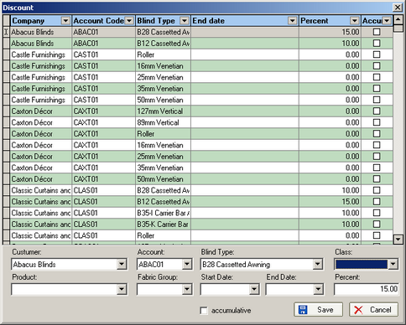

839. Blind Details > Blind Type Options

We no longer display the first tab (fields) on this screen.

840. Sales Files > Customers

There is no longer validation on VAT number. It is ok if this field is left blank.

844. Order Processing > Fitters Sheet / Sales Lead

We can now parameterise the default length of a diary appointment in Administration > Parameters.

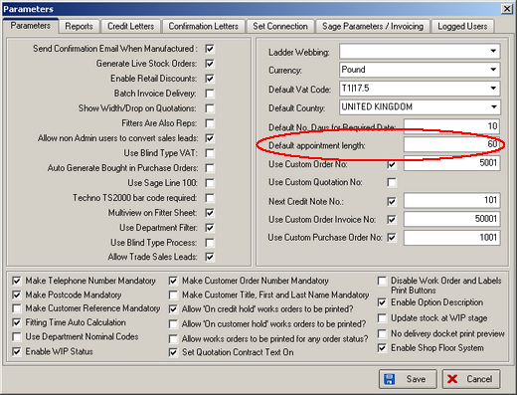

New Work and Customer Requests

137. Pricing > Border Option Pricing

There is a new way of pricing blinds that have borders on one or more sides of a blind.

Blinds can have borders that can be on any side of the blind (top, bottom and two sides) or any combination of these.

Example: borders on both sides and bottom, blind is 1500 * 1500
Two drops (1500 * 2) + 1 width (1500) = 4500.
The option is priced in 300mm increments and has a price of 5.00 per 300mm, so:
4500/300 = 15 * 5.00 = 75.00

A new form has been created, which holds blind type, fabric code, width multiplier, drop multiplier, increment, price. (In the above example width multiplier = 1, drop multiplier = 2, increment = 300, price = 5.00).

This option price is looked for at the same time as other option prices are found in the order entry program. If there is a price for an option in this table, it will supersede all other prices found for this option (but in reality there won’t be any).

146. Order Processing > Orders > Must Go

There are now security controls around who can flag an order as a Must Go. This has been added as an advanced permission in Administration > Users.

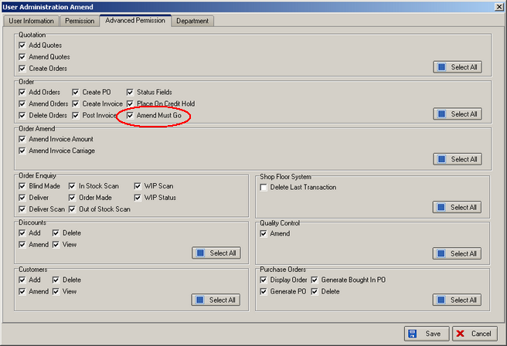

89. Shop floor system / Barcoding / Process status levels

We have partially completed a shop floor system. The purpose of this is further automate the processing of orders and to store extra information about timings and schedule planning.

At the same time it is also possible to record the date and time when each stage of the life of an order has been completed. We can now record when a blind was entered, when labels were printed, WIP, blind manufactured, order manufactured, delivered and invoiced.

Within manufacturing, we now hold different process levels for blind type eg for vertical blinds would have e.g. ‘headrail cut’ and ‘vanes made’. It is now possible to record each process as being individually completed (but there is also the facility to choose which processes you want to record times as some processes will be too short to scan). When all the processes have been completed, the status of the blind changes to manufactured.

When scanning is carried out, it can be done in ‘process type’ order. However you could have a situation where two parts of a blind are being made separately, and come together at the end. We therefore have to sub divide process types within a blind type into ‘process groups’. This means that more than one process group can be run (and therefore scanned) simultaneously.

In conjunction with this, we can also date/stamp every action that is taken when adding or altering data for an order as an audit trial including which user has completed the transaction.

Phase 1 of the shop floor system has been completed. The following steps should be carried out.

1. Enable the shop floor system in Administration > Parameters.
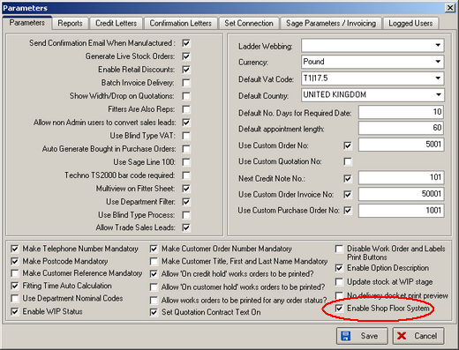

2. Set permissions for ‘Shop Floor System’ in Administration > Users.

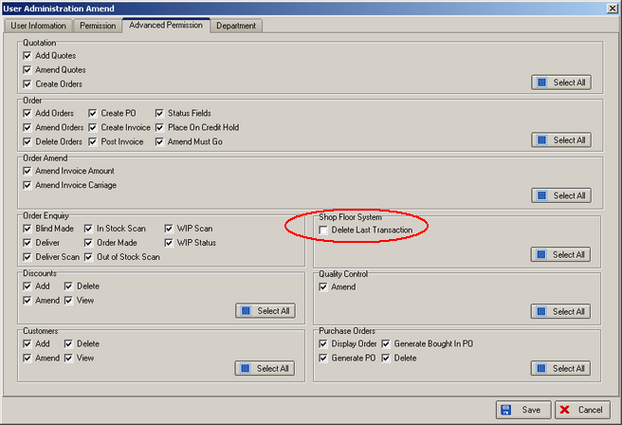

3. We have added one more table “Process Subdivision” to Administration -> System Tables. It stores the process sub divisions with codes (important notice: the code of the sub division should be a 4-digit number no less than 1000). Records should be entered here.

4. We have added additional fields to the Man Process Types tab of Blind Type Edit form, these fields are used to select a Sub division and check if a process is scanned or not. These must also be entered.

The program will work as follows:

The new logic is on the Order Enquiry form. If the “Enable Shop Floor System” parameter is enabled, an additional button “Shop Floor Scan” will be displayed on this form. There will also be a panel at the bottom of the form with the buttons “View Process Transactions” and “View Process Transactions by Subdivision”.

When you click “Shop Floor Scan” button, you will see a form which can be used for scanning. After each scan operation the program will check the validity of data received from the barcode reader and if there are errors, it will display a corresponding message. If the data is correct, the application will display the process completion confirmation, and then it will save the corresponding Process Transactions. If all processes have been completed for the scanned Serial Detail Line and you try to scan again, the program will show a corresponding message (an important detail – the last process in each Sub Division should be a scanned process, otherwise there will be no way to complete the sub division).

If, after a scanning operation, the program determines that all processes for all Serial Detail Lines have been completed, the status of the order detail will change to Blind Manufactured. If all order details have “Blind Manufactured” status – Order Made logic will be applied.

You can use “View Process Transactions” button to view the history of Process Transactions for the selected Order Detail Line. There is also “Delete Last Transaction” button on the form, it allows deleting the last transaction for the selected Serial Detail Line and Sub Division. However, you cannot delete the transactions for Order Detail if its status is Blind Manufactured.

When a user prints Works Order Label 1, the procedure checks to see if ‘Enable Shop Floor System’ parameter is enabled. If it is disabled, the old logic is applied, i.e. it prints the order detail id on the top small labels in the barcode, and subdivision field is not displayed. When the ‘Enable Shop Floor System’ parameter is enabled, the serial number of the order detail and the subdivision code is printed in the barcode, so that it can be scanned in “Shop Floor Scan” mode. The subdivision field is also being displayed below the barcode.

Here is the list of exceptions, which may appear when printing Order Label 1 with ‘Enable Shop Floor System’ flag enabled:

- If it prints the previously added order details (the serial number does not exist for these details), then the old version of the barcode will be printed and there will be no Subdivision field, i.e. it will look similar to the situation with ‘Enable Shop Floor System’ disabled.
- If a new order is added (serial numbers exist for the details of this order), but there are no processes and subdivisions for this Blind Type, then the barcode is not displayed and Subdivision field is not being displayed as well.
- If there are processes with only one subdivision for the blind type, then the barcode and subdivision field will be printed only on the top left label.

When we worked on this report, we completely reworked the stored procedure which generates Works Order label 1 report, with the purpose of speeding up the generation of work order labels.

