Blindata Release Note 2.5.7/8/9 

16 December 2005

Bug Fixes and Enhancements

788. Invoice – Bespoke 3

Totals were the wrong way round on report. The amounts are now in the same order as the totals on a standard order acknowledgement for a retail customer.

793. Order Processing > Fitters Sheet / Sales Lead

If you try to make a sales lead appointment for an employee who is not a rep, the message now says ‘This employee is not a rep’.

796. Order Processing > Orders

There is now a column for nett price on this form, with a total at the bottom. The contract column has been removed.

797. Logging Out

Sometimes people accidently click the x in the top right of the screen instead of the x on the form window. This means they are logged out immediately. If the x on the very top right is now clicked, a message appears saying ‘Do you want to log out?’.

798. Administration > Import from Excel > Fabrics

There is a new column in the spreadsheet, called cost price discount %. This field gets updated to cost discount in the fabrics table.

800. Order Processing > Fitters Sheet / Sales Leads

When a sales lead is converted to an order, there are occasions when the fitter and date of the fitting are not known. There is a new field in this form that says ‘Fitting details’ and defaults to Yes. If it is changed to No, then the sales lead is updated to an order but the fitter and fitting date is not updated.

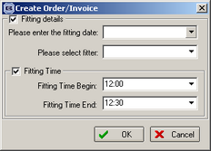

801. Order Acknowledgement / Sage Laser Invoice Print

We have moved ‘Page n of n’ over to middle of bottom of page.

814. Order Processing > Order Enquiry > Order In Stock

When we choose the "Order Out of Stock" Option on this screen it changes the status automatically back from "Work In Progress" to Works Order Printed", what we would like to do is when we choose the option "Order In Stock" it will automatically change the status forward to "Work In Progress", what is happening currently is we have to choose the Option "Order In Stock" and then choose the option "WIP Order Scan", we would like not to have this as a 2 step process to release the Order back into manufacturing but a 1 stage process.

815. Administration > Users

The copy function is now working again.

820. Fitters Sheet / Sales Lead

When you added a new appointment on the diary system and hit the refresh button to update the appointments it wiped everything off the diary screen (although the records were stored correctly). You then had to exit the form, then go back in and the appointments reappeared on the screen. This has been fixed.

824. Reports > Outstanding Orders Report

Cust O/N was being repeated in each order – fixed.

There is now a page break between customers.

Within each customer, orders are now placed in ‘do by date’ order.

826. Orders > Order Enquiry > Despatch

There is a new parameter in Administration > Parameters so that a delivery docket is not print previewed.
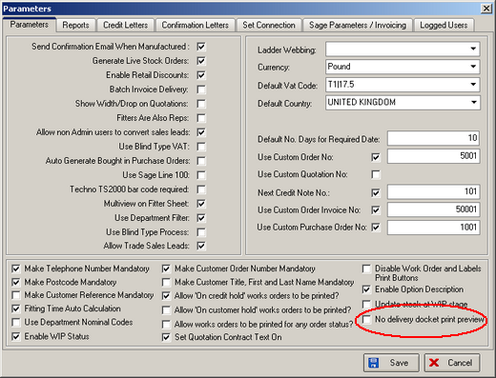

827. Reports > Receipts by Date

Receipt no. and customer name are now included on all receipt reports.

828. System Reports > Fitting Date Report

Order Tel. Number now appears on this report.

829. Orders > Order Entry

There is now a flag on the order totals tab to ensure order does not appear on the outstanding balances report. This is called ‘Exclude from Retail Balances’. If this field is true, then that order does not appear on the outstanding balances report.

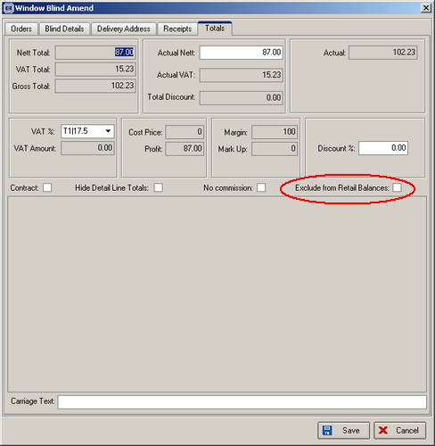

New Work and Customer Requests

101. Sales Files > Customers > Default Options

Some customers always request the same particular options for certain blind types, options that are not the default for that blind type. There is a new table that holds customer, blind type, option name and stock item. This is held in Administration > System Tables, and is looked at last by the program when defaults are being selected in order detail line entry.

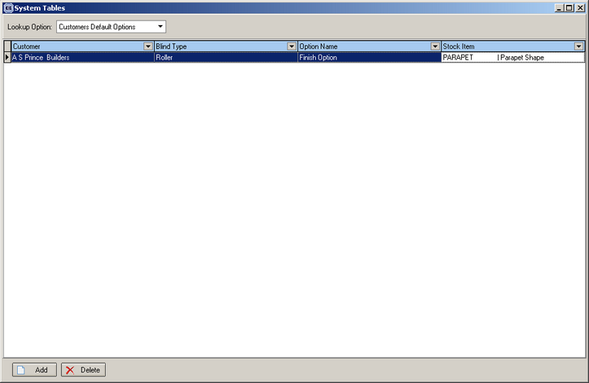

136. Option Pricing

There is a new, extra way of pricing an option. Here is an example of how it can be applied:

Roman blinds – cream or white linings attract an extra price, dependent on the amount of lining that is used. These are priced like this:

Blind size: width = 1500, drop = 1000

Lining drop 1000 + 750 (for turnings and pockets) = 1750.
Widths are multiples of 1370, so this blind requires 2 widths (the lining fabric is purchased in 1370mm wide rolls).
Lining = 1750 * 2 = 3500, rounds to 4m. The lining price per metre is 6.50.
Therefore option price is 4 * 6.50 = 26.00.

There is a new table, which holds blind type, fabric code (option), width multiple, drop add on and price per metre. In the above example, width multiple = 1370, drop add on = 750mm, price per metre = 6.50).

The form for this table should be in Pricing and should be called ‘Option Price Per Metre’.

This option price is looked for at the same time as other option prices are found in the order entry program. If there is a price for an option in this table, it will supersede all other prices found for this option (but in reality there won’t be any).

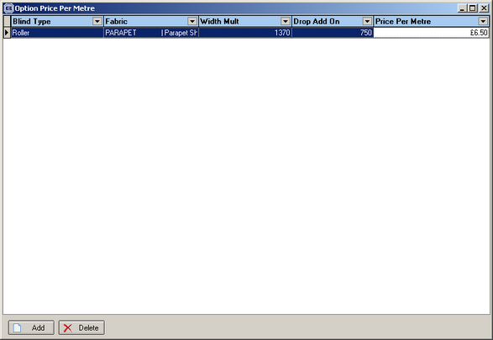

138. Delivery Docket - Laser Print Individual

There is a new delivery docket report that prints out a docket for each blind in an order.

