Blindata Release Note 2.5.6 

09 December 2005

Bug Fixes and Enhancements

789. Invoice – Bespoke 3

There is a new invoice layout. It is very close to the Sage Laser Invoice layout.

Not Numbered

The purchase order screen now displays all the detail lines properly.

Orders are changed to ‘Order Printed’, even when a miscellaneous line is included in an order.

The label numbering works correctly when the quantity of a blind is greater than 1.

New Work and Customer Requests

18. Check stock on order entry

It is now possible to see if there are any items that are not in stock when the orders are entered. If any item is out of stock a warning message appears to say so. This is parameterised by blind type and then by link option.

In the blind type form, there is a new field called ‘Display Stock Message’ (true/false). It defaults to false.

In the stock items form, there is a new field called ‘Display Stock Message’ (true/false). It defaults to false.

When a detail line is entered (blind or component), when the stock transactions are written, the blind type reads to see if ‘Display Stock Message’ = true. If true, the program also checks to see if ‘Display Stock Message’ = true for the specific stock record. If true, it then checks to see if there is enough stock to satisfy the order. It compares the quantity in the stock transaction against the stock in hand figure – on sales order figure. If there is not enough stock, a message appears saying ‘[Stock Code] – [Stock Description] – there is not enough of this item to manufacture the order’. This is only be a display message and still allow the operator to save the detail line.

22. Blind type – additional by width/drop products

Certain stock items (options) get used with blind types depending on the width and drop of the blind. Here are two possible examples.

1. When a roller blind is made, the tube size used is dependent on the width and drop of the blind – the bigger the blind, the bigger a diameter of tube is needed.

2. For venetian blinds, if the width size is less than 500mm then the controls can only be Standard; left or Right controls cannot be chosen.

In cases like this we can restrict the options available by looking at the size of the blind. The option displayed in the detail line defaults to the one which is the nearest with regard to width and drop.

The following table is used to hold both these conditions. This can be found in Blind Details > Blind Type Options > Link Options.

Stock Item Option | Width >= | Width <= | Drop >= | Drop <=
TUBE25 | 0 | 1200 | 0 | 1800
TUBE28 | 0 | 1400 | 0 | 1800
TUBE38 | 0 | 1800 | 0 | 2000
STANDARD | 0 | 3000 | 0 | 3000
LEFT | 500 | 3000 | 0 | 3000

If the option is not held in this table, there will be no width/drop restrictions.

We can set up a link field without any choices, then in the lower table we can select choices for that option by introducing criteria for width and drop.

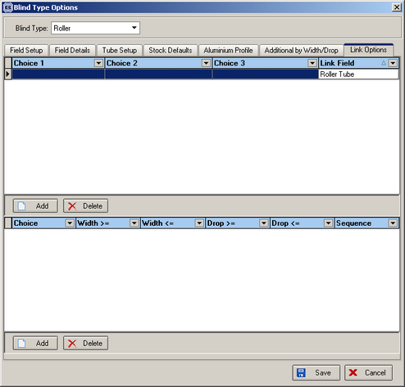

102. Scrap Cut Allowance for Vertical and Vanes Only Blinds

There is a new option on each vertical fabric to have a scrap cut allowance as each item has a different scrap allowance for production.

The new field is called ‘Scrap Allowance’ and is held in Stock Setup > Stock Items. It is only applicable to vertical and vanes only blind types. When we calculate the fabric usage for verticals and vanes only (as displayed in bill of materials and Production List Preview with Fabric Total), the calculation now works as follows:

((Man Drop – Headrail Depth + Fold Over Size + Scrap Allowance) * Number of vanes) * Quantity

124. Pricing > Discounts

It is now possible to have discount by fabric group as well as customer, product, blind type, promotion and class.

In the detail line entry program, we are now able to select a discount record by the fabric group for the fabric that has been selected.

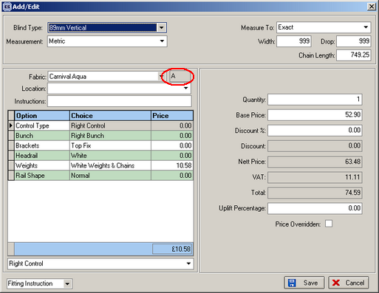

140. Sage Line 50 v12

We can now integrate Blindata with Sage Line 50 v12.

143. Stock in Hand Parameterisation

There is a new parameter in Administration > Parameters to determine when stock is deducted. It is called ‘Update stock at WIP stage’ and defaults to off. If it is switched on, all stock transaction updating and stock record updating takes place when work in progress is done.

