Blindata Release Note 2.4.7 

11 November 2005

Bug Fixes and Enhancements

720. Order Processing > Orders > Detail Line Entry > Measure To

The ‘measure to’ default is now working properly. The default ‘measure to’ is selected properly for all detail lines now.

729. Financials > Complete Postings to Sage Line 100.

The program now asks for a date range, before flagging the records within the date range as ‘Invoice posted’.

740. Pricing > Component Price Table

When you are doing a lookup here to add a new record, the stock code lookup is now working properly – previously stock items were missing.

749. Reports > Lead Times

This is now printing out times for all status fields.

758. Order Processing > Order Enquiry > Delivery Docket – Laser Print (Special)

The Order Telephone Number now appears on the delivery docket just below the delivery address.

759. Order Processing > Quotes > Repairs

For proforma customers it is now possible to create repair orders. Previously there was no option on the quote screen to perform repair orders.

761. Order Processing > Sales Leads / Fitters Sheet

If you amended a sales lead and saved it, the focus was no longer on that sales lead, but you could still try to convert it to a quote or an order. The focus now remains on that sales lead.

762. Invoice – Sage Laser Print

- Moved ‘INVOICE’ 2cm to the right.
- Move all three totals 2cm down.

763. Credits

There was confusion about which credit note number was to be used. We now use the left hand number in the screenshot, so this number is the one that is used as the reference when posting to Sage.

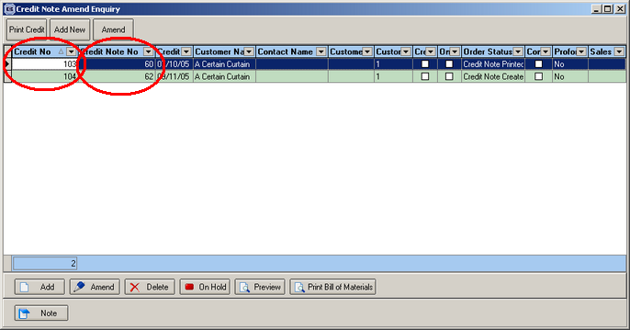

766. Invoice – Sage Laser Print

The VAT number now appears on the invoice.

New Work and Customer Requests

106. Sloping Verticals

There is a new flag for blind identifier = vertical, called ‘Sloping Headrail’. This has the following impact on the order detail entry.

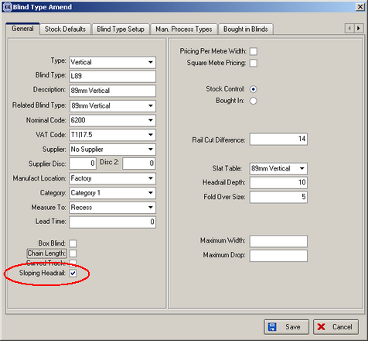

If blind type is flagged as sloping headrail, the user should be able to enter ‘Small Drop’ as well as width and drop.

Small drop now appears on works order labels.

112. Fitters Sheet / Sales Leads > Diary Screen

There is now an option to show a whole week for one rep/fitter as well as currently showing all rep/fitters for one day. This can be done by selecting the fitter (click on the column) and then clicking multiple days. You will then be asked for a date range.

We have also amended the layout of the screen as follows, the purpose of this being to display as much of a day as possible at once.

