Blindata Release Note 2.4.8-9 

15 November 2005

Bug Fixes and Enhancements

628. Order Processing > Archive Enquiry > Credit Note Print

When a Credit Note is reprinted using the 'Print Invoice' icon from the Archive Enquiry window, it now prints as a credit note, not an invoice.

729. Financials > Complete Postings to Sage Line 100.

The program now asks for a date range, before flagging the records within the date range as ‘Invoice posted’.

764. Administration > Users > Advanced Permissions

There are new advanced permissions for the Purchase order Enquiry buttons. These are controlled in Administration > Users > advanced Permissions.

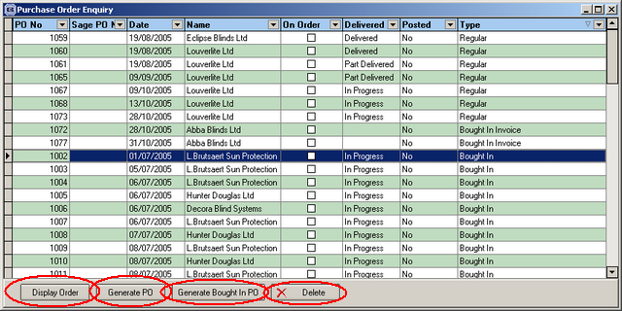

The permissions for ‘Generate Bought In PO’ also control the ‘Create PO’ in Order Amend Enquiry.

767. Order Processing > Sales Leads / Fitter Sheet

- The column on the left has been made narrower so more room is available for employee columns.
- We have removed the icon beside each rep name.
- The screen now defaults the display to 9-5, although you can scroll up to 8am and down to 6pm.

768. Order Processing > Sales Leads / Fitters Sheet

When you click on ‘Multiple days’, the following window appeared:

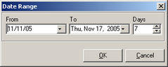

The ‘To’ date format has been corrected.

775. Fitters Sheet / Sales Leads

An error message appears when you try to save a sales lead as an appointment. Fixed.

776. Fitters Sheet / Sales Leads

If you try to drag an appointment from one rep to another, an error message appeared. Fixed.

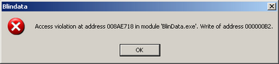

777. Fitters Sheet / Sales Lead

If you switch ‘Rep’ and ‘Fitter’ buttons off and on, switching between days did not work properly. You have to click on today, and only then can you change the date. Also, the screen appeared in a strange format at times. Fixed.

778. Fitters Sheet / Sales Lead

When you converted a sales lead to an order, the email address is now copied from the sales lead into the order record.

779. Fitters Sheet / Sales Lead

If you clicked on Multiple Days, and then x out of this form, an error occurred. Fixed.

780. Administration > System Tables > Enquiry Types

The following error message appeared. Fixed.

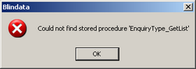

New Work and Customer Requests

113. Fitters Sheet / Sales Lead > Sales Lead Add/Amend

We can now record the following extra things in the sales lead:

- Enquiry is shop or phone (select from new table – Enquiry Type – in Admin > System Tables).
- Requested appointment date and time on enquiry
- If customer is interested in service or price (tick box).
- If existing customer (tick box)
- Have they been quoted a price already and a timescale?
- Mobile telephone number
- Email address in the sales lead.

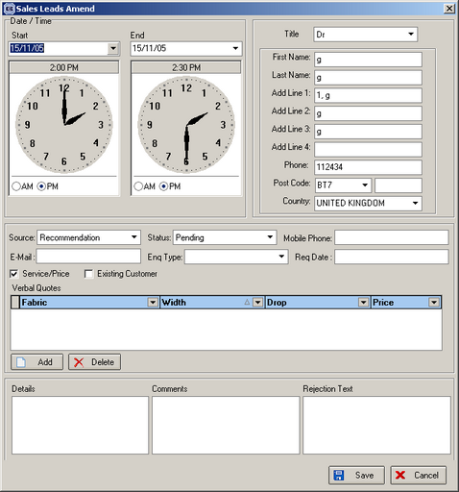

114. Fitters Sheet / Sales Lead

When you are prompted for a fitting date (when converting a sales lead to an order), the program now asks for a time as well as a date. This is also done in order entry when the fitting appointment is updated.

