Blindata Release Note 2.4.5 

4 November 2005

Bug Fixes and Enhancements

728. Order Processing > Order Enquiry > Deliver/Deliver Scan

A message now appears if the Despatch Employee is delivering a blind on a different day to the customer’s delivery day. It says "You are despatching this order on a different day to the customer’s delivery day" and "Do you want to continue?" - this will allow the user to despatch the blind but if no is clicked then the status of the order remains as "Order Manufactured".

730. Retail Balances > Outstanding Retail Balances

This report is now working correctly:
1. The report does not prompt for a date range.
2. The report only prints records with the following criteria : 'Invoice Printed', and not on invoice hold, and balance <> 0.
3. The phone no is now printing fully.
4. The report now shows to show invoice date not despatch date

731. Acknowledgement – Laser Print (Letterhead)

For retail orders, Delivery Company Name is now derived from contact name.

732. Sales Files > Customers

For customers where type=Retail there is no longer any validation on address fields in the customer records.

734. Bought in purchase orders

Purchase orders can be generated from sales orders when sales order status = ‘Order Printed’.

735. Validation Report

The validation report is was displaying records because of a rounding error in a stored procedure, when the orders were actually correct. This is no longer the case.

736. Purchase Order Bought In – Standard

Address line 4 and Country were the wrong way round. Fixed.

739. Order Processing > Order > Component Detail Entry

When you selected a component here, the price was not being found properly. It now look in Stock Setup > Stock Items > Selling Price, and then looks in Pricing > Component Price Table to see if there are any prices there.

743. Order Processing > Orders > Create PO

The message was truncating the text for numbers. Fixed.

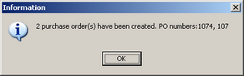

744. Purchase Order Enquiry > Bought In PO

When a bought in blind is delivered in a bought in purchase order, the status of the order detail line is now changed to ‘Blind Manufactured’. If all the blinds in that order have then been delivered (and so have a status of ‘Blind Manufactured’, the sales order status changes to ‘Order Manufactured’.

745. Sales Lead / Fitting Sheet

When you convert a sales lead to an order, the fitting date in the order was being updated with the sales lead appointment date. It should be the fitting date – fixed.

746. Outstanding Balances Report

The report now shows records with the following criteria: order status = ‘Delivered’, ‘Invoice Created’ and ‘Invoice Printed’, balance > 0, <> on hold (in Retail Balances screen).

750. Fitters Sheet/Sales Lead.

When we convert a sales lead to an order, the program now asks for a fitter as well as a fitting date. If ‘Fitting Time Auto Calculation’ is switched on in Administration > Parameters, the fitting appointment is also updated. Previously the fitter was found by looking at the postcode record and using the fitter that is held there.

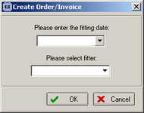

If there is a fitter held against the postcode, then this fitter appears in the field as the default and the user can change it if necessary.

751. Administration > System Tables > Option Names

When adding a new option name, you got an error message if you down arrow before entering the option code and then save. Fixed.

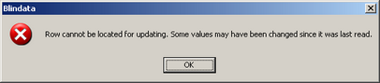

752. Order Processing > Orders > Receipt Entry

We have had a number of users who keep forgetting to down arrow to save the receipt record, and so the receipt isn’t recorded. There is now a save button on this screen.

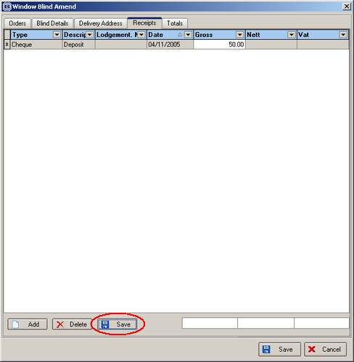

753. Works Order Label 5

We have moved everything down by 3mm and left by 2mm.

New Work and Customer Requests

105. Curved Tracks

There is a new flag for blind identifier = vertical, called ‘Curved Track’.

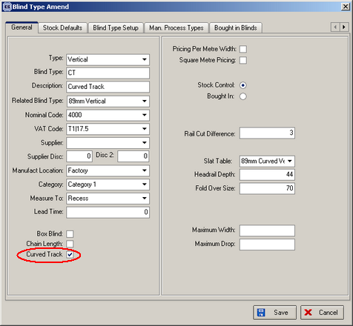

If blind type is flagged as curved track, the user can enter depth and number of vanes, as well as width and drop.

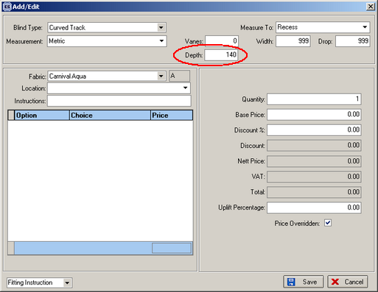
Depth now appears on works order labels.

The price of the blind is found by adding the width and the depth together (to get a dummy width figure) and then looking up the price table by width and drop, using the dummy width instead of normal width.

108. Chain Length Calculation

For some blind types, we need to be able to calculate the length of chain needed (this is the chain that is used to open and close the blind). The chain length has a default figure (eg 75% of blind drop) but we can also be able to adjust this figure in the detail line entry. There is a field in the blind type to determine whether the chain length is asked for or not.

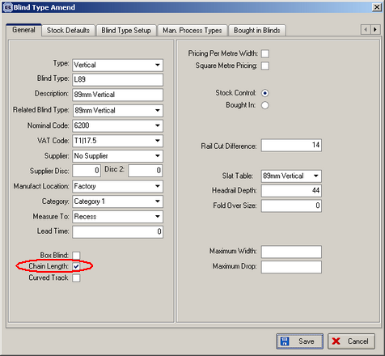

The functionality works this way:

- In the ‘Blind Type’ amend window, the user can set ‘Chain Length’ flag for this Blind Type.
- When you add/edit the order detail, Chain Length field is displayed, if this flag is checked for this Blind Type.
- By default it shows 75% of the blind Drop.
- The user can correct the value of Chain Length.
- When you change the drop of the blind, Chain Length will be also recalculated.

