Blindata Release Note 2.4.3 

28 October 2005

Bug Fixes and Enhancements

576. Stock Setup > Purchase Order Enquiry > Generate PO (Regular) > Purchase Order Edit screen

When 'Deliver', 'Free Stock' column was not calculating correctly.

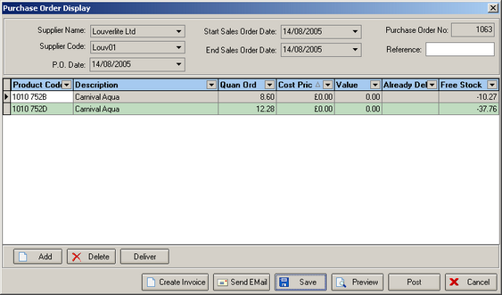

In the first line, 8.6 had been delivered, but free stock was showing as -1.68: it should be -1.67. Fixed.

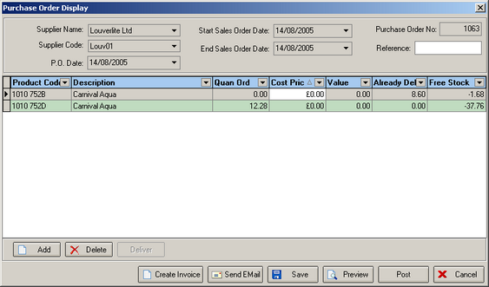

704. Order Processing > Production Documentation

It is now possible to print tickets by not only the Blind Identifier and Department, but also the Manufacturing Location and the Blind Type.

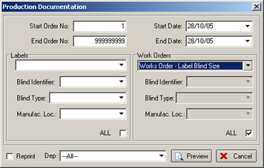

733. Purchase Order Bought In (Department)

The recently added special instructions now wrap onto a second line instead of truncating.

New Work and Customer Requests

81. Bought In PO Form

It is now possible to generate a purchase invoice from a purchase order and post it to Sage Line 50. You must make sure that Administration > Parameters > Sage Paramets / Invoicing is set up properly.

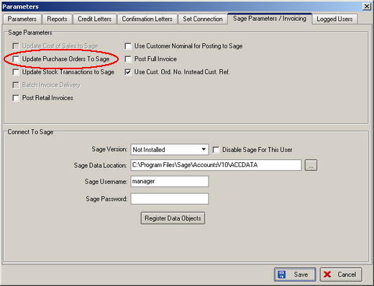

A purchase invoice can only be generated once the blinds have been delivered.

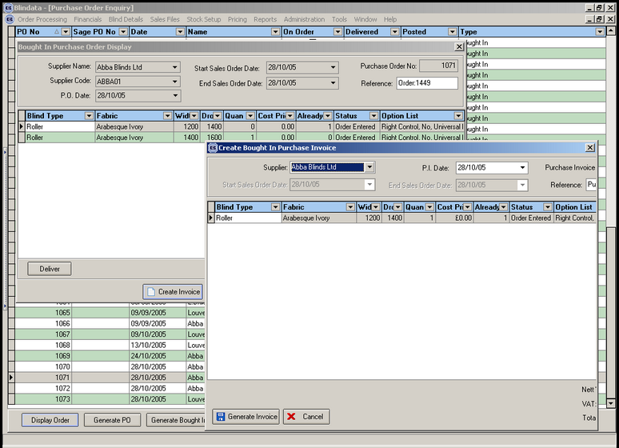

98. Reports > Lead Times

There is a new option to run the lead times reports between different status’ of manufacturing, by both days and hours.

When calculating lead times in hours and minutes, we only do this between a start and end working day eg only calculate from between 0830 and 1700.

Example:

Order manufactured: 13:45 18/07/05
Order delivered: 1105 19/07/05

This would calculate as 5 hours 50 minutes.

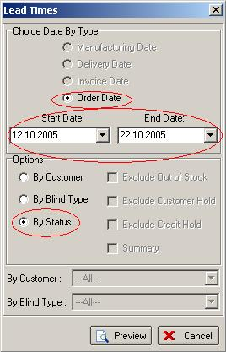

The input parameters for the report are the Order created start and end dates (see the screenshot above). ‘By Status’ must be selected first.

All orders details which have the first working status “Works Order Printed” will go on the report, so in this way we’ll be able to separate “Carriage” records, which are added as an order detail, only after the invoice is created, and the orders which have not been started yet.
If the order or detail status date is unknown and there is no way to calculate the difference between statuses, the report will print ‘ — ’.

