Blindata Release Note 2.4.0 

21 October 2005

Bug Fixes and Enhancements

687. Import Option Prices

A new routine has been added to import option prices from a spreadsheet. It is in Administration > Import from Excel. The spreadsheet has the same layout as ‘Import Price Table’ except fabric group is replaced by stock code.

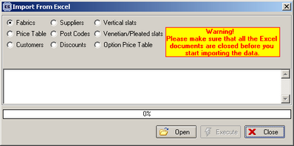

688. Sage Export File

A Sage export file can now be created for exporting invoices to Sage in Administration > Post Invoices to Sage.

690. New Invoice Layout

There is a new bespoke invoice layout.

702. Order Processing > Orders

If a retail order is entered directly in Orders (ie not via Sales Leads) with a required date and a fitter, a fitting appointment gets made in the fitter diary. See 705.

703. Stock Setup > Stock Items > Duplicate

This now says ‘Duplicate’, not ‘Dublicate’.

705. Order Processing > Orders

We have separated the fitting date from the required date. This has no effect on non retail Blindata customers. The fitter diary now gets updated with the fitting date, rather than the required date.

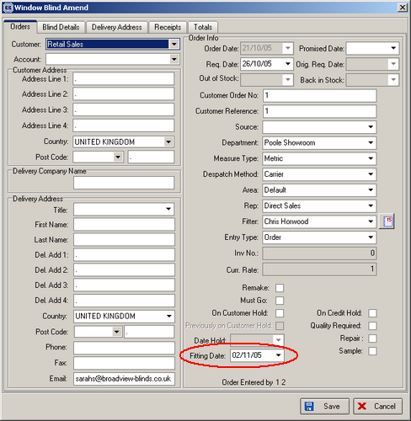

706. Order Processing > Orders

It is now possible to access the employee diary directly from the order entry screen.

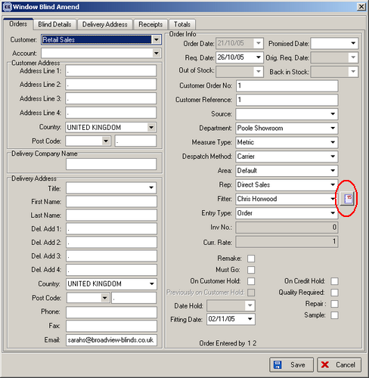

707. Archive Enquiry

The Archive Enquiry screen now filter orders according to department linked to the user logged on.

709. Financials > Retail Balances

Retail orders are now only suppressed from retail balances when status is 'invoice printed' and balance = 0 (previously they were also suppressed when there was an overpayment ie. negative balance).

710. Financials > Retail Balances

The 'Outstanding Retail Debtors' report can now be run from the retail balances screen.

711. Outstanding Retail Debtors

We have added Invoice Number to the 'Outstanding Retail Debtors' report.

714. Works Order A4 Individual

We have extended the print width of Customer Order No. field and changed the works order to print the phone no. entered on the order, not the phone no. in the customer record.

716. Pricing > Discounts

When entering a discount %, it is now possible to enter a discount % to 2 decimal places.

717. Deleting Records

An error message appeared when deleting records, although the delete worked. Fixed.

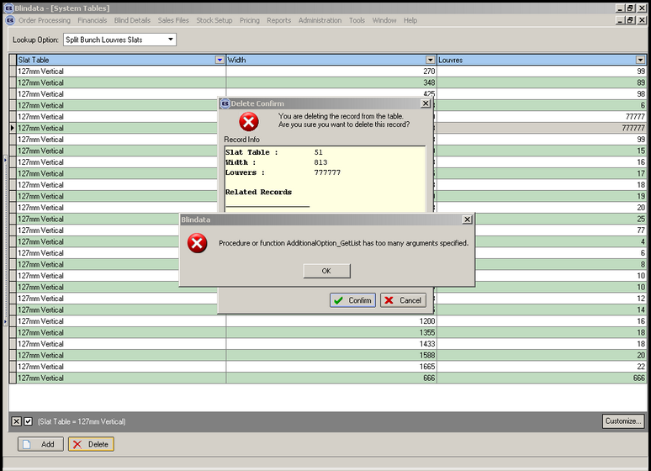

718. Administration > System Tables

When you enter a new option name, you no longer have to log out of the system before you can see it.

New Work and Customer Requests

85. Order Processing > Orders / Quotations

The following changes have been made to the component entry screen:

In the screen caption, ‘Extras’ now say ‘Components’.

There is a new way of looking up the product by description. The product can be found by two methods, either product code or product description.
- 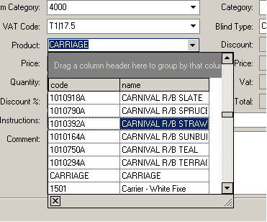

- And you can drag code and name columns yourself and select filters.

- 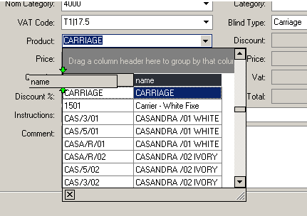

The VAT code lookup has been deliberately removed.

There is a more sophisticated way of picking up prices. We now hold a new table in the system (Pricing > Component Price Table) that holds the following fields:

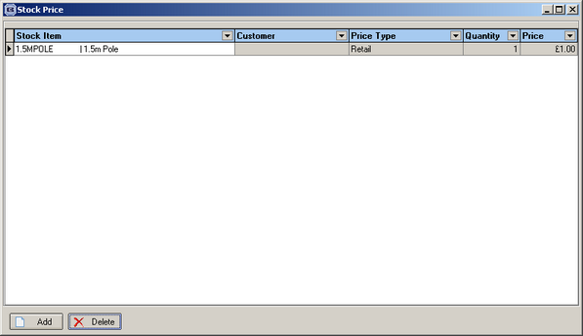

After the stock item is found in the component entry screen, the program should first look in the fabrics table for the price, and then in the new table to see if there is a record match. The match will be either:

By stock id, customer id, component quantity > price quantity

Or

By stock id, price code id, component quantity > price quantity.

It works according to this algorithm:

- A user has to add a new record which contains a Stock Item, ‘Customer’ or ‘Price Type’, ‘Quantity’ and ‘Price’ to the table ‘Stock Price’ (Pricing->Component Price Table);
- When adding or editing a component, the program will search for a price in Stock Price table by 2 conditions:
1) By Customer;
If the record is not found, then:
2) by trade type;
- Then it recalculated the following fields: ‘Vat’, ’Net Price’ ,’Total’.

We also added a new tab ‘Stock Price’ to the Stock item editing form (Stock Setup->Stock Item->Add/Amend), it is used to input prices for the Stock Item.

