Blindata Release Note 2.3.7/8 

14 October 2005

Bug Fixes and Enhancements

672. Stock Items

If you try to delete a record with children, a new window appears, warning the user of what they are about to do.

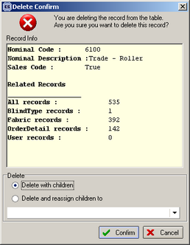

678. Invoice – Laser Print (Letterhead)

Uplift % is now applied correctly on unit price in this report.

683. Order Processing > Production Documentation

We can now filter works order printing by department (but only if Administration > Parameters > Use Department Filter is switched on). The user can choose which department works orders are to be printed out, providing they have permission to see that department (set up in Administration > Users > Departments).

684. Works Order Label 5

Amendments carried out:

All blind identifiers:

Small top left label now includes ‘Order Date’ and ‘Do by date’, ‘Cust. Ord. No.’ and Cust Ref’. ‘Do by Date’ format is dd/mm/yy, nor dd.mm.yy.

On top two small labels, we are able to define which options should appear. This can be done by using the following fields (1 should be for the top two labels and 2 for the larger lower label):

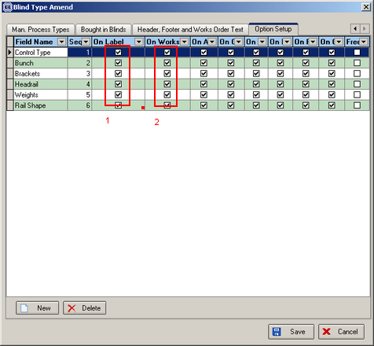

On largest label, we have inserted Agent: (same as Customer) immediately beneath Order No.

On right hand lower label, we have included ‘Order Date’ and ‘Do by date:’ across from ‘1 of 2’ and ‘1R, 1V’ fields.

On lower right label, blind identifier letter appears on top right corner. Ok.

Venetian blind identifier:

Small top rhs label is blank.

On largest label, we have removed ‘C/S:’ and cord spacing field.

Roller blind identifier:

‘Tube cut’ appears on top left label. Ok.

Vertical blind identifier:

Total fabric length appears in metres, not millimetres.

Vanes only blind identifier:

Both top labels are blank.

Fold to fold size is on lower left label.

Headrail only blind identifier:

Lower rhs label is blank.

Total fabric length is on lower left label.

Velux blind identifier:

Top two small labels are blank.

Velux code is on lower left label.

External blind identifier:

Top two labels are blank.

689. Reports > Outstanding Orders

There is now an option to choose by department (with a choice to select all departments).

693. Stock Setup > Purchase Order Enquiry > Generate PO

It is no longer possible to create a regular purchase order for stock items from a sales order that is on credit hold or customer hold.

694. Stock Setup > Purchase Order Enquiry > Generate PO

When you try to print a PO from here, the purchase order prints properly.

695. Order Processing > Orders

The following message now says ‘A fitter appointment has been created.’

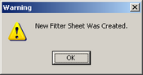

697. Retail Balances

It is only possible to hold an invoice if the order has status ‘despatched’, ‘invoice created’ or ‘invoice printed’.

698. Administration > Users

The following error occurred when you try to amend a user. Fixed.

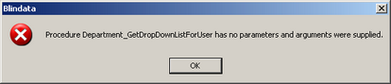

700. Order Processing > Orders

When entering a retail order, the 'customer address' used to populate the 'delivery address' automatically as the address lines were entered. This is working.

701. Order Processing > Orders

When entering a retail order, the 'Delivery company name' now populates from the contact name after it has been entered to avoid staff having to enter it twice.

New Work and Customer Requests

95. Headrail Cut Calculation, Tube Cut Calculation and Fabric Drop Calculation

Previously for vertical blinds we calculated the headrail cut as the blind size width – rail cut difference (in blind type record)

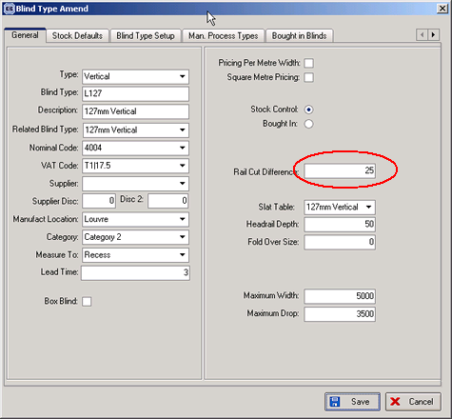

For roller blinds we deducted the tube cut difference to get the exact tube cut size and the fabric cut difference to get the fabric width:

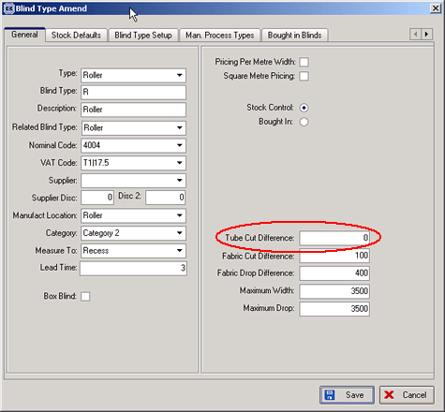

For roller blinds we added the fabric drop difference to get the fabric drop:

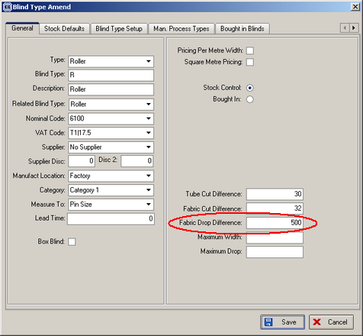

This functionality will still work, but we have introduced a new function to determine headrail cut, tube cut and fabric drop add on dependent on options selected for blinds.

Solution

In Administration > System Tables > Option Names we now have three new codes called ‘Rail Calc’, ‘Tube Calc’ and ‘Fabric Drop Calc’.

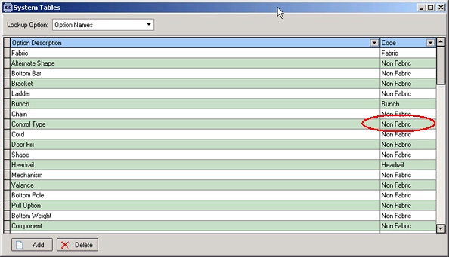

In Administration > System Tables, there is a new table called ‘Option Calculation’. This contains two fields: ‘stock code’ and ‘option difference’. For a vertical blind, after options are selected in order detail entry, the program now checks if the option is set to ‘rail calc’. If it is, the rail cut difference is taken from the option calculation table instead of the blind type. For a roller blind, if an option is set to ‘Tube Calc’, the tube cut difference is selected from the option calculation table instead of the blind type. Also for a roller blind, if an option is set to ‘Fabric Drop Calc’, the fabric drop difference is selected from the option calculation table instead of the blind type.

109. Financials > Retail Balances

We have amended the Retail Balances screen to include the following fields:

Order No | Cust No | Contact Name | Total | Balance | Order Status | Inv No | Inv Date | Inv Hold | Dept | Letter Sent | Letter Sent

We have added ‘Create Invoice’, ‘Print Invoice’, ‘Hold Invoice’ and ‘Clear Invoice Hold’ buttons to the screen.
‘Print Invoice’ is available only when the order has status ‘Invoice Created’ and invoice not held.
‘Create Invoice’ is available only when the invoice is not held.

When an invoice is held, the original invoice number and invoice date are retained in Inv No and Inv Date fields for reference.

When clicked, the ‘Clear Invoice Hold’ button:
- prompts for new invoice date to be entered (original invoice number will be retained)
- sets the order status back to ‘Invoice Created’.
- clears the ‘Hold’ status

It will then be up to the operator to re-print the invoice.

We have excluded ‘held’ invoices from all retail debtors reports and credit letter routines.

