Blindata Release Note 2.3.5/6 

10 October 2005

Bug Fixes and Enhancements

Further optimisation has been carried out on the system, which should lead to a minor improvement in overall performance of the system.

621. Order Processing > Orders

There is now the functionality to input a different invoice address on orders. There is a new flag in the customer record that determines if the invoice address can be changed in the order or not.

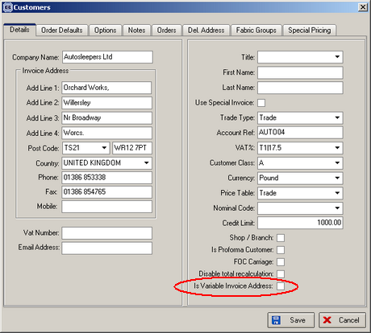

627. Financials > Post Credits to Sage > Audit Trail Report

The audit trail headings are now correct for credit notes.

657. Order Processing > Update Fitting Appointment

It is now possible to set a fitting appointment from order entry for orders that have not been converted from sales leads. Required date and fitter fields must be filled in.

660. Order Enquiry > Blind Manufactured / Order Manufactured

If a blind is ‘bought in’, the WIP status is now bypassed.

665. Reports > Sales Analysis > SA by Blind Type by Fabric

This report now includes blind quantity and sales value.

671. Works Order Label 1

For Repair Orders Only

The following text appears on the main label if an order is flagged as a repair. Manufacturing processes are ignored.

Time Taken______Parts Required_____________Operator________QC____Pack____

The log number also now appears on the label.

673. Order Processing > Orders

The following error appeared if a fitter was not entered in an order:

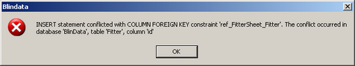

677. Financials > Retail Balances

This screen is now filtering orders by Department according to the user logged on. This is only applicable if Administration > Parameters > Use Department Filter is switched on.

680. Works Order A4 Individual

1) Some fields were being picked up incorrectly - every works order printed was picking up Order Number, Customer telephone no and Delivery company name from the very last works order in the run.

2) The works order numbering eg. '1 of 7' now resets on change of works order number.

3) The options list was out of sync when option descriptions wrapped onto second line. We have widened the option description field to twice its current print width (and turn wrapping off) and moved option choices further to the right.

4) Address Line 4 was missing from Contact Address at top of works order.

5) Remove 'No of Vanes' from works orders for Blind Id 'L' (vertical blinds). (It still appears for Blind Id 'O' - vanes only.)

New Work and Customer Requests

