Blindata Release Note 2.2.4 

30 August 2005

Bug Fixes and Enhancements

564. Credit Note – Letterhead Logo

A new credit note is available – same style as Invoice Laser Print (Letterhead Logo)

566. Work Order – Label 4

Rollers:

Made ‘Tube Cuts Size’ and measurement bigger bold font.

‘Fabric Cut’ says ‘Fabric Length’

Verticals

H’rail cut – now larger font and bold

All blind types:

Moved spec ins. across to below options – put border round spec. ins.

‘Req. Date’ on small labels is in bold. Changed text to ‘Dispatch Date’ on all labels.

Removed bold from blind type, order date.

569. Order Acknowledgement reports

Added page numbers (Page 1 of 2 style)

570. Delivery Docket reports

Added page numbers (Page 1 of 2 style)

579. Order Acknowledgement / Invoice

If an actual amount is entered in the totals tab, the discount % is held against the detail line to 2 decimal places, and now appears on reports to 2 decimal places.

597. Rounding Issues

Rounding problem resolved.

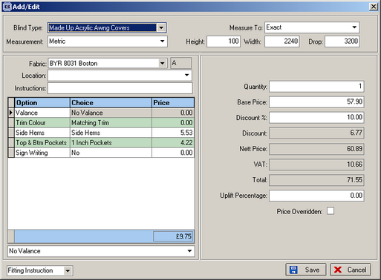

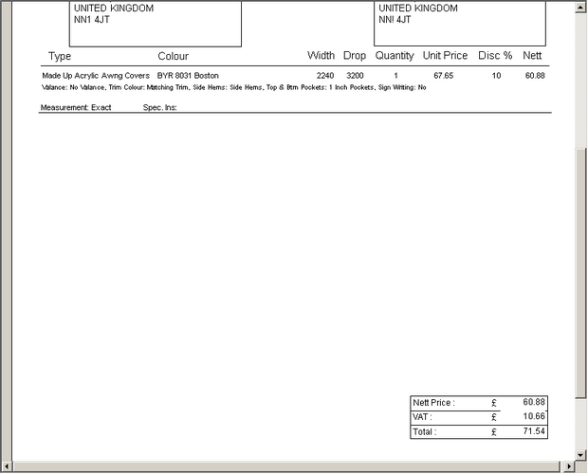

New Work and Customer Requests

