Blindata Release Note 2.2.0 

15 August 2005

Bug Fixes and Enhancements

493. Order Processing > Order Enquiry

Screen was too slow in loading - taking between 6 to 8 seconds to load. This has been improved.

545. Order Processing > Orders > Repairs

The following error occurred when you try to add a repair line. Now fixed.

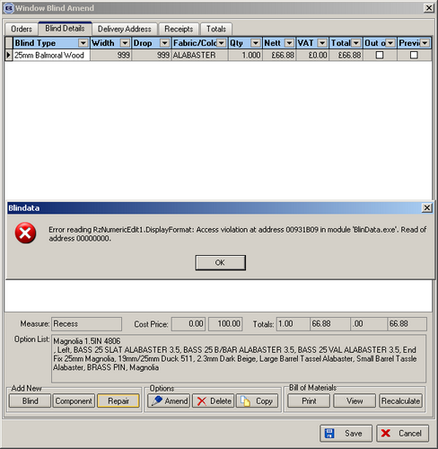

577. Order Acknowledgements / Invoices

The totals on these reports were incorrect if a quantity of > 1 was entered in a detail line. Fixed.

New Work and Customer Requests

88. Repairs

There is a new button on the order entry screen for ‘Repairs’. This is a true/false button and should be placed below ‘On Credit Hold’. It should default to false.

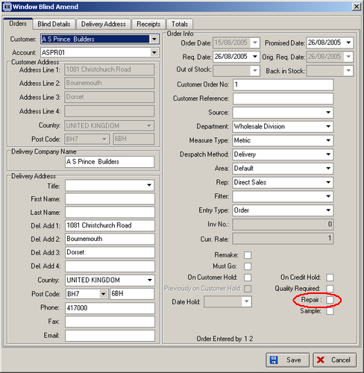

When repair is flagged as true by the operator, it is now possible to enter a repair detail line in window blind amend. There is a new button (which is greyed out if repair = false).

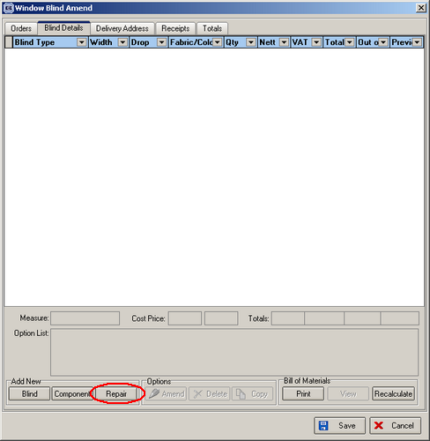

When adding a repair detail line, it is possible to enter blind type (from a lookup), a description of the problem and a nett amount (or gross, depending on whether the customer is trade or retail.

