Blindata Release Note 2.1.4-9 

14 August 2005

Bug Fixes and Enhancements

512. Report - 'works order - label blind size'

The margins on this report have been altered slightly to suit all printers.

534. Order Processing > Archive Enquiry

‘Custumer’ is now spelt ‘Customer’.

535. Administration > Company Details

Postcode lookup now appears in alphabetical order. This is the case in sales leads, customers, suppliers, order entry and quotation entry.

536. Administration > Company Details

The following message appeared sometimes when you try to save the record:

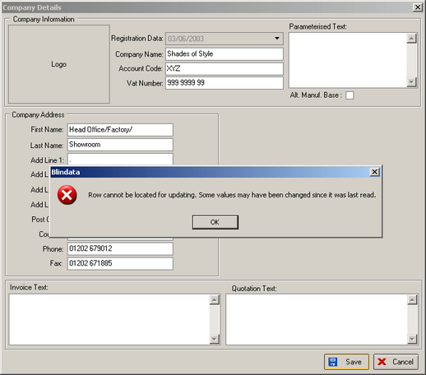

537. Administration > Maintenance

When various tables were deleted, the underlying addresses were not being removed. If you switch all options on, it now only leaves an address for the company detail record.

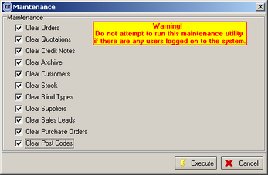

538. Reports > Sales Analysis > Sales Analysis by Customer (Descending)

There is a new sales analysis report that shows sales in descending customer turnover order.

539. Stock Setup > Suppliers

When setting up the first supplier, the following message appeared when trying to save the record. Fixed.

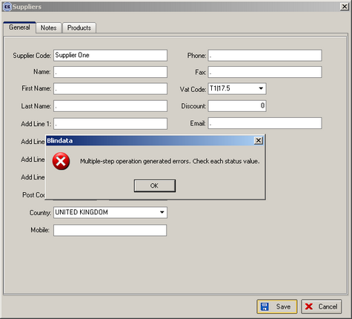

540. Invoice Batch Print

The program has been speeded up to stop timeout errors.

542. Sales Files > Customers
If you entered an account code with more than 8 characters and then tried to save the record, the following message appeared. The message now says ‘Account ref must not be greater than 8 characters’.

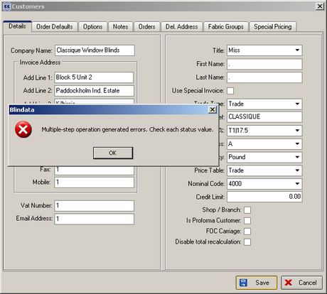

544. Order Processing > Quotations

When converting a quotation into an order, there was a bug if a carriage line is involved. Carriage lines do not get converted into orders, but the total amount that was moved into the order total includes carriage. Fixed.

548. Order Processing > Orders > Detail Line Entry

If the base price or discount % is changed, the price overridden button is switched on automatically. This now locks the option choices. If you want to amend an option, the price overridden button will have to be unchecked first.

549. Order Acknowledgement Print / Invoice Print

If you enter a retail order, the invoice total is now printing correctly.

550. Order Processing > Orders

All amount fields now display to 2 decimal places in the totals tab field.

552. Delivery Docket Laser Print (Letterhead)

Detail line amounts are no longer printed on this delivery docket.

New Work and Customer Requests

