Blindata Release Note 2.1.4/5 

8 August 2005

Bug Fixes and Enhancements

512. Report - 'works order - label blind size' (URGENT)

We are still having problems with the 'works order - label blind size' at one customer site. It won't print to one particular printer, but it used to. The customer is starting to get quite angry with us. I spoke to you about this last week, and asked Shulc to make sure that the page width was less than or equal to a normal report (customer listing, I think).

This report will still not print out properly on a particular printer, but if you try to print another report, for example ‘Customer Listing. I visited the site myself last Wednesday, and it definitely happens. Can we check the width and drop of ‘Works Order – Label Blind Size’ to make sure it is ok.

I will test this onsite on Wednesday.

Vladimir

534. Order Processing > Archive Enquiry

‘Custumer’ should be spelt ‘Customer’.

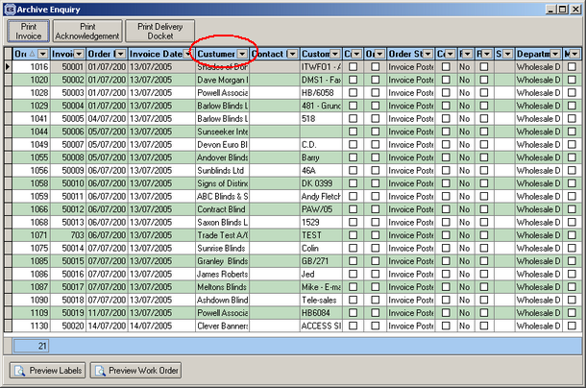

Pavel

535. Administration > Company Details

Postcode lookup should appear in alphabetical order. This should also be the case in sales leads, customers, suppliers, order entry and quotation entry.

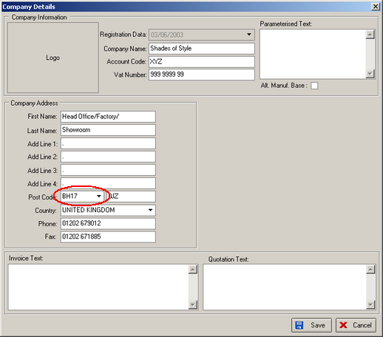
Vladimir

536. Administration > Company Details

The following message appears sometimes when you try to save the record:

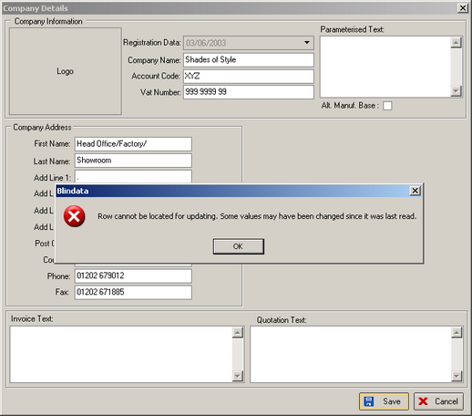

Vladimir

537. Administration > Maintenance

When various tables are deleted, the underlying addresses are not being removed. If you switch all options on, it should only leave an address for the company detail record.

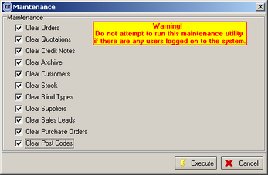

We have modified the corresponding triggers and stored procedures. After that we enabled all options on this form, there remained about 10 records in our test database: one record for company (which is correct), several records for departments and several records for users. It works this way because the functionality of this module does not clear the departments and users tables.

Pavel

538. Reports > Sales Analysis > Sales Analysis by Customer (Descending)

We need a another sales analysis report, which is the same as ‘sales analysis by customer’, but which orders the records by actual nett, highest first.

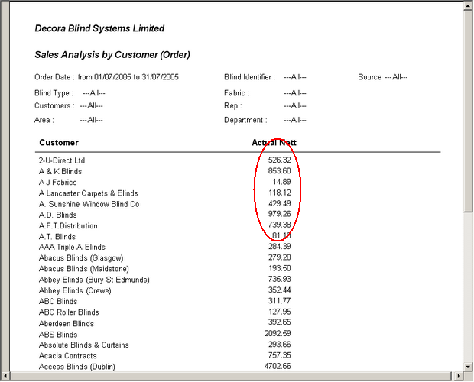

Vladimir

539. Stock Setup > Suppliers

When setting up the first supplier, the following message appears when trying to save the record.

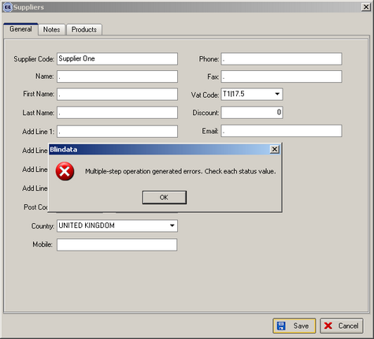

Vladimir

540. Invoice Batch Print

We have an important issue at Decora that needs to be dealt with asap. The invoice batch print is bringing up a timeout message. It also uses 100% of CPU usage and freezes everyone else. They upgraded from 2.03 to 2.1.2 at the weekend. This needs to be looked at urgently.

We have reduced the length of Fitting Instructions to 100 characters. This should fix the timeout problem.
Vladimir

542. Sales Files > Customers

If you enter an account code with more than 8 characters and then try to save the record, the following message appears. The message should say ‘Account ref must not be greater than 8 characters’.

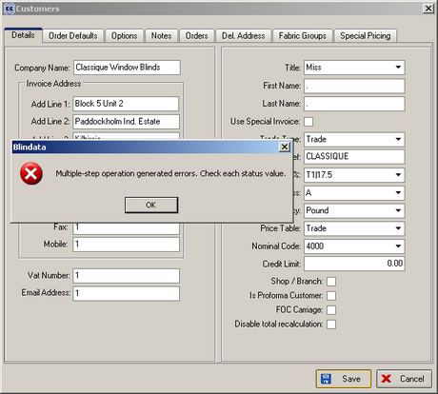

Vladimir

544. Order Processing > Quotations (URGENT)

When converting a quotation into an order, there is a bad bug if a carriage line is involved. Carriage lines do not get converted into orders, but the total amount that is moved into the order total includes carriage. It should not. In the example below, the nett total is correct, but actual nett is wrong.

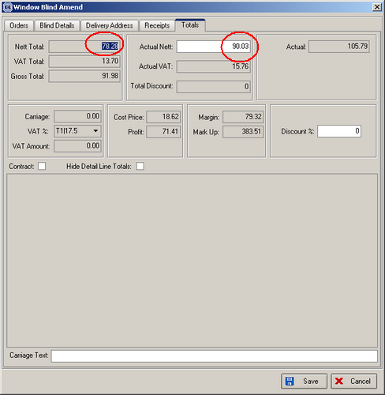
Vladimir

548. Order Processing > Orders

If you enter an order detail line, a price calculation error can occur if you do the following:

Enter a detail line that has an option price:
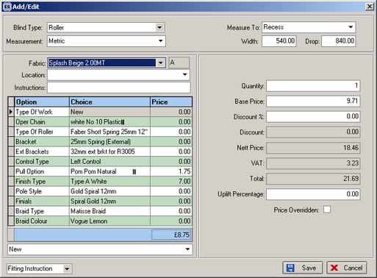
Override the price by putting in a discount percentage. This will then mean the price overridden button gets ticked automatically:
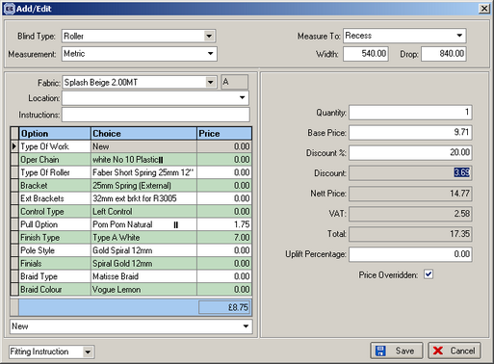

Change an option, which then changes the option price, but not the overridden price:
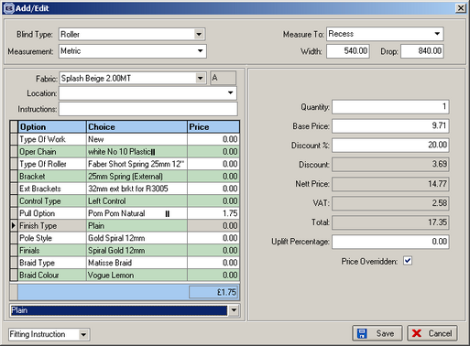

In this way, the (base price + option price sum) less discount does not add up.

I think we need to stop the amendment of options if the price overridden button is ticked.

This is still incorrect, because you can still change an option and then the base price + option price does not add up properly. We need to stop the changing of the option, not just the price of the option.

Pavel

549. Order Acknowledgement Print / Invoice Print (URGENT)

If you enter a retail order, the total is correct, but the order acknowledgement, invoice etc does not print the correct amount

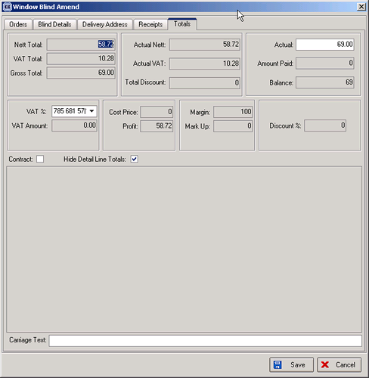

The VAT is being added to the total. Because it is an order for a retail customer the total of 69.00 includes VAT. Therefore on the reports the actual nett should be 58.72, actual VAT should be 10.28 and the actual 69.00
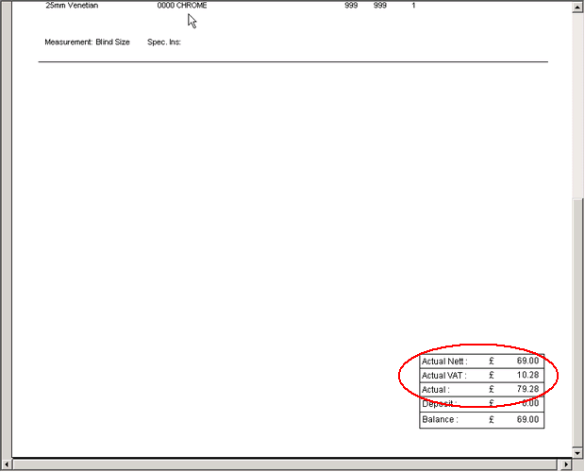

This is still incorrect. It is now showing Actual instead of Actual Nett:

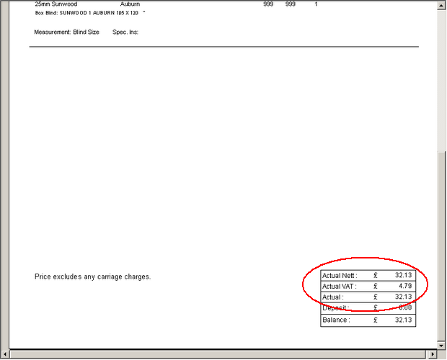

Actual Nett should be 27.34.

Pavel

550. Order Processing > Orders

All amount fields should display to 2 decimal places (also check deposit and balance field). 0 should be 0.00, 25 should be 25.00 etc.

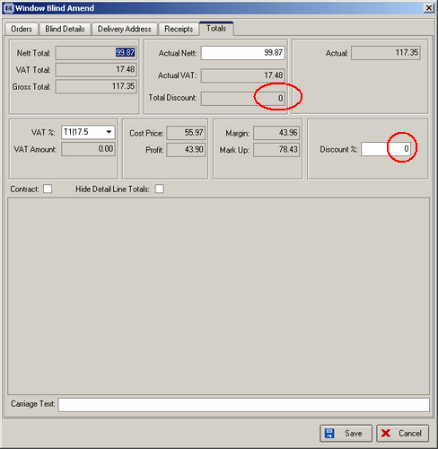

Pavel

551. Invoice Batch Print (Invoice Bespoke 1)

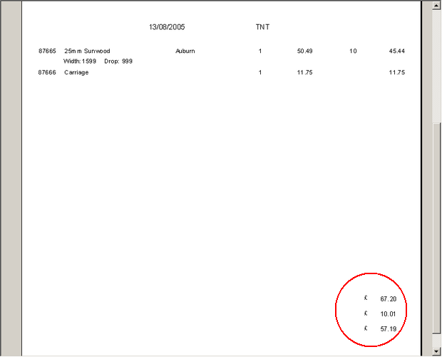

The invoice should print:

57.19
10.01
67.20

The individual print is ok though.

Pavel

552. Delivery Docket Laser Print (Letterhead)

Detail line amounts should not be printed on this delivery docket:

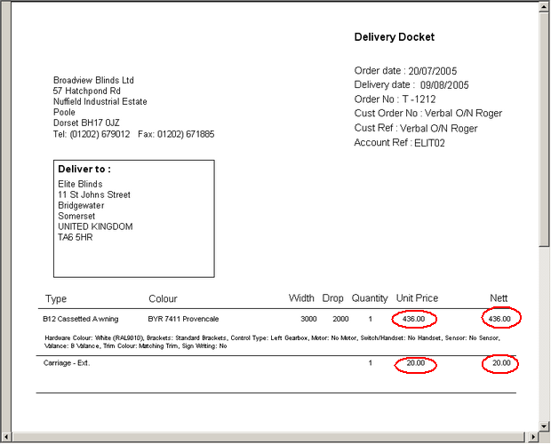

Roman,
Can you make the following change to bug 552, please. As well as the unit price and nett being removed, the discount should also be taken out.
Thanks,
Alistair
Pavel

New Work and Customer Requests

