Blindata Release Note 2.1.1/2 

29 July 2005

Bug Fixes and Enhancements

521. Order Processing > Orders

There was a rounding error on retail orders that has been fixed.

524. Financials > Daily Sales Report
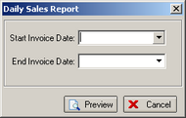
This report now asks for a start invoice date and an end invoice date.
525. Order Processing > Fitters Sheet / Sales Leads

Previously the lookup only worked for the first letter. If you typed R, it found companies that start with R. If I then typed E, it looked for companies starting with an E. It now looks for companies that start RE. Please note the letters must be typed fairly quickly for this to work.

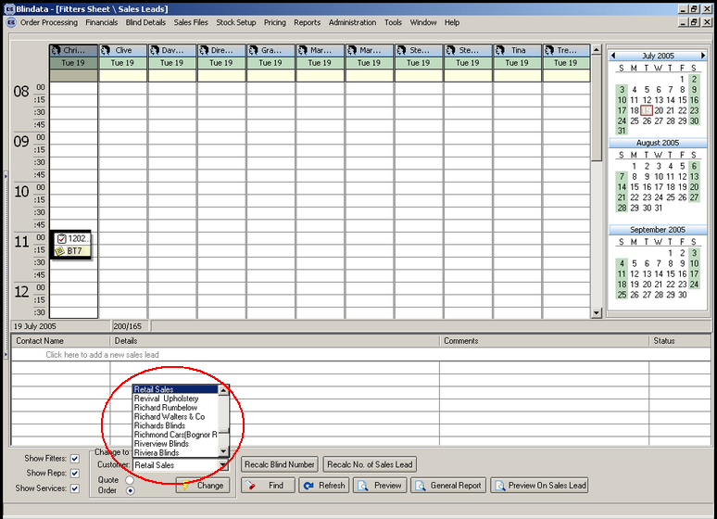

526. Order Processing > Fitters Sheet / Sales Leads

This message now says ‘This employee is not a fitter’.

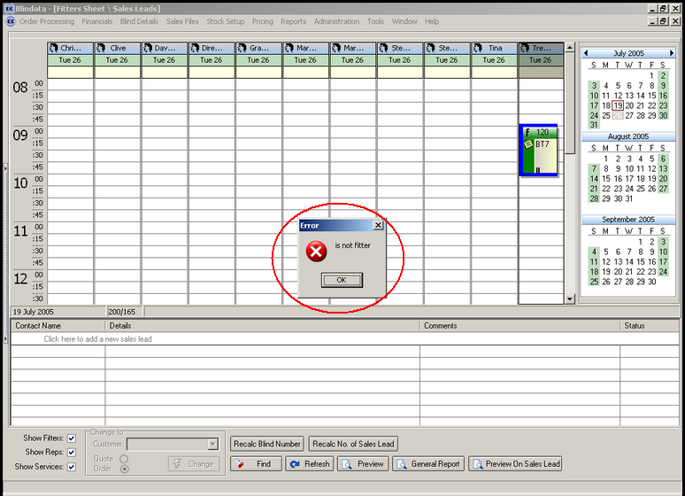

528. Stock Setup > Purchase Order Enquiry > Generate Bought In PO

Purchase orders are now generated properly where sales orders were previously on customer hold.

530. Invoice - Laser Print 11 Detail Lines

For a component detail line, the invoice now prints the comment field, not the fabric description.

532. Order Processing > Orders

Rounding errors had appeared again in the order entry program. Here is an order with two detail lines:

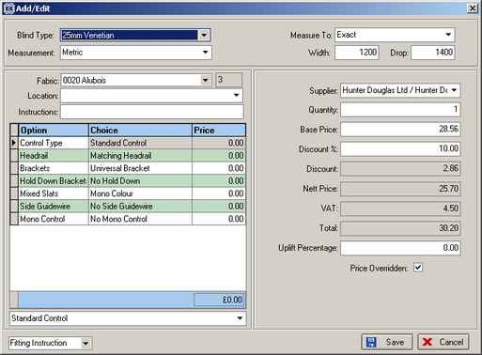

The total amount had been calculated incorrectly. It should be 51.40, not 51.41. The totals should always be calculated by adding up the detail lines (which will already have been rounded to two decimal places). 28.56 less discount of 10% = 25.704 = 25.70. The total should be 25.70 + 25.70 = 51.40.

533. Receipts Table

A customer reported that they could not see a particular receipt on the receipts report by date report (Reports > Receipts by Date). Fixed.

New Work and Customer Requests

91. Quality Check Flag

There is a new flag on the order table for "Quality Check" similar to the "Remake" flag. This means that an order can be forced to go through the quality check system, even if it isn’t a remake. To release an order that has been set to quality check required, go to Administration > Quality Control.

The order gets to Quality control form, if it “Quality Control Required” flag is checked for this order. It will remain there, until the user confirms that the quality has been checked and delivers the order.

At the moment, it is possible to check “Quality Control Required” flag even after the order has been delivered. As discussed we’ll change that in the next version. After the order has been delivered, it should not be possible to check “Quality Control Required”, or “Remake” flags.

The label now says "QUALITY CHECK", similar to "REMAKE" in exactly the same position.

