Blindata Release Note 2.0.0/1/2 

17 June 2005

Bug Fixes and Enhancements

463. Order Processing > Orders

Required dates that have been manually entered are no longer changed automatically by amending an order.

475. Financials > Post Invoices to Sage

We no longer display the ‘transaction’ message after each transaction has been posted to Sage Line 50. A message now appears at the end to say ‘All transactions have been successfully posted’.

479. Works Order – Label Blind Size

This report was still too wide for some printers and printed out in landscape. We have made the margins wider to try to resolve the problem.

When this label is set to print imperial measurements, it now print 32 1/8 instead of 32.125 (ie fractions instead of decimal places).

480. Invoice – Laser Print 11 Lines

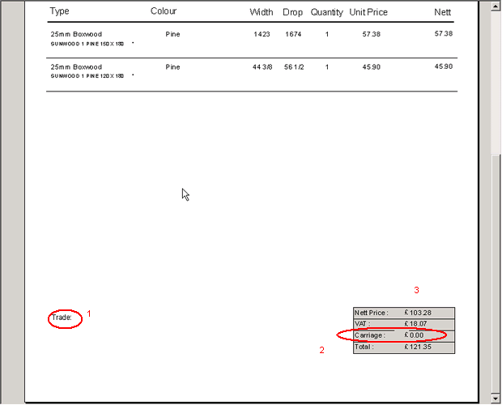

- Removed ‘Trade:’ but keep invoice text.
- Removed ‘Carriage’ and carriage amount
- Remove background colour from entire report.
- Right justified totals.

482. Order Processing > Orders

The following error occurred if you try to copy an order detail line. Now fixed.

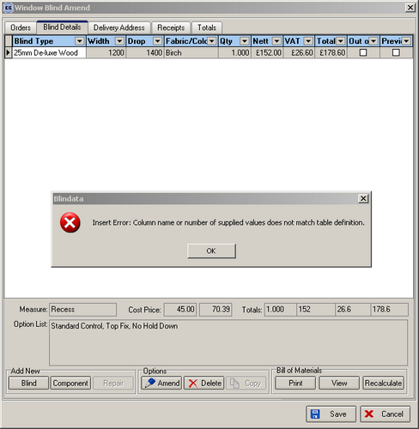

484. Invoice Laser Print (Letterhead)

The company address is now printing properly:

488. Delivery Docket Laser Print (Letterhead Logo)

There is a new delivery docket for logos – based on Delivery Docket Laser Print.

489. Works Order Label 4

Third set of labels on page has been moved down 2mm.

New Work and Customer Requests

82. Order Processing > Orders > Create PO

After the ‘Purchase Order created’ message appears, the print preview for the purchase order now displays. If a purchase order has already been created for the sales order, a message appears saying ‘A purchase order has already been created – would you like to reprint the purchase order?’. If yes, the purchase order print preview appears.

84. Reports > Sales Analysis

There is a new Sales Analysis by Manufacturing Location by Blind Type report.

