Blindata Release Note 1.8.9 

16 May 2005

Bug Fixes and Enhancements

379. Order Processing > Orders

When entering a component, the ‘on sales order’ figure in the stock record is now being updated properly.

383. Purchase Order Regular - Standard

Vat No. now comes from Administration > Company Details > Vat Number.

‘Cust Ref.’ says ‘Reference’.

391. Financials > Create Invoices

The delivery date is no longer (sometimes) changed when ‘Create Invoices’ is being run.

401. Reports > Sales Analysis > Sales Analysis by Rep by Customer by Blind Type

The title of this report is now correct.

402. Order Processing > Orders

This happens when an order is being added to the system. The Bill of Materials screen View button was greyed out when it shouldn’t have been. Fixed.

403. Financials > Create Invoices

Carriage should be set to nominal code 6400 (for Decora only). Is this hardcoded at the moment to 4000?

409. Financials > Post Invoices to Sage

The Financials > Post Invoices to Sage window was including Retail orders even though 'Post Retail Invoices' was deselected on the Administration > Parameters > Parameters tab, and on the Administration > Parameters> Sage Parameters/Invoicing tab. Fixed.

410. Order Processing > Orders

When exiting out of ‘bill of materials’ form, an error occurred. Now fixed.

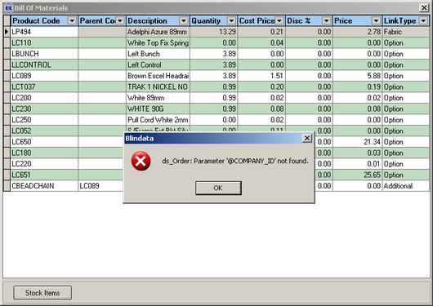
Gavs

411. Works Order Label Blind Size

If a blind is entered as an imperial size, the calculation for metric was being divided by 25.4 instead of being multiplied. Fixed.

New Work and Customer Requests

