Blindata Release Note 1.7.8/1.7.9 

22 April 2005

Bug Fixes and Enhancements

Un-numbered:

In the delivery Address section of the Order form, there is a field for an email address. The maximum length it allowed was 30 characters. We have extended it to 50 characters.

268. Reports > System Reports > Blind Type Ordered

There is now a total for all the blinds on this report.

269. Pricing > Discount Management

It is now possible to look up and enter customers by account code as well as customer name.

273. Order Processing > Orders (Client 1757)

There is a new field in the Orders table, delivery company name, which defaults to customer name (if it is a trade customer, if retail it should be left blank). It is now possible for the user to amend the delivery company name on the orders screen.

The delivery company name appears between invoice address and delivery address on the screen.

‘Delivery Docket Laser Print (Special)’ has been changed so the following fields are printed in the delivery address:

Delivery Company
Order Contact Name
Delivery Address 1
Delivery Address 1
Delivery Address 1
Delivery Address 1
Country
Postcode

So if delivery company is blank, everything will get moved up one line.

285. Margins on Works order – label reports

We had a problem with printing the works order label reports. On some printers the printer top margin is too small and this then upsets the line up of the labels. The margin between labels also appears to be different. The labels start to go up the page by about 1.5mm for each set of labels, so by the third set of labels, the ‘Order No’ line is not on the label at all.

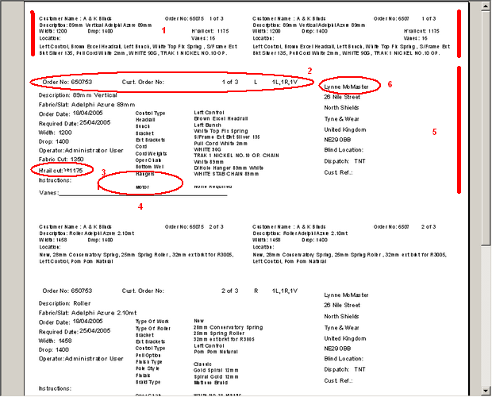

Only changed ‘Works Order – Label Blind Size’.

The first label starts 5mm from the top: the print should start 2mm below where the existing print starts. The depth of the first label is 20mm, so we should squeeze everything on this label into 17mm. This should just make room for 6 lines. This gives us 1mm tolerance at the bottom of the first label. (1)

The big label starts at about 35mm from the top. We should keep the bottom of this print where it is but squeeze everything towards the bottom of the label. The problem is only at the top of the label, where it is printing too high. The existing line up on the address label is fine. (2), (5)

Headrail cut needs tidying up for vertical blinds. (3)

Should be company name for trade order. (6)

286. Reports > System Reports > Blind Type Ordered

Blind Type ordered report is no longer including quotations.

313. Financials > Invoice Batch Print

When doing a reprint, it is now possible to reprint orders with status = invoice posted.

318. Invoice Bespoke 1

On the Invoice for any "Velux" Blind Types it was stating "Velux Code", this now says "Code".

325. Sage Integration > Create/Update Customer Records from Sage

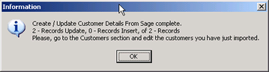

The text now says:

Create/Update Customer Details from Sage complete.
2 records in total processed (2 updated, 0 inserted).
Please go to the Customers section and edit the customers you have just imported.

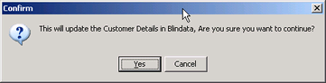

There is now a full stop (.) after Blindata, not a comma.

327. Order Processing > Orders > Add new & then save

When a new order is saved, focus now moves to the new order added to the list of orders (otherwise it was too easy to print wrong order by mistake).

330. Financials > Invoice Print and Post > Print Invoice

The 'Print Invoice' button prints out the invoice and now changes the status to 'Invoice Printed'

333. Order Processing > Orders > Place on Credit Hold

There is a new button on the order amend enquiry that allows a user to switch an order to ‘on credit hold’. This is controlled in ‘Advanced Permissions’.

At the same time as this is done, we have made a change in the Sales Files > Customers form. If you switch a customer to being ‘On Stop’, all orders for that customer get put on credit hold. This is correct. However, if you then switch ‘On Stop’ off, all orders get taken off credit hold. This functionality is not required and has been removed.

334. Administration > Users > Advanced Permissions

We need two extra buttons here:

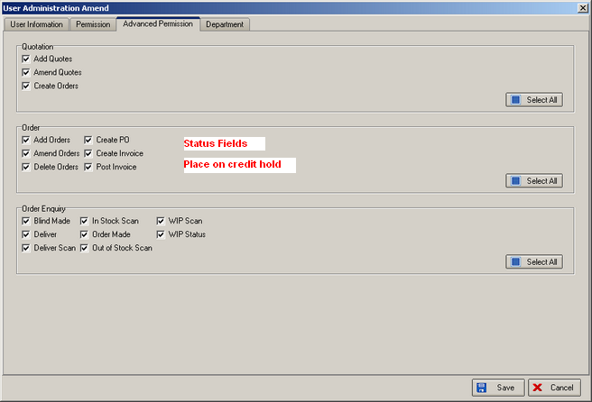

337. Blind Details > Blind Type Options > Field Setup

It is now possible to save tick box settings for printing options on Delivery Dockets (tick boxes for all other docs saved OK).

343. Pricing > Discounts
On the Discounts screen the Sage Account Code has been added, the heading now says ‘Account Code’.
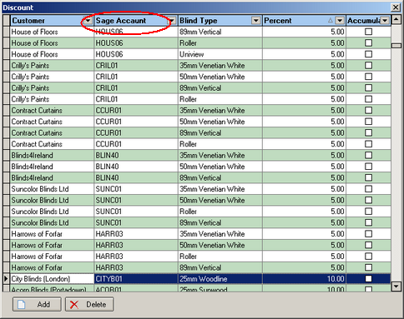

344. Delivery Docket Print

After the addition of the Delivery Company, you could not print a despatch note for a new order or an old order - you receive the following error message. Now fixed.

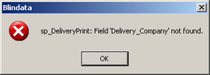

New Work and Customer Requests

12. Order Processing > Production Documentation > Label Print 200 x 24

Vertical/rollers labels are now always shown as recess size. Venetians/pleated are always blind size on label.

