Blindata Release Note 1.7.5 

15 April 2005

Bug Fixes and Enhancements

290. Order Processing > Order Enquiry

‘All out of stock’ and’ All in stock’ buttons are now scans, in the same way that ‘In Stock’ and ‘Out of Stock’ buttons are.

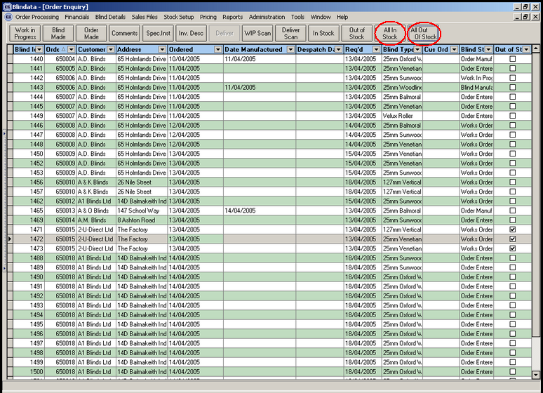

291. Administration > Users

‘All out of stock’ and ‘All in stock’ buttons for Order Enquiry now have advanced permissions.

The same permissions also apply to the ‘All in Stock’ and ‘All Out of Stock’ buttons as well as ‘In Stock’ and ‘Out of Stock’ buttons.

292. Order Processing > Quotations

There is now a facility (button) to e-mail quotations.

301. Order Processing > Orders

In order detail line, we have now ensured that the price of a blind is found properly when a second line is entered. If nothing was updated on the second line of an order, the blind was not priced correctly. This has been fixed.

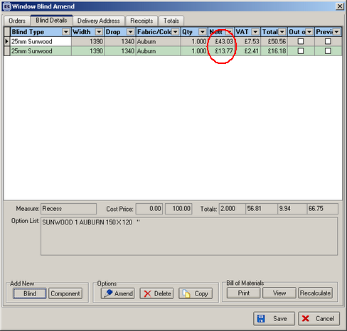

302. Order Processing > Order Acknowledgement – Laser Print

Orders 650527 and 650327 were printing too many lines on order ack.

You need to do the following with these orders: open Order Amend form and save it, the program will save all the records correctly and the report will be printed correctly. The problem won’t appear for new orders.

303. Order Processing > Order Acknowledgement – Laser Print

We have removed the background colour from the order acknowledgement.

304. Order Processing > Orders/Quotations

The e-mail address is now 50 characters in Orders table and Customer table.

305. Order Processing > Orders/Quotations

The currency field in the orders screen is now locked.

307. Financials > Create Invoices

A number of invoices were created without carriage when there should have been carriage added. We think this is now resolved but should be checked carefully for a few days.

310. Order Processing > Production List > Order Control Report

When you choose ‘Exclude Out of Stock records’, the ‘out of stock’ are no longer appearing on the order control report.

314. Order Processing > Orders

We have removed the filter message ‘Order status NOT LIKE Invoice Posted’.

Also:

When ‘Invoice Bespoke 1’ is printed from Financials > Invoice Print and Post, the totals in the bottom right were too low. The layout is now the same as the ‘Invoice Batch Print’.

New Work and Customer Requests

