Blindata Release Note 1.7.4 

15 April 2005

Bug Fixes and Enhancements

298. Invoice Bespoke 1 (CRITICAL)

Invoice print layout was incorrect in two different places. If you went onto a second page, the first page was not stopping at the bottom of the detail area. The layout was different between the invoice batch reprint and the invoice print from the ‘Post Invoice to Sage’ screen. The ‘Post Invoice to Sage’ layout was wrong.

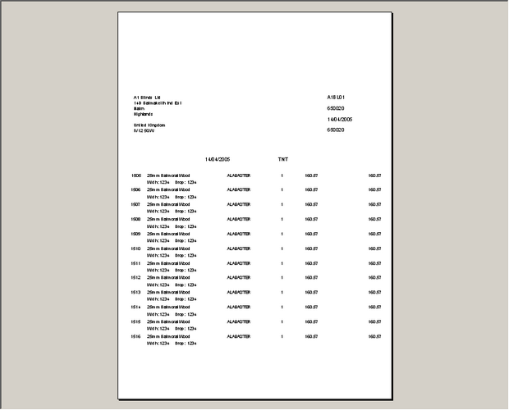
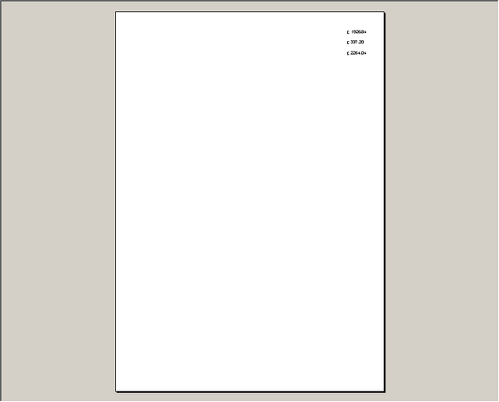

The above happened if you printed an invoice with 12 detail lines on it.

Also, the invoice layouts were different depending on where you are printing from. Here are the choices:

- Financials > Invoice Batch Print
- Financials > Invoice Print and Post > Print Invoice button
- Financials > Post Invoices to Sage > Print Invoice button
- Order Processing > Archive Enquiry > Print Invoice button.

The layouts are now all the same.

306. Works Order – Label 1

Numbering was wrong on label – fixed.

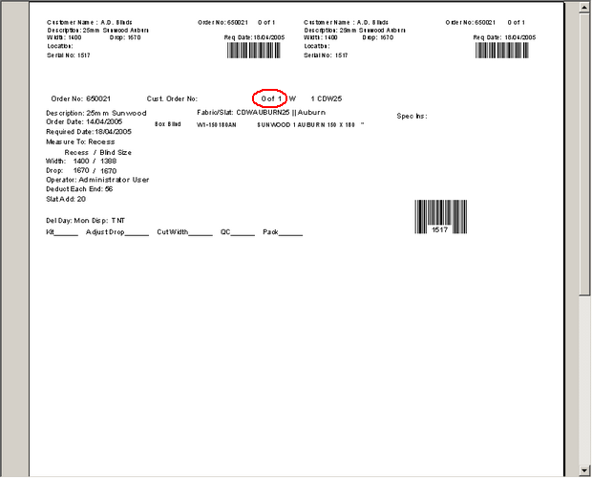

309. Order Processing > Archive Enquiry

There are now orders being displayed here.

New Work and Customer Requests

