Blindata Release Note 1.7.3 

14 April 2005

Bug Fixes and Enhancements

288. Date Formats

There is a new table to hold date/time stamp for recording when status changes were made to orders.

When change the status of an order detail line or an order, we now write a record to a new table that holds order id, order detail id, operator id, status reached and date/time. The table is named OrderStatus_Change in the database.

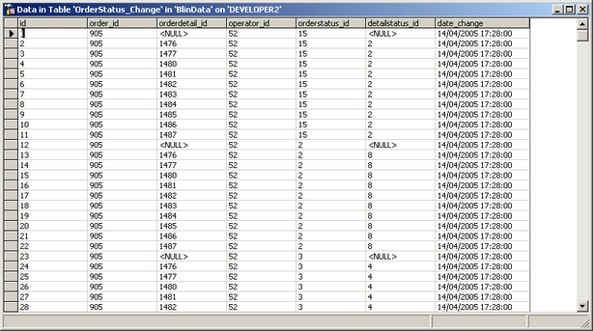

Description:
As you can see some data appears to be missing (null) in these records (orderdetail_id and detail status_id). These fields are required only when the status is changed in Order Detail table. All other records appear when status was changed in Order Detail table. Fields orderstatus_id and detailstatus_id show to what status an Order or Order Detail was changed. operator_id field shows who changed the status of orders.

297. Order Processing > Quotations

If you converted the last quotation into an order completely, and then enter a new quotation, the same quote number gets used. This has been fixed.

298. Invoice Bespoke 1

Invoice print layout was incorrect. If you printed onto a second page, the first page was not stopping at the bottom of the detail area. These items have now been fixed with the exception of an invoice that has 12 detail lines – this happens:

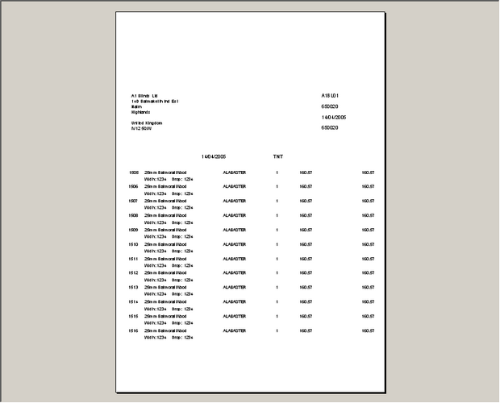


299. Delivery Docket Laser Print (Special)

The delivery docket did exactly the same thing as #298 but has been fixed.

New Work and Customer Requests

