Blindata Release Note 1.7.0 

11 April 2005

Bug Fixes and Enhancements

251. Administration > Users

There are now menu permission options for:

Order Processing > Quality Control
Financials > Retail Balances
Financials > Complete Posting to Sage Line 100.

252. Administration > Maintenance

The option to clear Orders now works. This failed because the table OrderInvoiceAddress had been added and it was not being cleared.

253. Order Enquiry > Despatch Scan > Deliver Docket Laser Print (Special)

When you deliver scan an order, the dispatch docket now print without having to resave the order.

254. Order Processing > Production Documentation > Works Order - Label 1

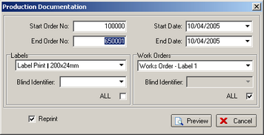

The start order number can now be entered properly.

255. Order Enquiry > Blind Made

If you flagged an order as Work in Progress and then tried to Blind Made a particular blind within that order straight away it gave you the usual record lock message but then changed the status to Blind Manufactured and added a Manufactured date; if it was the only blind on the order it would not then prompt you "Would you like to Manufacture the Order". This has been fixed.

256. Order Processing > Orders On Hold

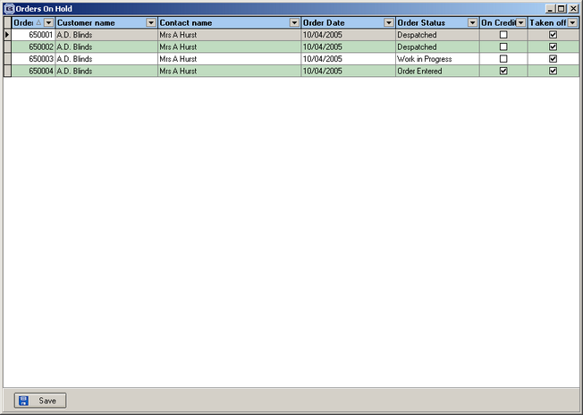

When you click on ‘Taken Off’ and change it to true, ‘On Credit’ now changes automatically to false.

257. Financials > Retail Balances

The menu option is now called ‘Retail Balances’, not ‘Retail Balance’.

258. Reports > Cancelled Orders

The menu option is now called ‘Cancelled Orders’, not ‘Canceled Orders’.

259. Order Processing > Order Enquiry > Delivery Docket Laser Print (Special)

Delivery docket layout changes made – this report only.

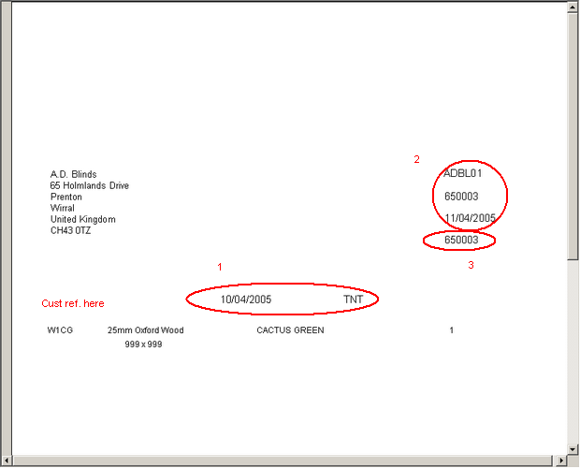

1. Moved these fields up 3mm and left 35mm.
2. Moved these fields up 3mm and left 20mm
3. Replaced this field with operator name, move up 3mm and left 20mm.
4. Moved Despatched Operator down 10mm (should be 20mm from bottom of page)

260. Financials > Invoice Batch Print > Invoice Bespoke 1

Moved invoice layout – down 1.5mm

262. Order Processing > Orders

When amending a detail line, the defaults were getting reset; this meant changes were being lost - this has been fixed.

New Work and Customer Requests

