Blindata Release Note 1.6.6 

24 March 2005

Bug Fixes and Enhancements

157. Reports > System Reports > Customers On Stop

There is a new report, Customers on Stop. This prints a list of all customers on stop, showing account code, customer company name, address, postcode.

170. Sales Files > Customers

When setting up new customers the delivery address was defaulting to the wrong address when a second customer is added. This has been fixed.

Also tab order has been corrected in customer entry.

191. Order Processing > Orders > Detail Line Entry

It is now possible to enter fractions of inches in detail line entry for width and drop – an order can be placed in inches like this: 48 1/8 width, 67 ½ drop. This is then stored as 48.125 width and 67.5 drop. Fractions of inches used are 1/8, ¼, 3/8, ½, 5/8, ¾, 7/8.

The width and drop will only appear in this format if the detail line has been entered in imperial. If metric, there will be no change.

199. Order Processing > Order Enquiry

It is now possible to reprint a delivery docket using the Deliver button.

201. Reports > Sales Analysis

Very large figures were being generated for some sales analysis reports. This is caused when there is a discrepancy between nett and actual figures, or when base prices are 0. This has been corrected.

203. Order Processing > Quotations > Quotation Laser Print

‘Sage Account Ref’ now says ‘Account Ref’.

207. Order Processing > Production Documentation > Works Order – Label 1

Operator name was not printing out in full. Slat add/deduct calculation is now working correctly.

208. Order Processing > Production Documentation > Works Order – Label 1

We can now determine the number of labels that print out depending on the numbers of records set up in Blind Details > Blind Types > Blind Type Setup.

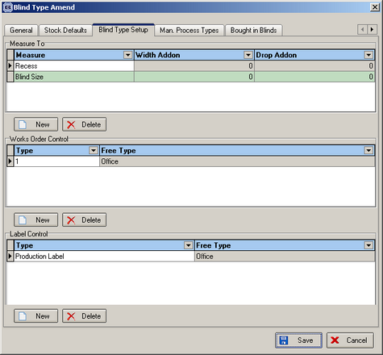

New Work and Customer Requests

49. Administration > System Tables > Employees (Client 1757)

There are now three more employee types – Production, Warehouse and Despatch. This means we will have 6 employee types in total: Fitters, Reps, Service, Production, Warehouse, Despatch. The last three will not be used in the diary.

55. Remake Log Number

A new field has been introduced to the Orders table called ‘Log Number’. This is displayed on the order entry screen if remake has been ticked.

56. Remake Quality Control

There is an important quality control issue with remakes. If a blind is remade, it now has to be quality checked before it is despatched. The following changes have been made to the system.

There is a new field in the Orders table called ‘Quality Control Checked’. It is a true/false field.

A new menu option (in Order Processing) is available, called Quality Control, which shows all remake orders. It also shows order id, order date, Log number, customer, required date, customer order no. and quality control checked. The only field that can be changed is quality control checked.

The deliver scan and deliver buttons on the order enquiry screen have the following additional logic applied to them: if an order is a remake, quality control checked must be true before the order can be delivered. If not, a message should appear saying ‘This order is a remake and has not yet been quality checked, please contact the Quality Department’.

