Blindata Release Note 1.5.9 

25 February 2005

Bug Fixes and Enhancements

98. Order Processing > Orders > Works Order Print

When works order is printed from order entry, the order enquiry status is now updated to ‘Works order printed’, the same as in Order Processing > Production Documentation.

112. Financials > Create Invoices

If Administration > System Tables > Area > Carriage amount = 0, a carriage detail line is no longer created in an order when ‘Create invoices’ is run.

115. Order Processing > Orders > Order Acknowledgement print

No longer showing separate charge for options, only the total unit price/discount/nett price (inc the extra amount for options).
118. Order Processing > Orders > Component Detail Entry

The following error message no longer appears if category or nominal code is not filled in:

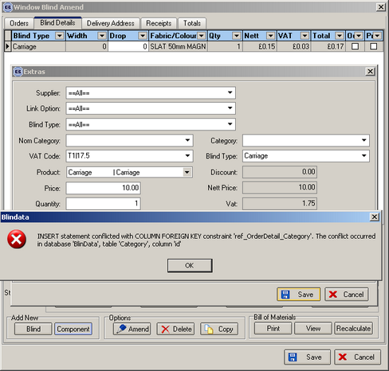

125. Order Processing > Production List > Order Control List

The options to ‘Exclude Records Before Status’ and ‘Exclude Records After Status’ are now working properly – they were the wrong way round.

The criteria chosen ‘Show all records / Show records with status / Exclude Records Before Status / Exclude Records After Status’ now prints on the top of the report.

The records are now printing out in the correct order – Must Go, Delivery Day, Previously Out of Stock, Remake, Regular (all others).

Status field will now fit into space easily.

‘Garnd’ is now spelt ‘Grand’.

In blind types field (1L, 1R etc), it was missing out blind identifiers O and C. This has been corrected.

Dates now show in format 21/02/05, not 21/02/2005. This will save space.

The correct number of records is now printing – there is only be one record per order

127. Order Processing > Quotation > Print Quote

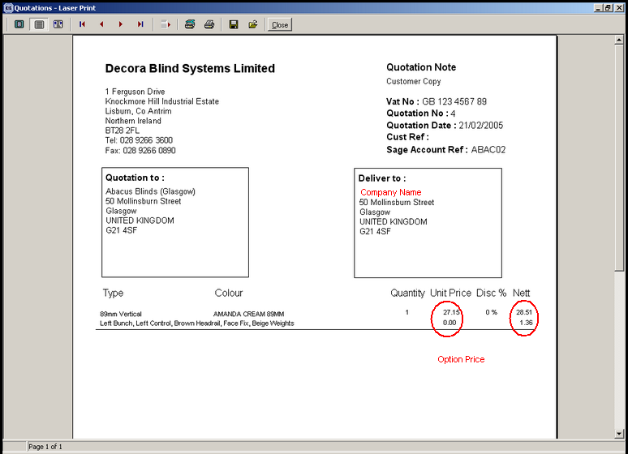

Company name is now showing on delivery address.

If discount is zero, it does not display 0 on the detail line.

128. Order Processing > Credit Notes

Proforma field no longer appears for credit notes.

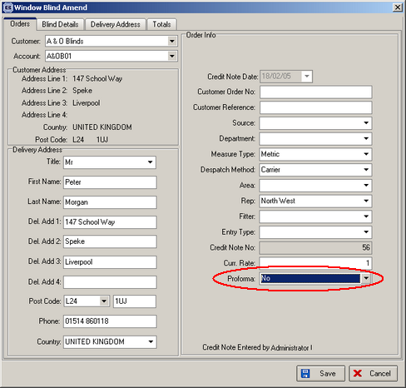

New Work and Customer Requests

34. Logging In

You can no longer log in more than once as the same user.

The functionality has been implemented by adding 2 additional fields to the existing table [User]:
[is_active] – shows if the user is active/inactive (boolean)
[active_time] – stores the last time when the user was active (the running application updates this field with the current server time every 2 minutes).

When the user logins to the system, the system checks activity for this user in the system ([is_active]). If the user is active ([is_active] = true), it verifies the last recorded activity time, and if it is more than 3 minutes (the running application updates that field every 2 minutes), the user is considered to be inactive (his computer could freeze, or restarted unexpectedly) and allows logging in. This way we’ll be able to avoid a situation where the application gets unexpectedly terminated, and the user status remains active. In these circumstances, users will be able to re-login again after 3 minutes.

40. Order Processing > Orders

It is now possible to e-mail order acknowledgements to customers. Therefore we need to hold e-mail address against retail orders. Trade orders are ok, because the e-mail address is already held against the customer.

