Blindata Release Note 1.5.7 

21 February 2005

Bug Fixes and Enhancements

96. Order Processing > Credit Note Entry

Removed proforma field, tidied up text, no credit limit message appears at end of entry. Also, the only date that appears on this screen is ‘Credit Note Date’.

97. Order Processing > Production Documentation > Works Order – Label 1

We have made space on the label by doing the following:

1. Put special instructions above the barcode on the right hand ‘address’ label
2. Move everything from ‘Order Date:’ up a line on large label – there is room to do this as we have moved fabric description already.
3. For verticals, put H’rail Cut and No. of Vanes on the same line.
4. This will then leave space for Delivery Day and Despatch Method.

Also, we have removed h’rail cut on two small labels at the top.

The options are now displayed like this:

Control Type LLCONTROL Left Control
Headrail LBHEADRAIL Brown Headrail
Bunch LBUNCH Left Bunch
Etc ETC Etc

Also, if blind identifier = X (velux), the Velux Code now appears below operator, like this:

Velux Code: 406

102. Order Processing > Orders

The following order for a retail customer produced rounding errors again:

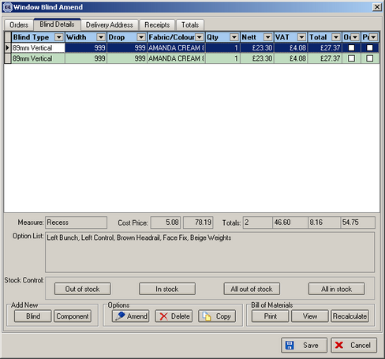

This was the individual line:

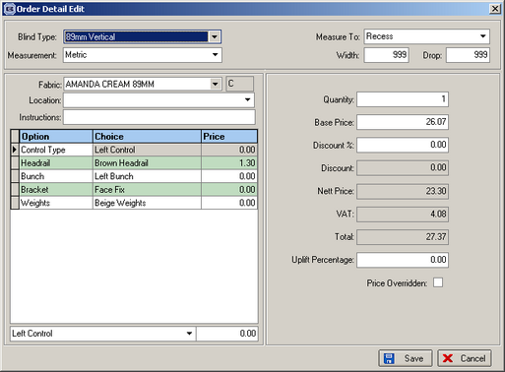

The total screen was as follows:

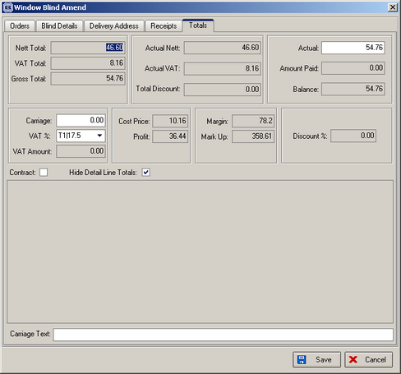

The total was changed to the following:

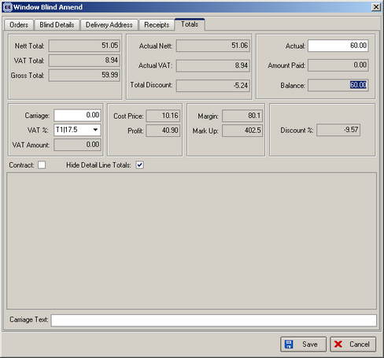

But the detail lines showed this:

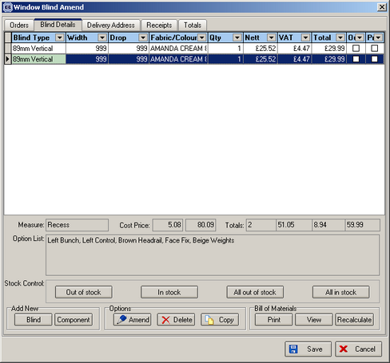

There were two things wrong here. The individual lines should total to 30.00 each and the total displayed below the individual lines should be 60.00, not 59.99. This was caused by additional option pricing and is now fixed.

106. Order Processing > Production Documentation > Works Order – Label 2

This report has been altered so the number of labels printed is related to the number of records set up in Blind Details > Blind Types > Blind Type Setup.

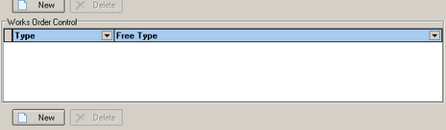

108. Order Processing > Orders

When entering an order for a blind type that has a related blind type different from blind type, the fabric group is now found properly.

113. Order Processing > Production List

The fabric total is now included in Production List by Blind Type with Fabric Total.

116. Order Processing > Quotations > Quotation Print

If proforma = No, text on top right now says ‘Quotation Note’. If proforma = Yes, this text says ‘Proforma Invoice’.
You can now set text on the bottom of the quotation. There is a new field in Administration > Company Details to hold quotation text.
We now show headings on the quotations for width & drop
We now show the delivery address as well on the quotes so that if a customer has stated a different delivery address they can see that it has been changed as requested.
120. Order Processing > Order Enquiry > WIP Scan

If ‘Enable WIP Status’ is switched on in Administration > Parameters, when we click on ‘Blind Made’ or ‘Order Made’, we now to check that the order has status = ‘Work in progress’. If it hasn’t, a message appears saying ‘This order has not been passed to ‘Work in Progress’.

New Work and Customer Requests

3. WIP Status

There is another order status field called ‘Work in Progress’. This fits in between ‘Order Printed’ and ‘Order Manufactured’. It will be used by the production manager to identify orders that have been checked and released into the factory.

This is a feature that will not be required by most customers, therefore there is a new parameter set up in Administration > Parameters, called ‘Enable WIP Status’.

If ‘Enable WIP Status’ is enabled in Parameters, there is be a new button on the order enquiry called ‘WIP Scan’ that changes the status of an order from ‘Order Printed’ to ‘Work in progress’.

4. Order Processing > Archive Enquiry

There is a new option on the Order Processing menu called ‘Archive Enquiry’. This only shows records with order status = Invoice posted.

6. Reports > Sales Analysis (Client 1757)

There is a new report called ‘sales analysis by nominal by blind type’ in Reports > Sales Analysis.

7. Order Processing > Production Lists

Format of both order control and production list reports have been changed to portrait and not landscape.

29a. Order Processing > Order Enquiry

Two new buttons are now on the order enquiry screen:

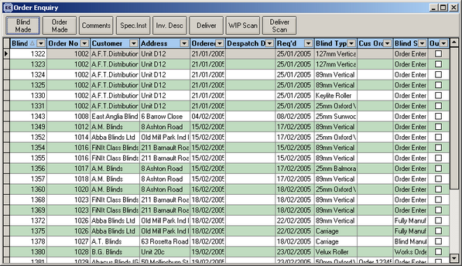

This means that orders can be scanned and be set to ‘Work in Progress’ or ‘Deliverd’, subject to status.

30. Velux Code (Client 1757)

We can now hold blind types against velux code, so when detail line is entered only velux codes that relate to that blind type as shown. There is a new table in Administration > System Tables where we can set blind types up against velux codes.

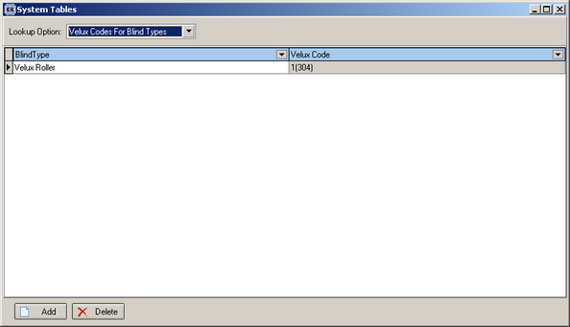

The only other change that has been made is as follows. When the velux detail line is entered, the velux codes displayed are restricted to those with the relevant blind type.

31. Order Processing > Order Enquiry (Client 1757)

E-mails can now be sent to customers when orders are despatched. The e-mail contains the following details: order no., customer order number, customer reference, delivery date, carrier, blind details (blind type, fabric/slat, width, drop, options). This is currently on the ‘Order Amend Enquiry’ screen, but can be moved.

32. Order Processing > Production Lists

There is now a separate production report for roller fabric quantities – called Production List Preview with Fabric Total.

36. Maximum Blind Sizes (Client 1757)

A pop up message now warns if blind sizes are over maximum width and drop amounts.

There are two new fields in the blind type table, ‘Maximum Width’ and ‘Maximum Drop’. These are both numeric fields and hold mm amounts. In the order detail entry routine, the program checks that the maximum sizes are not exceeded. If they are, messages appear saying ‘The maximum width for this blind type is …. Please consult customer.’ or ‘The maximum drop for this blind type is …. Please consult customer.’. These messages appear immediately after width and drop have been entered. If the ‘Maximum width’ and ‘Maximum Drop’ fields are set to null, the messages are not displayed.

37. Order Processing > Orders > Print Order Acknowledgement

Parameterised text now appears on order acknowledgement. There is a new text field in Administration > Company Details where we can hold text that will appear at the bottom left of the order acknowledgement print.

41. Order Processing > Orders

There is now an option to e-mail invoices to customers.

