Blindata Release Note 1.5.4 

31 January 2005

Bug Fixes and Enhancements

29. Order Processing > Orders > Detail Line Entry
When entering a second detail line for an order, the details should default to the previous entry. It is not doing this for the fabric – it goes back to the first one in alphabetical order. This is now working.

39. Order Processing > Orders

An Order could be changed to ‘Order Made’ without it having to go to Status ‘Works Order Printed’ first. If you click on the ‘Order Made’ when the order status = ‘Order Entered’, a message now appears saying ‘Order has not yet been printed out’.

The same logic now applies in Orders > Order Enquiry for the ‘Blind Made’ and ‘Order Made’ buttons.

Reports > Financial Reports

There is a new menu option for some financial reports.

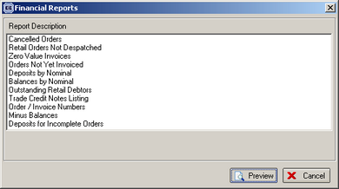

42. Order Processing > Orders

When you tried to enter an order for a proforma customer the correct message comes up, but then you get this message appearing.
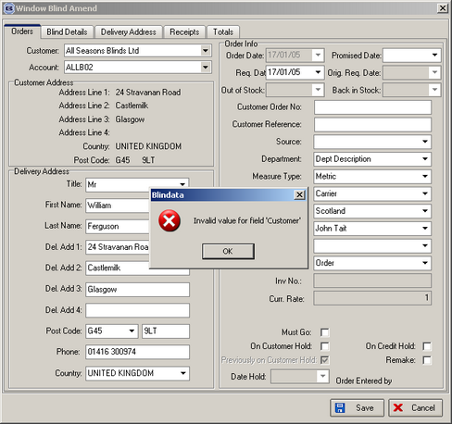

This has been fixed.

43. Order Processing > Quotations

If you set a quotation to proforma = yes, the following message no longer comes up:
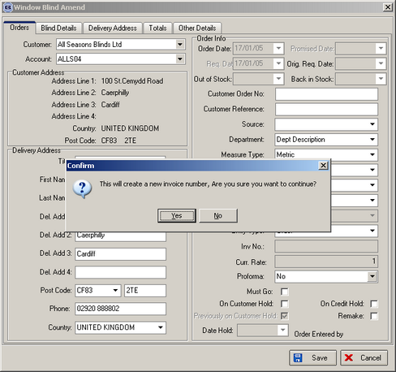

44. Order Processing > Orders

If you enter an order and click on ‘Blind Details’, you will get a validation error if certain fields have not been filled in. The icon then got stuck as an hourglass until the ‘Blind Details’ tab was clicked again (after mandatory fields had been filled in). As an example, if you do not enter ‘customer order number’, the following message was displayed:
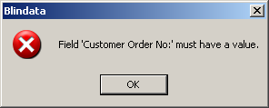

The hourglass appears when you click OK, but now does disappear properly.

53. Order Processing > Orders > Order Delete

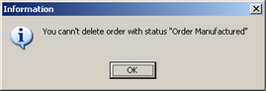

This message now says ‘You cannot …’, not ‘You cann’t…’.

54. Invoice Print and Post > Invoice Batch Print

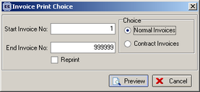

You can now batch print invoices by invoice or order number.

55. Report on sales lead form (Client 1832)

A new report has been introduced that will show a default sales lead form with sales lead names and address and a default order entry form. The user can select a sales lead and then print out a sales lead sheet.

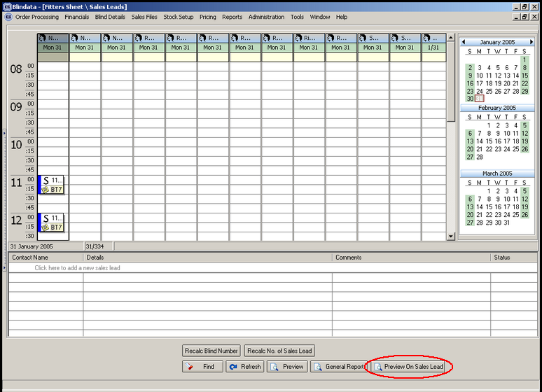

56. Order Processing > Fitters Sheet/Sales Leads

When a sales lead is converted into an order, the operator name is now being displayed on the order entry screen.

57. Order Processing > Quotations

When a quotation is converted into an order, the operator name is now being displayed on the order entry screen.

58. Reports > System Reports > Blind Type Ordered

The following error occurred when you try to run this report:

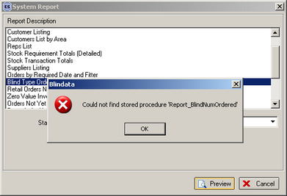

This has been fixed.

59. Order Processing > Production Documentation > Works Order – Label 1

In the following label, the trim amount is now 38.5, not 32.5. The calculation now uses the blind size, not the entered size. In this case the calculation is (1050 – 973)/2 = 38.5

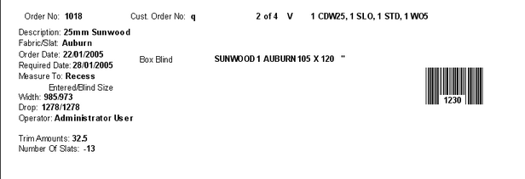

60. Order Processing > Production Documentation > Works Order – Label 1

For blind identifier = L, headrail cut calculation now appears below fabric cut:

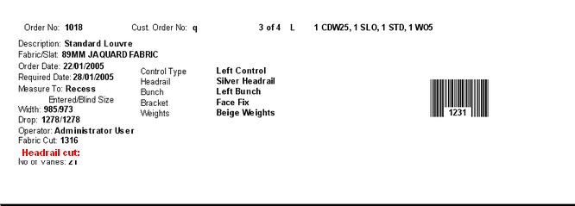

61. Order Processing > Production Documentation > Works Order – Label 1

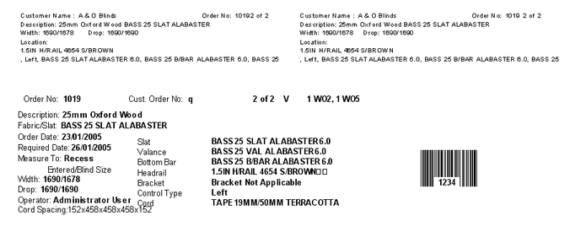
In the above example, the cord spacing has been worked out correctly for the blind. However, if in Administration > Parameters, Ladder Webbing = Metric Accumulative, the cord spacing calculation will display as 152-610-1068-1526. This will only work for orders that are entered after the parameter change has been made.

62. Order Processing > Production Documentation > Works Order – Label 1

Cord Spacing now appears if blind identifier = W.

63. Sales Files

There is a new menu option called ‘Customer Delivery Days’. This allows a user to select a customer by either account code or name and then amend the delivery days:

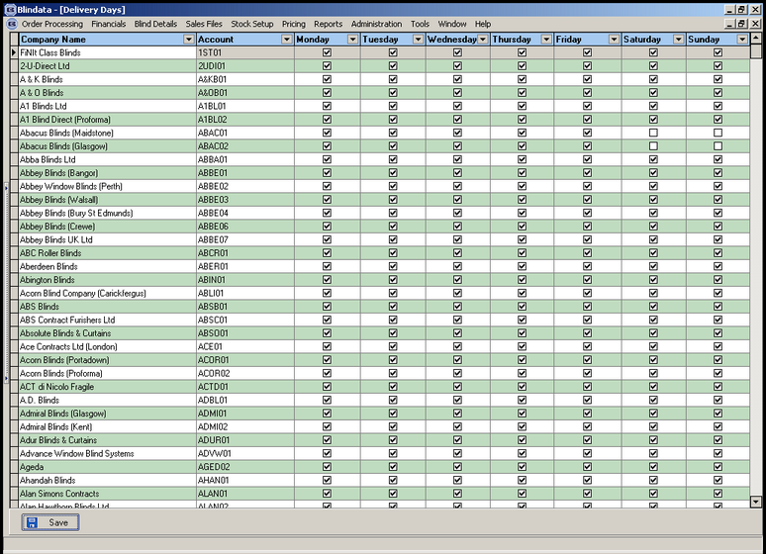

64. Order Processing > Production Documentation > Works Order – Label

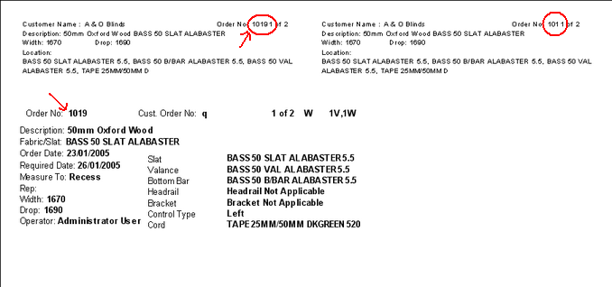

The circled areas have been tidied up.

New Work and Customer Requests

Order Processing > Fitters Sheet / Sales Leads

Number of sales leads is now displayed on the screen in same way no. of blinds to be fitted is done.

14. House number field in sales lead address entry (Client 3717)

When the postcode field lookup is done, the address lines are filled in. The user then has to insert a house number at the start of address line 1. There is now a separate field (only on the sales lead screen) for entering a house number.

15. Description to be held against postcodes (Client 3717)

In System Tables > Postcodes, there is a new field called Description. The purpose of this is to show either days or times of day available. For example, a particular rep may only work on Monday in a particular area and this should be known by the operator, so when the postcode is entered in sales lead entry, display rep/fitter and description from postcode/employee screen in the sales lead window, as indicated:

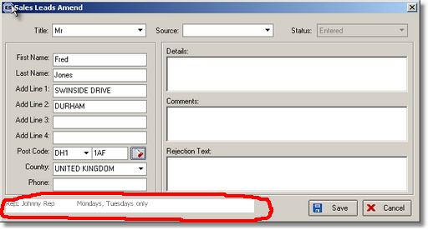

On appointments pad, there is now a clearer distinction between sales leads and fittings. Sales leads are blue and fittings are green.

19. Sales lead / Fitters Sheet Client 3717

There is now a ‘Refresh’ button on the Fitters Sheet / Sales Lead screen

