Blindata Release Note 1.5.2 

17 January 2005

Bug Fixes and Enhancements

Order Processing > Production List > Order Control Report

Orders with status description = order cancelled do not appear on this report.

Works orders / Labels

For retail orders, the contact name is now being shown properly on all works orders and labels.

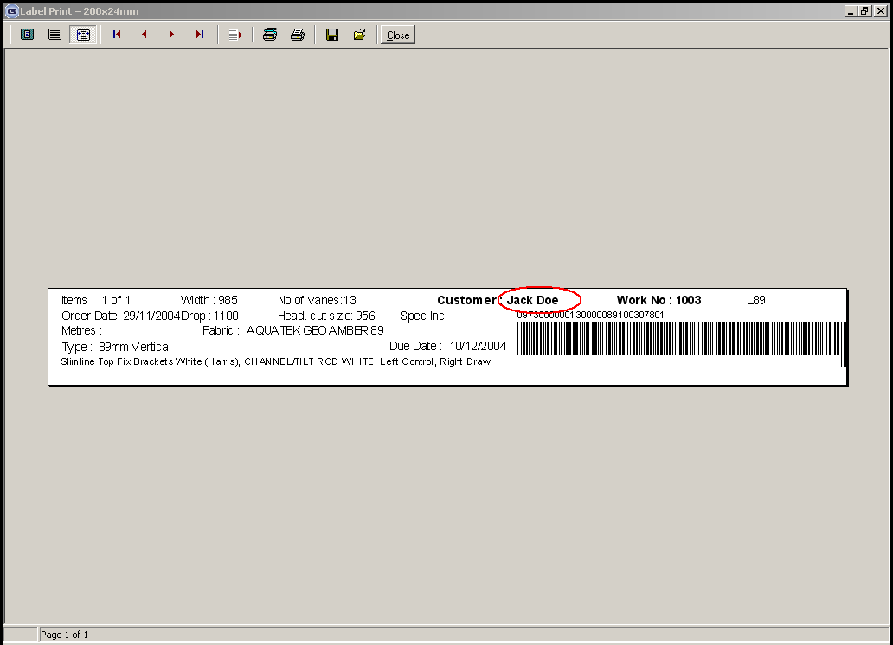

Administration > System Tables > Area Codes

The carriage amount is now displayed to 2 decimal places.

Order Processing > Production Documentation > Works Order – Label 1

The ‘measure to’ field is now displayed on the label. Both entered sizes and blind sizes now appear on ‘works order – label 1’.

Blind type codes instead of the blind identifier codes now appear ie ‘2 V25, 3 WO5’ instead of ‘2V, 3R, 1L’.

Reports > System Reports > Retail Orders Not Despatched

The title of the report now appears every time there is a new department.
Order Processing > Fitters Sheet / Sales Leads

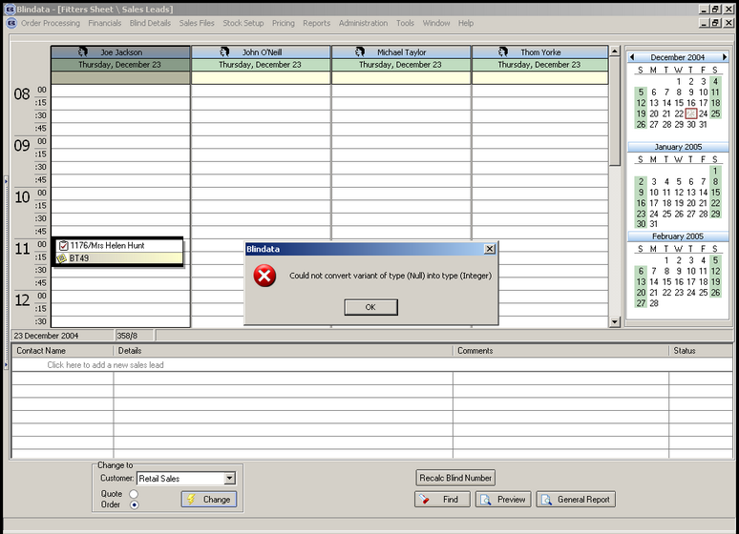

If you try to convert a sales lead into an order, and you have used a postcode that does not have a fitter set up against it, the above error occured. This has now been replaced by a proper message.

New Work and Customer Requests

Order Processing > Orders

We have changed the way ‘on credit hold’ and ‘on stop’ works in the order entry program. Previously an order was automatically flagged as ‘on credit hold’ if the relevant customer record is ‘on hold’. The logic has been changed to the following:

- If a customer is ‘on stop’, you should not be able to enter an order. As soon as the customer is entered, a message should appear saying ‘Customer is on stop. An order cannot be entered.’ If you try to convert a quotation for a customer who is ‘on stop’, the same message should appear.
- For a Sage Line 100 user, after a customer is entered in the order entry program, the credit limit for that customer should be compared with the sum for the following fields:
Sage Customer Balance
Sage Order Totals
The sum of all outstanding orders for this customer in Blindata (all orders with status <> cancelled and <> invoice posted.
If the sum of these amounts is greater than the credit limit figure, the order should be flagged as ‘on credit hold’.

Order Processing > Quotations/Orders

We have changed the way in which pro forma invoices are processed in the system.

Explanation - according to HM Customs and Excise, pro forma invoices are described as follows:

Pro-forma invoices are often used to offer goods or services to potential customers. Such an offer may or may not be taken up, and the goods or services will not be supplied unless payment is received. If you use pro-forma invoices in this way, they cannot be used as evidence to reclaim input tax, even if they show all the details required for a VAT invoice. You should ensure that they are clearly marked “THIS IS NOT A VAT INVOICE”. If, after you have issued such an invoice, you actually supply the goods or services to your customer, or receive payment, then you must issue a proper VAT invoice.

The following changes have been made to the software.

- It is only be possible to enter a pro-forma invoice in Order Processing > Quotations.
- A quotation can only be converted to an order if the Pro forma field = ‘No’ or ‘Paid’.
- The invoice number field has been removed from the quotation screen and the enquiry screen.
- When a quotation is printed and Pro forma = ‘Yes’, the report says say ‘Pro forma Invoice’ instead of ‘Quotation’.
- On the order entry screen the Pro forma field is not be displayed.
- If you try to enter an order for a customer that is flagged as a ‘pro forma’ customer, a message appears saying ‘This is a Pro forma customer. Please enter the order as a quotation’.

Order Processing > Orders

Calculation of required date

The algorithm to calculate the required date now works in the following way:

- The lead time is calculated by looking at the ‘default number of days to required date’ in the Parameters table. If this is not to be used, it should be set to 0.
- The program checks to see if lead time by customer is used. This is be done by checking if, in the customer’s record, the ‘default no. of days for required date’ field is > 0. If so, this figure is held and we skip to step 4. If not, we go to step 3.
- The program then runs through the detail lines and works out the highest ‘lead time’ by looking at the blind type record lead time for each detail line and then storing the highest. If this is not used, the lead times should be set to 0.
- The program then examines the holiday table to see if any holidays are applicable and then works out the required date based on removing weekend days, holidays and then adding the lead time days to the order date to get the required date. If the ‘on customer hold’ flag has been unchecked, the calculation will be done from the current date, not the order date.
- A check is then made to see if ‘delivery days’ are used. If so, the required date is moved on to the next delivery day date.
- When the Required date has been calculated using the above 5 steps the Promise date and the Original required Date should be set to the same date. [Not working. These two fields are not being updated.] This Original Required date cannot be edited or changed from here.
- If the ‘Must Go’ flag has been ticked, the required date will be set to the current date. A Reason Code will be entered for a ”Must Go”. Ok.
- Once an item has been placed out of stock and then placed back in stock the Required date will be changed to current date plus lead time calculation (based on the calculation in steps 1 to 5).
- The promise date should be entered if an item has been flagged as out of stock so that we know what date we have promised the customer.

Order Processing > Orders

The mandatory validation on Title, First Name and Last Name in order entry is now optional. This can be set via a parameter in Administration > Parameters.

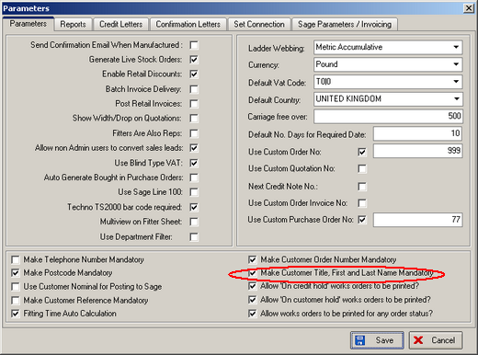

Administration > System Tables > Must Go Reason

There is a new table to hold ‘must go’ reasons. This gets used in the order entry program.

Order Processing > Orders

If a customer is ‘on stop’, you are now unable to enter an order. As soon as the customer is entered, a message appears saying ‘Customer is on stop. An order cannot be entered.’ If you try to convert a quotation for a customer who is ‘on stop’, the same message appears.

Order Processing > Orders > Order Entry

The ‘On Credit Hold’ Tick Box now has its own security credentials so that only certain users can take it off credit hold. A user can only amend this button if they have permission to access Sales Files > Customers.

Order Processing > Orders

‘On Customer Hold’ field now appears on this screen.

Order Processing > Orders > Order Entry

If ‘Must Go’ is flagged, the system now prompts for a ‘must go’ reason.

Order Processing > Orders > Order Entry

A new field ‘Original Required date’ now appear in the ‘Orders’ screen.

There is now a ‘remake’ flag on the order entry screen.

The operator name now appears on the screen.

A ‘Previously on Customer Hold’ field, a “date field that it was placed on Customer hold”, a “date field that it was placed Out Of Stock”, a “date field that it was placed Back in Stock” are now displayed in the order entry screen.

Order Processing > Order Enquiry

The ‘out of stock’ field now appears on Order Enquiry screen.

Order Processing > Production Documentation

The default for the ALL tick box is now on the Works Order Side (see screenshot):

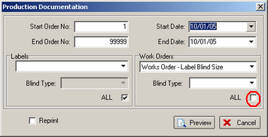

Order Processing > Production Documentation > Works Order – Label 1

Request from client 1757: need to display trim amounts for box blinds and also the number of slats to add or remove from the blind.

The trim amount is calculated by taking the manufacturing size of the blind and subtracting it from the width of the box blind that is being used, and then dividing by 2.

Example: man. width of blind is 1380. Box blind width used is 1500 (found in Box Blinds table). Therefore trim amount = (1500 – 1380)/2 = 60. This is displayed on ‘works order – label 1’ in place of cord spacing (which isn’t needed for box blinds).

Calculation for working out the number of slats to add or remove.

If the figure is negative the rounding is going the correct way eg (1560 – 1600) / 23.6 = -1.69. The number oo slats is rounded up to -1, not down to -2.

Sales Files > Customers

The customer account code now appears as the first column on the customer enquiry screen.

Financials > Invoice Batch Print

There is a new invoice report called ‘Invoice – Bespoke 1’.

Order Processing > Production Documentation > Work Order – Label 2

A new works order label layout has been created called ‘Works Order – Label 2’. It is based on ‘works order – Label 1’, but does not have anything printed on the right hand side lower label ie no bar code or delivery address. However it prints the department and the rep on the largest label.

Order Processing > Production Documentation > Works Order Label 1

‘Do by Date’ now says ‘Required Date’. The trim field (circled) is now in bold.

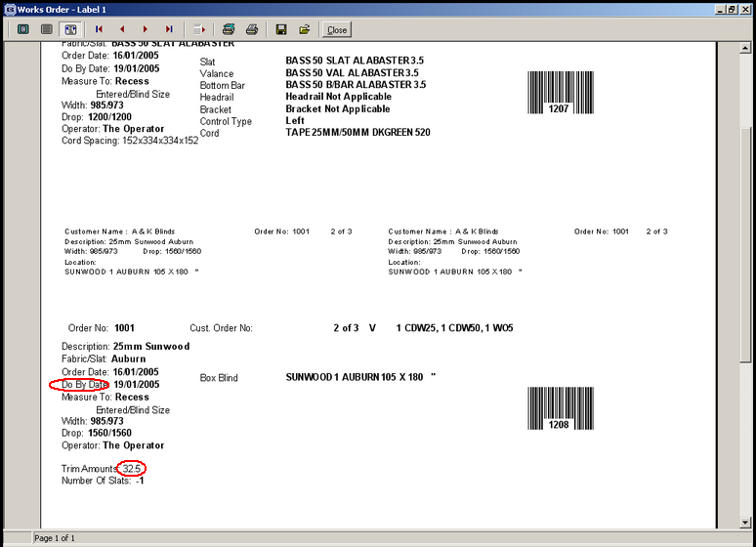

Order processing > Fitters Sheet/Sales Leads
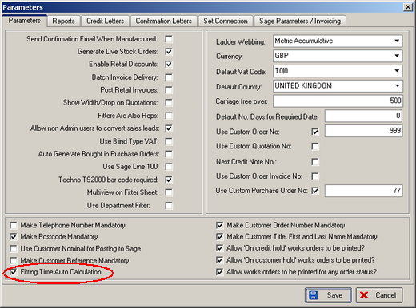

There is a new field in the Administration > Parameters that allows you to set automated fitting times. This means that fitting appointments will be recorded directly against the fitter for the fitting date. The next available time for that date will be chosen.

It will also be possible to move fitting dates and fitters from the orders form – this will update the fitter diary as well.

It will no longer be possible to move or delete a sales lead once it has been converted to an order.

It will no longer be possible to move or delete a fitting appointment once that order has a status of dispatched or beyond.

