Blindata Release Notes 1.2.7 - 1.5.0 

24 January 2005

Bug Fixes and Enhancements

1. Order Processing > Orders > Detail Line Entry

If a roller blind is entered, the program checks to see if the blind can be made. It does this by checking to see if the size of the blind will fit inside the roll width for the fabric (roll width in Fabrics table). The rules are as follows:

If Calculator = Width, the program checks that the drop + drop add on <= roll width of the fabric. If not, a message appears saying ‘Blind drop is greater than roll width’.

If Calculator = Drop, the program checks that the width <= roll width of the fabric. If not, a message appears saying ‘Blind width is greater than roll width’.

If Calculator = ‘Width or Drop’, the program checks that at least one of either width or (drop + drop add on) <= roll width of the fabric. If not, a message appears saying ‘Both blind width and drop are greater than roll width’.

‘Width or drop’ calculation examples:

Example | Blind 1 | Blind 2 | Blind 3 | Blind 4 | Blind 5 | Blind 6
Roll Width | 1800 | 2000 | 1800 | 2000 | 1800 | 2000
Calculator | W or D | W or D | W | W | D | D
Drop add on | 200 | 200 | 200 | 200 | 200 | 200
Blind width | 1500 | 1200 | 1600 | 1000 | 1200 | 1600
Blind drop | 900 | 2000 | 800 | 1500 | 1400 | 1000
Fab. cut size | 1500x1100 | 1200x2200 | 1600x1000 | 1000x1700 | 1200x1600 | 1600x1200
Fab usage | 1100 | 2200 | 1600 | 1000 | 1600 | 1200

Please note the difference between example 1 and 2. In example 1, fabric usage is 1100 because this is the most efficient way to cut the fabric from the roll. In example 2, the fabric usage is 2200 because the fabric can only be cut one way from the roll.

2. Sales Leads

In sales leads, it is now only possible to assign a sales lead to an employee who is only a rep.

By switching ‘Show fitters’, ‘Show reps’, ‘Show service’ off and on, sales leads do not
Redisplay properly. They only redisplay after you come out of Fitters Sheet / Sales Leads and then go back in.

3. Stock Setup > Dimension Calculations

You can now enter a negative amount in drop add on in Stock Setup > Dimension Calculations.

4. Administration > Import from Excel

When importing fabric records, there are two extra fields imported, Calculator and ‘Default Code’. They will use the description field: Width, Drop, Louvres, Louvres * Fabric Length etc and the default letter.

5. Administration > Import from Excel

There is a new import option for Suppliers. See spreadsheet layout in documentation.

6. Order Processing > Orders > Order Detail Edit

The tab order has been corrected after fabric – it now goes to ‘Location’, then ‘Instructions’ field.

7. Order Processing > Orders > Order Acknowledgement print

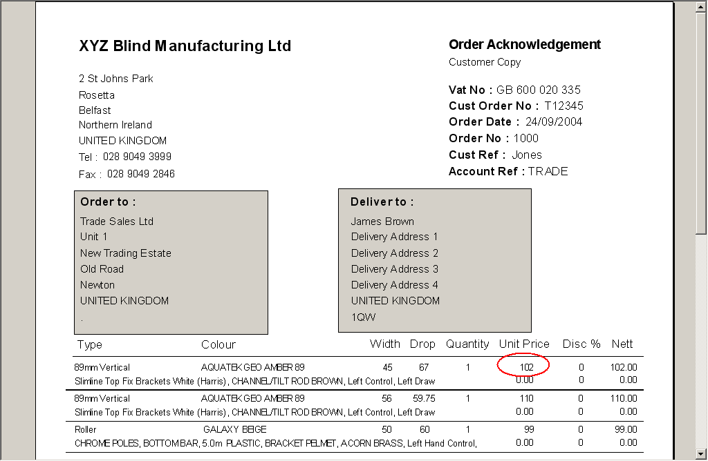

The unit price is displayed to 2 decimal places.

8. Orders > Fitters Sheet / Sales Leads

The text that says ‘Click here to add a new task’ now says ‘Click here to add a new sales lead’.

9. Administration > Restore Database

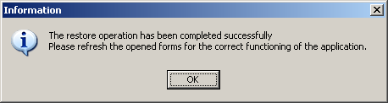

The above message now says ‘The restore operation has been completed successfully. Please refresh all opened forms.’

10. Wood slat Calculator

A new calculator is available for wood slats. This allows the program to generate stock transactions for wood slat blinds, by using dummy fabric codes with calculator = Woodslat.

There are three main wood components that make up a wood blind: valance, slat and bottom bar. There will only be one valance and one bottom bar used per blind, but the number of slats will depend on the drop size of the blind. This will be selected from Administration > System Tables > Venetian Slats.

Valances, slats and bottom bars are bought in from suppliers and held as stock items. They are bought as different lengths, in 6 inch increments from 3’ (36 inches, 914mm) to 10’ (120 inches, 3048mm). Because they are relatively high value items, the 6” increments are all held as individual stock items. As well as this there are different colours of wood used, which means more codes. As there are two different slat sizes, 25mm and 50mm.

Wood slat stock codes should be held in the following format:

W1GO30 25mm Golden Oak 3’ slat
W2GO30 50mm Golden Oak 3’ slat
W3GO30 25mm Golden Oak B/bar
W4GO30 50mm Golden Oak B/bar
W5GO30 25mm Golden Oak Valance
W6GO30 50mm Golden Oak Valance

The first two letters determine the wood size and type:

W1 = 25mm slat
W2 = 50mm slat
W3 = 25mm bottom bar
W4 = 50mm bottom bar
W5 = 25mm valance
W6 = 50mm valance

The third and fourth characters determine the wood colour:

GO = Golden Oak
Etc

The fifth and sixth letters determine the width of the wood

30 = 3’ (36 inches)
35 = 3’ 6” (42 inches)
…
95 = 9’ 6” (114 inches)
10 = 10’ (120 inches)

There are also dummy stock codes set up, W1GO and W2GO and these will have link option = fabric. A new calculator called Woodslat will be used. This means that when a detail line is entered for a wood blind, one of these dummy stock codes is selected when fabric is chosen.

If the detail line has link option = fabric and calculator = woodslat, the program will look up the (new) table below and append the code to the dummy code to produce the stock item that will be used.

The new table will be held in Administration > System Tables > Wood Sizes.

Width of blind (max) | Imperial | Code
762 | 3’ | 30
1066 | 3’ 6” | 35
1219 | 4’ | 40
1371 | 4’ 6” | 45
1524 | 5’ | 50
1676 | 5’ 6” | 55
1829 | 6’ | 60
1981 | 6’ 6” | 65
2134 | 7’ | 70
2286 | 7’ 6” | 75
2438 | 8’ | 80
2591 | 8’ 6” | 85
2743 | 9’ | 90
2896 | 9’ | 95
3048 | 10’ | 10

So if a blind is entered with a width of 2000mm, and the fabric/slat chosen is W2GO, the program will calculate the following stock transactions in the bill of materials:

W2GO70 x number of slats in blind
W4GO70 x 1
W6GO70 x 1
11. Works order labels

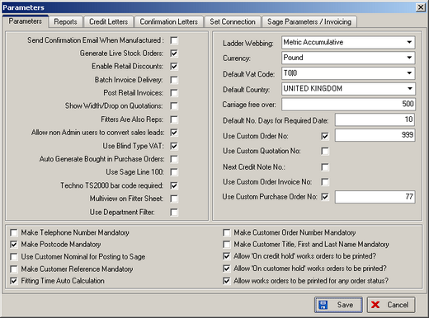

There are new parameters for the following:

Allow ‘On Credit Hold’ works orders to be printed?

Allow ‘On Customer Hold’ works orders to be printed?

Allow works orders to be printed for any status?

12. Pricing > Option Price Enquiry

The caption for this screen now says ‘Option Price Table’ instead of ‘Trade Price Tables’.

13. Blind Details > Blind Type Options

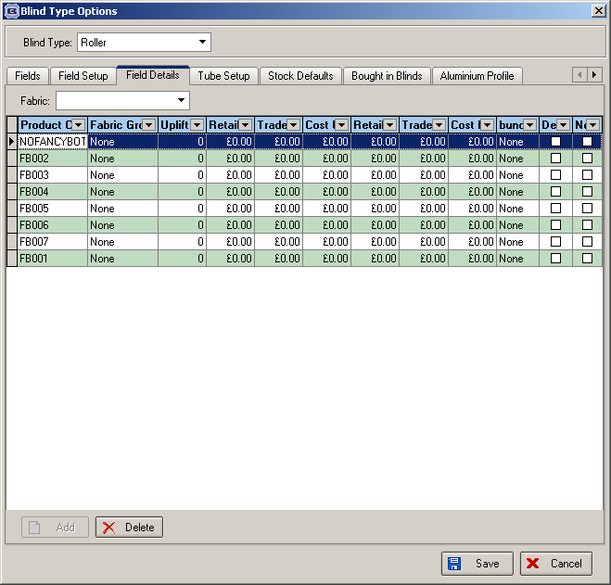
There is no longer a delete option on this screen.

14. Administration > Parameters

Blind manufacturers in the UK use a large number of ways to print out documentation for making blinds.

Blinds can be entered in the system in metric or imperial. They can also be entered with different ‘measure to’ settings.

When works orders are printed out, we get requests that measurements are printed out in different ways:

Blind size, metric
Blind size, imperial
Blind size, metric and imperial
Entered size
Entered size, metric
Entered size, imperial
Entered size, metric and imperial

There is now a parameter set up in the Parameters form to cater for this.

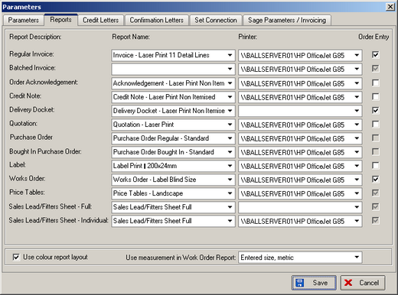

15. Order Processing > Production Documentation

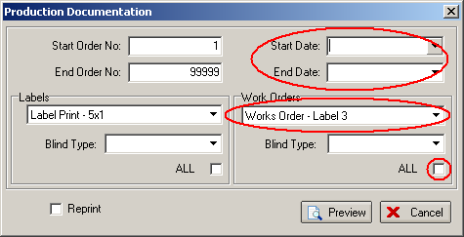
When this menu option is chosen, the start and end date now default to today’s date, the works order report defaults to the works order report that is set in Administration > Parameters, and ALL is ticked.

16. Stock Setup > Stock Transaction Entry

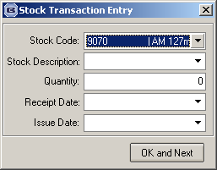

Both stock code and stock description lookup now display records in alphabetical order.

17. New Calculator required

There is a new calculator, called ‘Width Variable x Drop’. This calculate a quantity in the same way as ‘Width Variable’, but then multiplies that figure by the drop size of the blind.

18. Label print 88mm x 35mm

There is a new label print – 88mm x 35mm.

19. Purchase order processing (for stock)

The functionality will work as follows:

1. The user will print out a list of sales order stock transactions (Reports > System Reports > Stock Transaction Totals) by order date and also a detailed list. This will then enable them to calculate the exact amounts to be ordered, whilst checking actual stock amounts.

2. The user will then generate a purchase order by individual supplier. This is done in Stock Setup > Purchase Order Enquiry and by selecting Generate PO. This will select relevant sales order records, grouping them by stock item and appending them to the purchase order transactions table.

As well as this, the user is able to enter purchase order stock transactions manually, and will not be reliant on the generate PO option.

The amounts to be ordered can be amended (in the quantity ordered column) prior to saving the record and printing out the PO. Once this purchase order has been saved, the sales order stock transactions will be flagged so they cannot be picked up in another purchase order. The purchase order date on the stock transaction should be recorded. The ‘on purchase order’ amount for the relevant stock records should also be increased. The purchase order is then sent to the supplier, either by fax or e-mail. We hold the supplier e-mail address in the supplier table.

Tables updated: records appended to purchase order transactions, ‘on purchase order’ field in stock item increased

3. When the goods are received, the user returns to the purchase order via Stock setup > Purchase Order Enquiry and records what has been delivered (ie is going into stock). This is done by entering a delivered amount against the detail line in the purchase order. However we need to allow for partial deliveries of purchase orders, therefore the purchase order transaction line needs to hold an ‘already delivered’ field as well as ‘amount delivered’. When the purchase order is saved, a routine will be run so that ‘already delivered’ = ‘already delivered’ + ‘amount delivered’ and ‘amount delivered’ is zeroised. This means multiple partial deliveries can be made for purchase orders. It should also update the relevant stock transactions with ‘receipt dates’. (These stock transactions should be updated in chronological order).

Tables updated: purchase order transaction records updated with delivery amounts, stock transactions appended with stock receipts, sales order stock transaction receipt date updated, ‘on purchase order’ field in stock item reduced, ‘stock in hand’ in stock item increased.

4. The same rule will apply for purchase invoicing. It will be possible to enter partial invoices against purchase orders. This will require extra fields in the purchase transaction record (‘amount invoiced’ and ‘already invoiced’. It should also be possible to amend the purchase invoices totals (as rounding and VAT calc. Differences may have taken place).

When we make adjustments to cost prices in individual purchase order detail lines, there should also be an option to update the cost price in the stock record. This should be a prompt (if the price has been changed).

5. When ‘Post’ is clicked, the purchase invoice information will be updated directly into Sage Line 50. This will break down the purchase invoice detail lines by nominal code.

Tables updated: purchase order transactions, purchase order records (amounts).

Overall Stock Levels

These are changed by two main types of transaction: issues and receipts.

Issues

Issues reduce stock in hand figures, and take place when either blinds are manufactured or if a stock issue adjustment has been made.

Receipts

Receipts increase stock in hand figures, and take place when either a purchase order has been delivered or if a stock receipt adjustment has been made.

On purchase order amounts

These are increased when purchase orders are created and decreased when purchase orders are delivered.

On sales order figures

These are increased when sales orders are entered and decreased when orders are flagged as manufactured.

20. Box Blinds

Box blinds can be bought in pre made from abroad, and have the width trimmed and slats added/ removed to/from the drop. See Access version (Pricing > Box Lookup Table, Blind Details > Blind Types).

These box blinds arrive as stock items (literally they are blinds that are in boxes!). Each box has a stock code dependent on the colour of the wood and the size of the blind.
When a blind is entered in a detail line, the program should check if it is a box blind, and then calculate stock usage by working out the correct stock item (box blind) to use. No other stock items will be used.

This should be done in the following way.

Firstly, we need to hold a new table that holds box blind information. It should be accessed in Administration > System Tables > Box Blinds and should show the following:

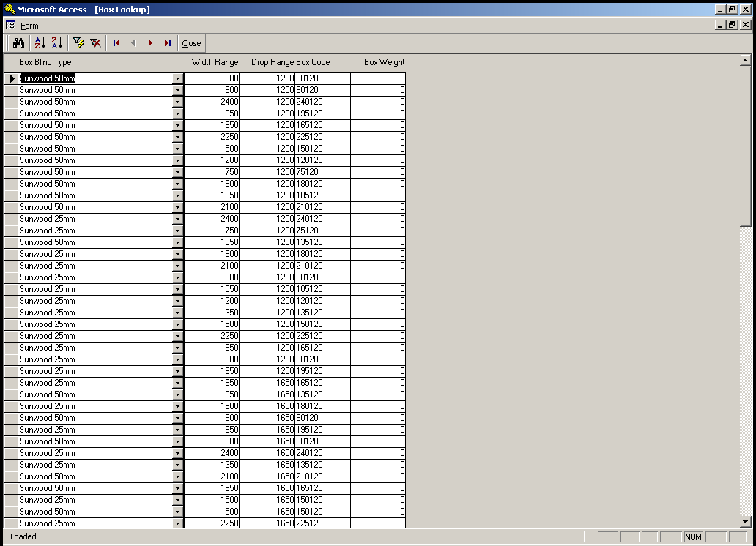

Blind type is the blind type.

Width Range and Drop Range are the sizes up to which that box blind can be used.

Box code is a part of the actual stock code for the box blind.

Box weight is the weight of the box blind.

In the blind type table, we need a new field called ‘Box Blind Type’. This will be a 5 character text field.

In the fabrics table, we need a new field called ‘Box fabric code’. This will be a 12 character field.

We need a new calculator called ‘Box Blind’.

Therefore when a detail line is entered, and the fabric calculator = ‘Box Blind’, the program should calculate what stock item to use by concatenating the ‘box blind type’ from the blind type table, the box code from the box blind table and the box fabric code from the fabrics table. This should then be stored in a new field in the order detail line.

21. Out of stock field in order detail line

This is required for clients who are not relying on stock control figures. We need to be able to record if an item is out of stock which means that a blind cannot be made. Instead of looking at individual stock items, we only want to record the fact that the blind cannot be made because something is out of stock.

We are two new fields in the order detail line: out of stock and previously out of stock. The second field is required because we need to record the fact that, at one point, the detail line was flagged as being out of stock.

22. Administration > Parameters

On the form Parameter there is an option to disable Department filter.

23. Administration > Users

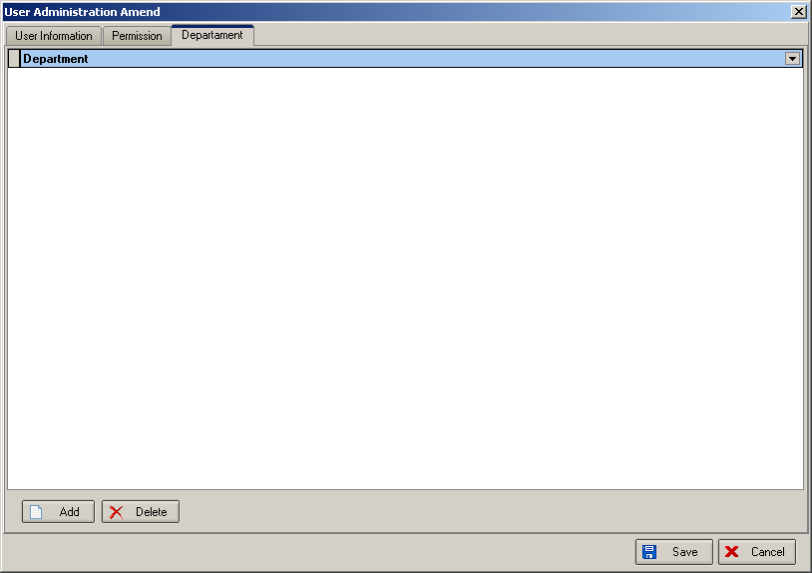

Departments can now be set up for users.

24. Administration > System Tables > Department

When you add a department in Administration > System Tables > Department, there are new fields in the department record.

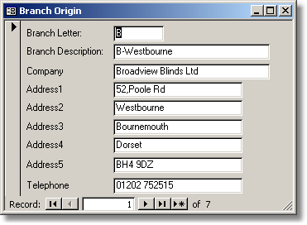

25. Order Processing > Order Amend Enquiry > Print Works Order > Label print

The head cut size has been corrected.
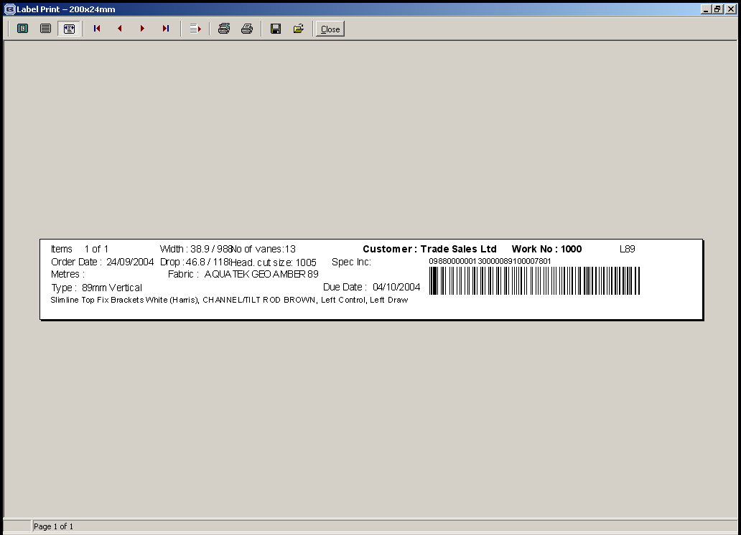

26. Administration > Import from Excel

For the fabric import, there is an extra field to be imported. This is ‘cost nominal code’ and it is validated and imported to nominal_cos_id in the same way as nominal_id is done.

27. Stock Setup > Suppliers

The e-mail address only allowed 20 characters. It now allows 40.

28. Nominal codes by blind type and department

On the form Administration->Parameters there is a new flag “Use Department Nominal Code”
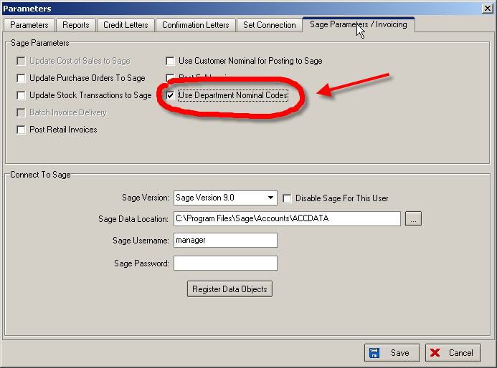

On the form Administration->SystemTables->Multiple Nominal Codes you can now input BlindType, Department and the corresponding Nominal Code.
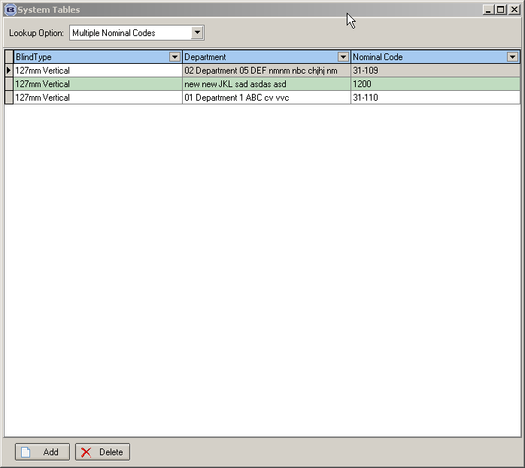

29. Importing / Maintaining Full postcodes (not client specific)

Postcodes can now be imported to Blindata. See import spreadsheet.

30. Administration > System Tables

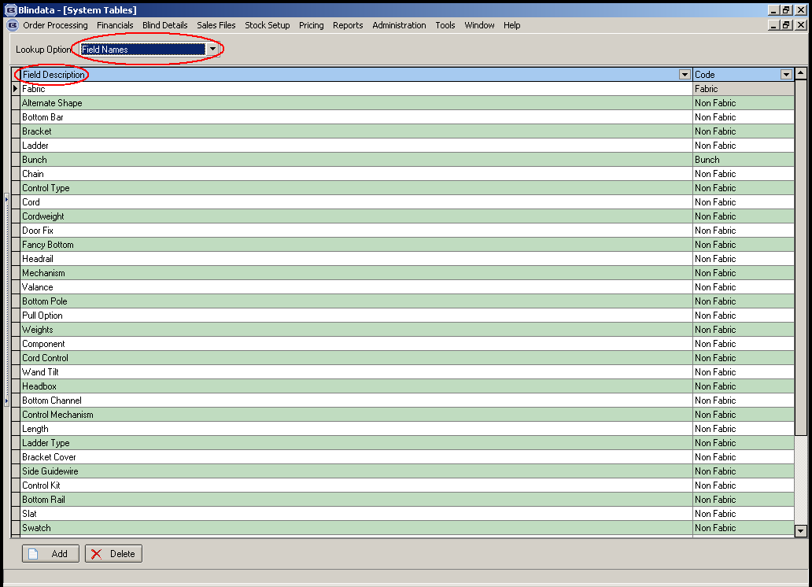

We have changed ‘Field Names’ to say ‘Option Names’ and ‘Field Description’ to say ‘Option Description’.

31. Administration > Import from Excel > Customers

When customer records are imported, a delivery address is now created (using the invoice address). Also, the Account Reference is imported in upper case.

32. Order Processing > Orders

‘Must Go’ and ‘Department No’ now appear on the order amend enquiry screen.

33. Order Processing > Production List
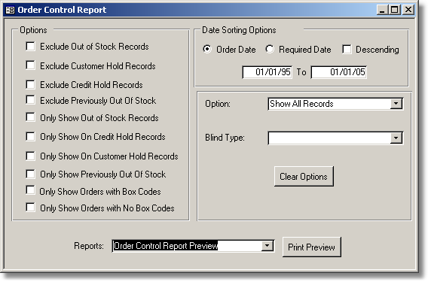

There are a number of reports that get printed here:
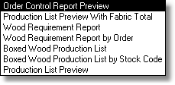
These reports can be restricted by the following options:
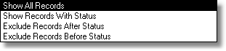

Order Control Report

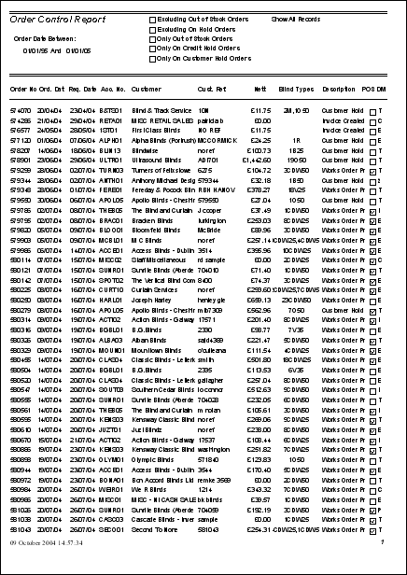

The report shows, for each order record: order number, order date, required date, account code, customer name, customer reference, nett value, blind types, status description, previously out of stock flag, despatch method abbreviation.

Production List by blind type with fabric totals

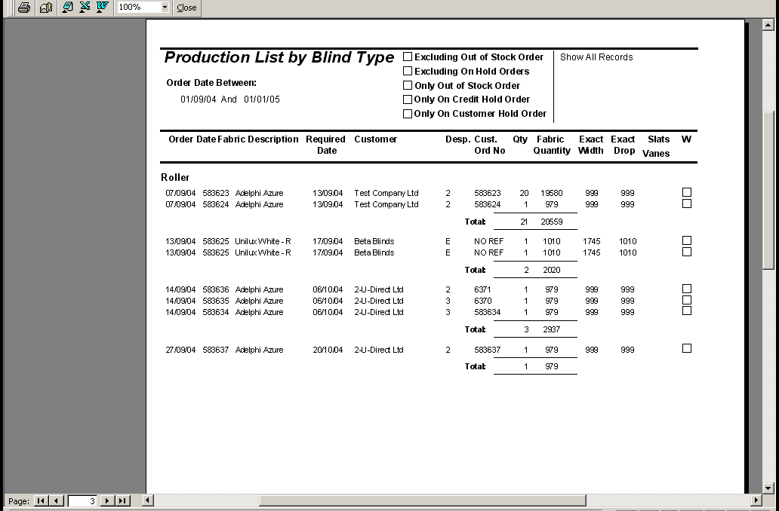

This report is grouped by blind type, and shows detail line records with fabric amounts, numbers of vanes and slats where appropriate.

34. Order Processing > Orders

Multi currency invoicing has been implemented.

35. Administration > Import from Excel > Discounts

See Import Spreadsheet for Discount records

36. Administration > System Tables

There is now an option to maintain ‘Measure To’ table.

37. Administration > System Tables > Blind Identifiers

There is a new blind identifier = External, Description = E.

38. Order Processing > Orders

There is now validation on the fitter field when you are entering a retail order. This is not required as trade sales will not normally have fitters applied to the orders.

39. Administration > System Tables > Currency Types
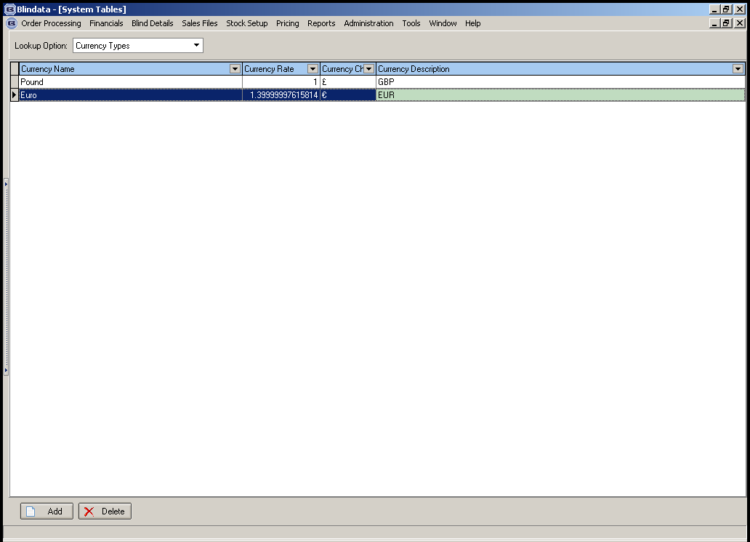

Currency rate is now displaying to the number of decimal places entered.

40. Order Processing > Orders > Order Entry

Lookups have been improved in order entry, in particular customer, blind type and fabric.

41. Improvements to Problems/Complaints (Client 9 – Phase 2)

Spec for reports same as existing reports.

42. Reports > System Reports > Blind Type Ordered

There is a new report called Blind Type Ordered. It shows the numbers of each blind type ordered.

43. Pricing > Price Table Enquiry > Print by Blind Type
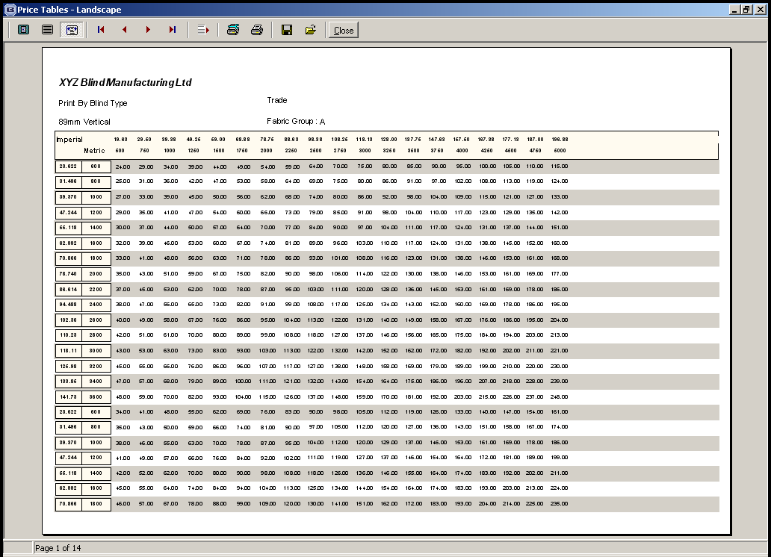

The report is now grouping records properly by fabric group.

44. Blind Details > Cord Spacing

A modification that has been made for cord spacing. We need to be able to hold multiple records for blind types, for example

Blind Type | First Cord at | Max. Spacing | Max Width
50mm Wood | 80 | 100 | 400
50mm Wood | 100 | 200 | 500
50mm Wood | 150 | 400 | 9999

When the cord spacing calculation it should first of all check the width of the blind to see what record to look at in the example table above. If the blind is 475mm wide, it should use the second record, and base the calculations on first cord = 100 and max. spacing = 200.

45. Order Processing > Orders > Order Entry

The tab order was incorrect after Del Add 4. It should then go Postcode (first part) > Postcode (second part) > Phone > Country > Order Date. It is now fixed.

Phone number fields now allow uo to 30 characters. This will allow the entry of two numbers, which is useful.

46. Order Processing > Orders > Order Entry

There is now a lookup facility to select the customer by account code as well as customer name. The account code lookup records should display in alphabetical order.

47. Order Processing > Orders > Order Entry > Receipt Entry

Lodgement number is no longer a mandatory field.

48. Blind Details > Blind Types

The blind type description field has been extended to 30 characters.

49. Stock Setup > Suppliers

The supplier name field has been extended to 30 characters.

50. Administration > Users

There is now an option to copy User records.

51. Administration > Holidays/Weekends

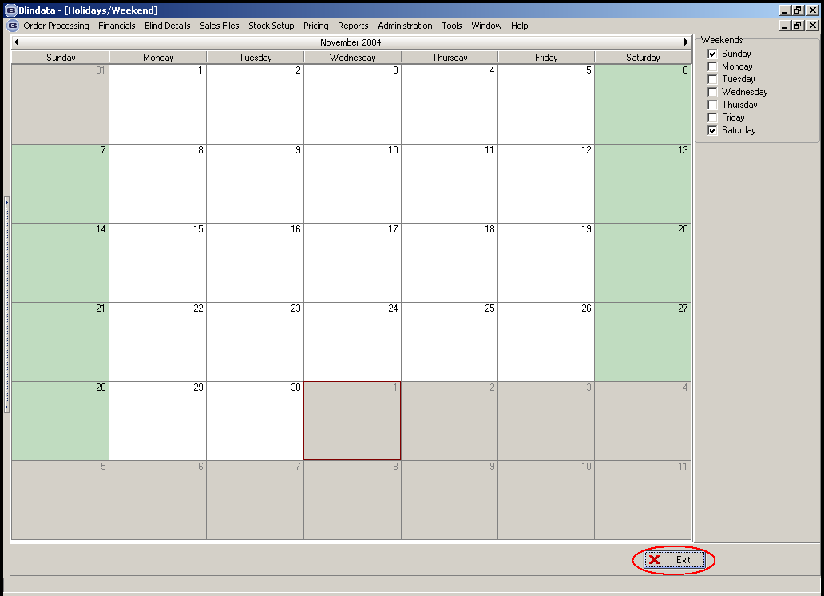

We can now define working days and holidays in the system.

52. Order Processing > Orders > Bill of Materials

The calculator ‘Width Variable x Drop’ is now taking Dimension Calculations into account.

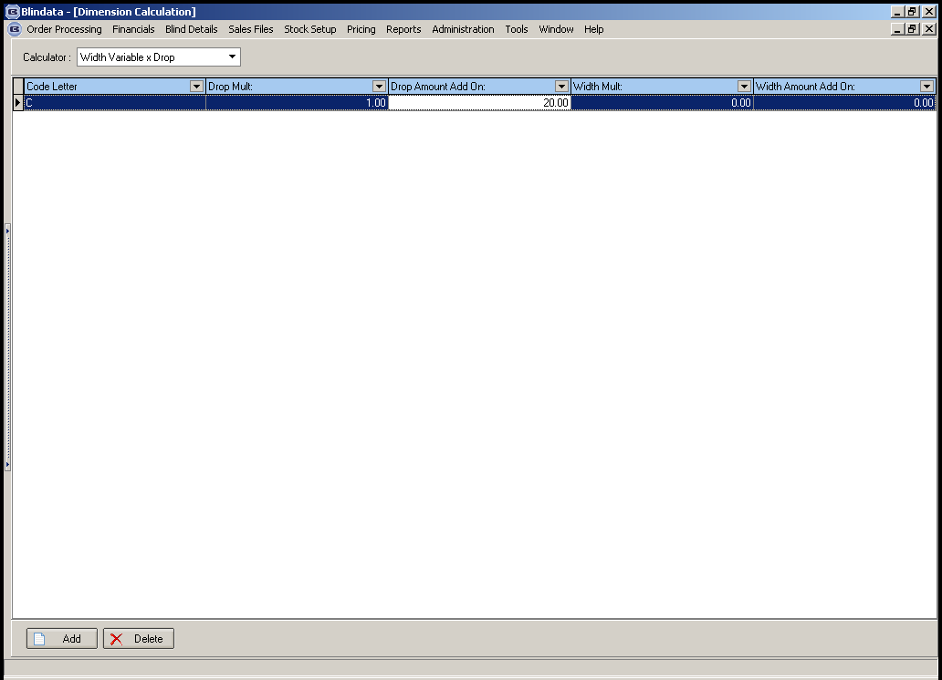

The calculation should be (Variable amount x (Drop + Drop Amount Add on))/1000.

53. Blind Type Details > Blind Types
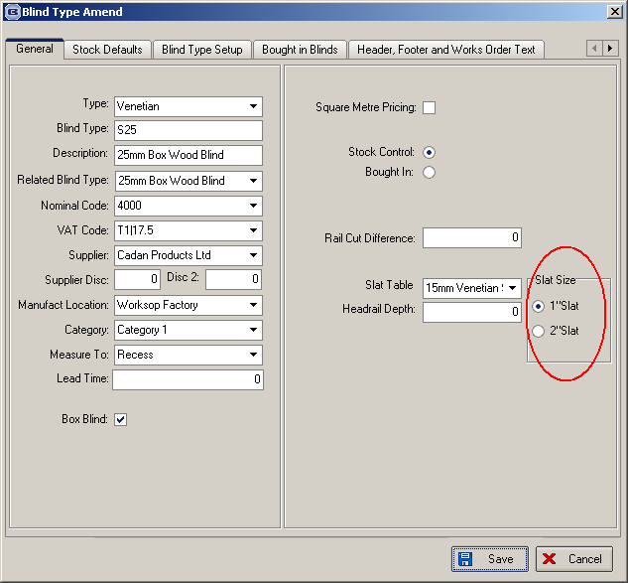

The circled information is redundant and has been removed.

54. Exporting sales invoice records to Sage Line 100 (Client 1757)

There are some rules that we need to apply to the software before this will work properly.

1. If Administration > Parameters > ‘Use Sage Line 100’ = True, all posting to Sage Line 50 should be disabled. The ‘Post’ buttons on ‘Order Amend Enquiry’ and ‘Invoice Print and Post’ should not be visible. Invoices will never be posted to Sage Line 100 individually – they will always be done in batches.

2. If Administration > Parameters > ‘Use Sage Line 100’ = True, the only place you will be able to post invoices is in Financials > Post Invoices to Sage. When this screen is displayed, it will show a list of all orders with status = invoice printed. When you click on ‘Post Invoices’, the csv file will be generated in the folder defined in Administration > Parameters > Sage Data Location. The report should be generated after the csv file is generated.

3. Once the csv file has been imported to Sage, the ‘Complete Posting to Sage Line 100’ button can be clicked. This button should be moved from Financials > Invoice Print and Post to Financials > Post Invoices to Sage. The ‘Complete Posting to Sage Line 100’ button should be on the Financials screen and only visible if Administration > Parameters > Use Sage Line 100 = True.

55. Reports > Lead times report

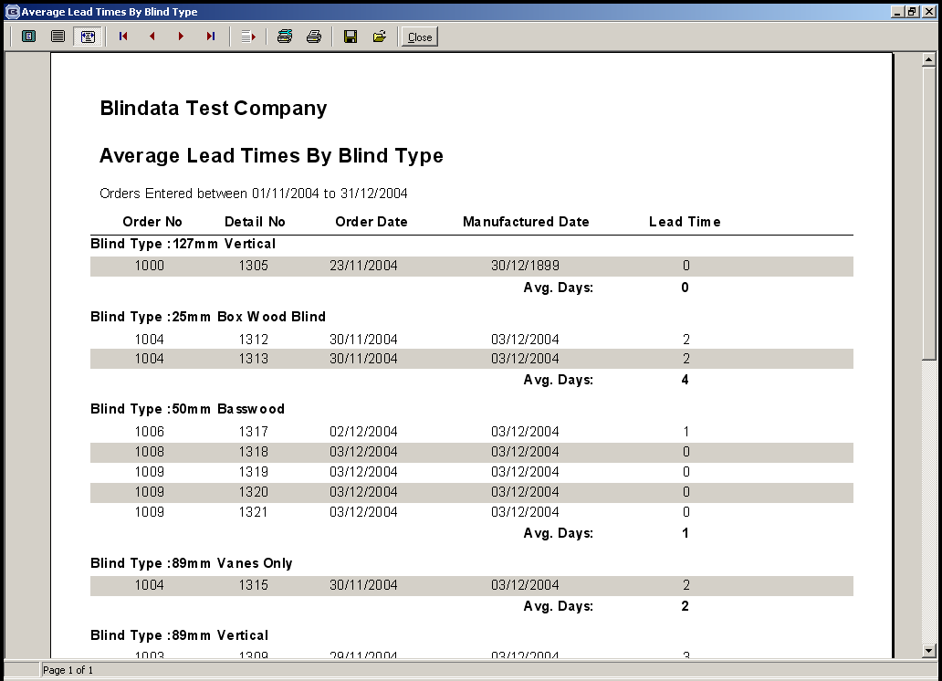

56. Order Processing > Complaints

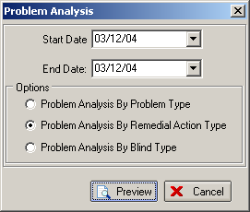

There are three new complaint reports.

57. Order Processing > Orders

Rounding errors

Because of rounding errors, we should recalculate the order detail lines when we amend the total on an order, by taking the discount percentage and applying it to each line.

If a blind is subsequently changed or added to the order, the total of the order should be recalculated and the actual figures will again equal the sum of the detail lines.

Example 1: trade order

Detail line 1 Nett 56.00 VAT 9.80 Total 65.80 (nom. Code 4001)
Detail line 2 Nett 45.24 VAT 7.92 Total 53.16 (nom. Code 4002)
Detail line 3 Nett 12.89 VAT 2.26 Total 15.15 (nom. Code 4002)

Order total Nett 114.13 VAT 19.98 Total 134.11

The actual nett figure gets changed to 110.00 + 19.25 VAT = 129.25. We must then calculate the detail lines as follows:

Line 1: Nett = 56.00 * (110.00/114.13) = 53.97, VAT = 9.44, total = 63.41
Line 2: Nett = 45.24 * (110.00/114.13) = 43.60, VAT = 7.63, total = 51.23
Line 3: Nett = 12.89 * (110.00/114.13) = 12.42, VAT = 2.17, total = 14.59

This gives nett = 109.99, VAT = 19.24 with a total of 129.23.

We now have a discrepancy between the actual figures and the sum of the detail lines. We should correct this by adding 0.01 to both the nett and the VAT in the last line. The totals will now agree.

If we have a detail line that has a zero amount this should not be included in the above calculation or when the sums are grouped by nominal code prior to posting to Sage.

Example 2: retail order

The principle is the same as for a trade order except the actual figure is being changed, not the actual nett. The rsst of the calculation is the same.

58. Order Processing > Post Invoice

At the moment an invoice cannot be posted to Sage if there is a zero amount in a detail line. The following message appears.

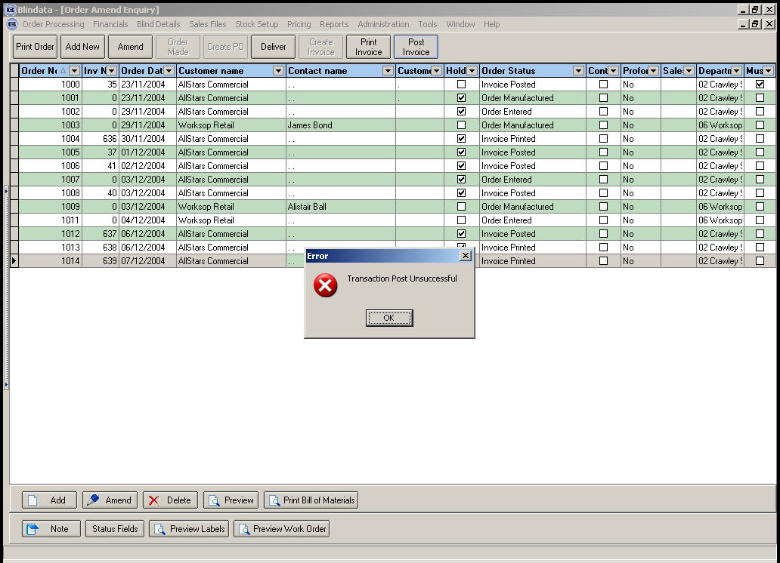

Also, the following problem occurs when we amend the totals for an order. Here is an order with two detail lines:
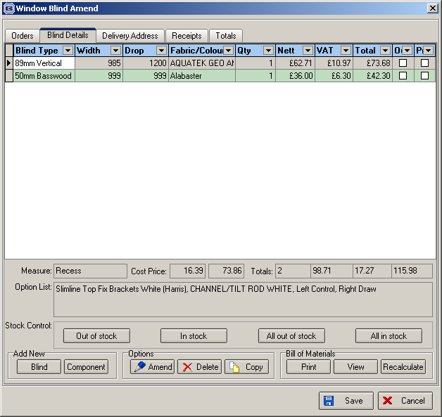

The totals have been changed:
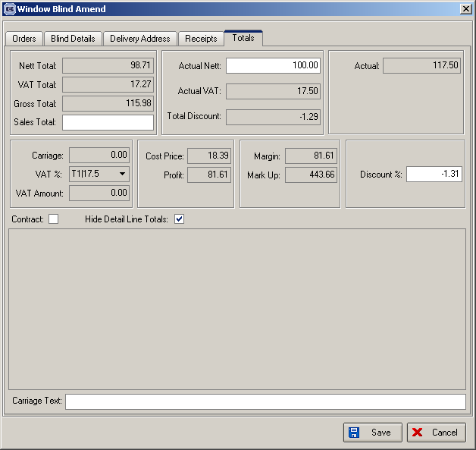

When this invoice gets posted to Sage, it gets posted like this:
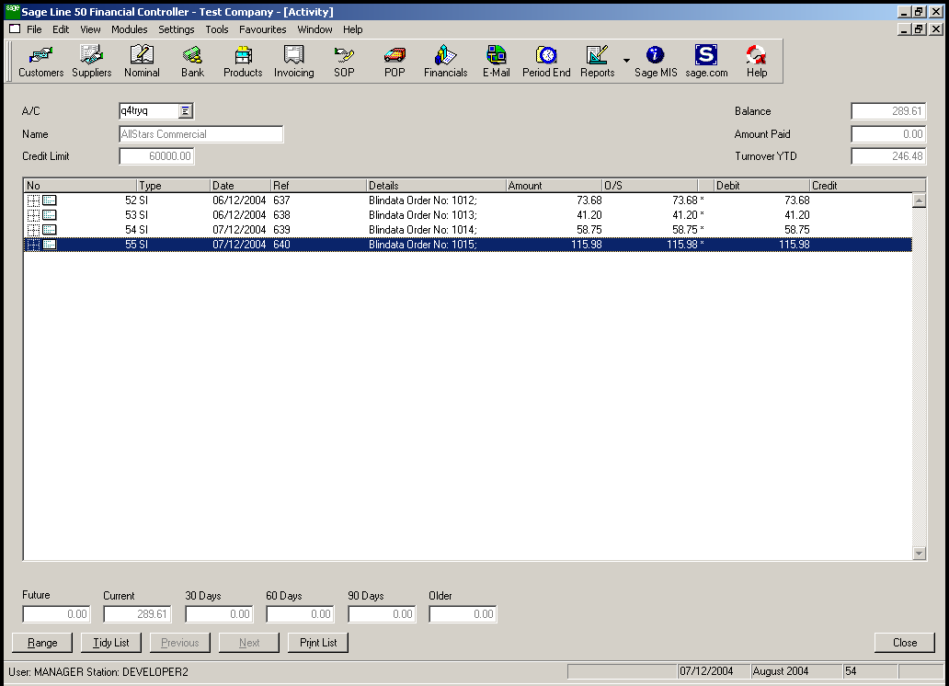

But this is the incorrect total. The amount posted should have been 117.50. This also means that the nominal breakdown is wrong:
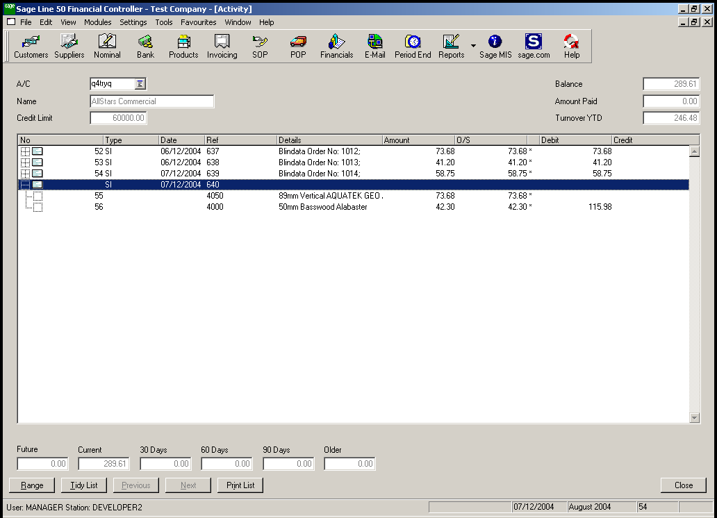

There we need to apportion the total correctly against the detail lines. In this case, this means we have to multiply each detail line by 117.5/115.98. Each result must be to 2 decimal places, so there is a possibility of rounding errors. We may therefore have to make an adjustment of 0.01 to get the figures matching. The overall invoice amount in Sage must match the invoice amount in Blindata.

The situation is more complicated when one or more of the detail lines has a zero amount in it. If at least one of the lines has an amount, then we can apportion the whole value of invoice to that line. But you could have a situation where none of the detail lines has an amount against it, and someone has just entered a total. In this case, the lines will have to be apportioned equally.

Order Entry Solution

When we amend the total on an order, we should recalculate the order detail lines, by taking the discount percentage and applying it to each line.

Example (trade order):
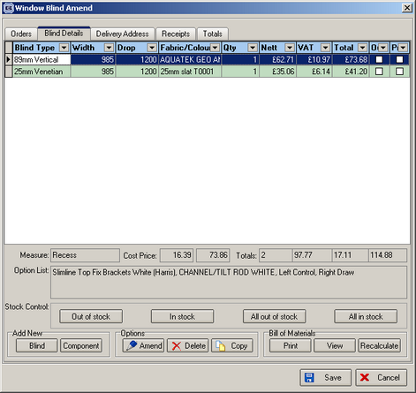

Totals screen:
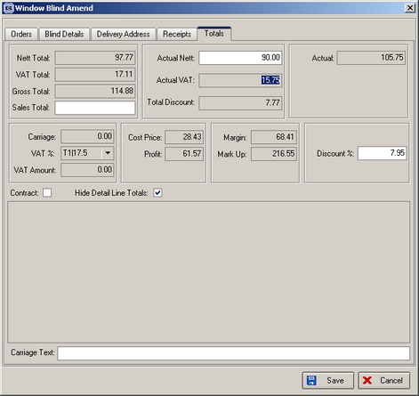

Once we change the actual nett to 90.00 from 97.77, the system calculates the discount % as being 7.95 (1 – (90.00/97.77) * 100) = 7.94722 = 7.95.

This should then recalculate the detail lines as follows:

Nett = (62.71 * (100 - 7.95)/100 = 57.72, discount % = 7.95, discount = (62.71 – 57.72) = 4.99, VAT = 10.10
Nett = (35.06 * (100 - 7.95)/100 = 32.27, discount % = 7.95, discount = (35.06 – 32.27) = 2.79, VAT = 5.65

This gives a total of:

Nett total = 89.99, VAT = 15.75.

The actual nett entered is 90.00 so we must add 0.01 to the last detail line nett amount.

Once the detail lines have been recalculated, the price overridden button should be checked in each detail line.

We have decided to simplify matters from here.

If a change is made to a detail line or a detail line is added, the program will simply behave as it does now.

If another change is made to the actual nett, the discount % in the totals screen should be zeroised before the change is made (there should be validation for this). It will mean that you start from the same figure each time before the total is amended.

The same rules will apply for a retail sale, but the calculation will be different.

Example (retail order):
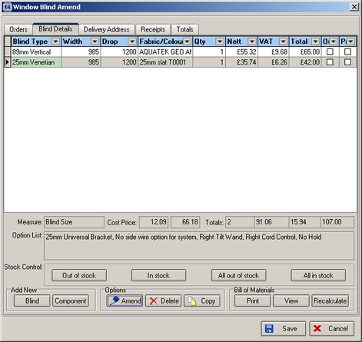

Totals screen:
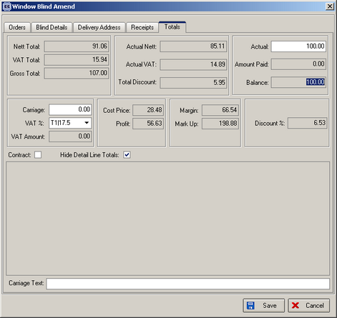

The detail lines should be recalculated as follows:

Line 1 total = (65.00 * (100.00/107.00)) = 60.75, discount % = 6.53, nett = 60.75 * (100/117.5) = 51.70, VAT = (60.75 – 51.70) = 9.05, discount = 55.32 – 51.70 = 3.62

Line 2 total = (42.00 * (100.00/107.00)) = 39.25, discount % = 6.53, nett = 39.25 * (100/117.5) = 33.40, VAT = (39.25 – 33.40) = 5.85, discount = 35.74 – 33.40 = 2.34

So total = 100.00, nett = 85.10, VAT = 14.90.

Therefore there are no rounding errors here.

59. Order Processing > Orders

If you enter a sales lead and turn it into an order, you can define the fitting date whilst creating the order. However, if you then go into the order and add blind detail lines, this can affect the fitting date (required date). We have now disabled the lead time calculation if the order has been generated from a sales lead, because the fitting dates were being overwritten.

60. Order Processing > Orders

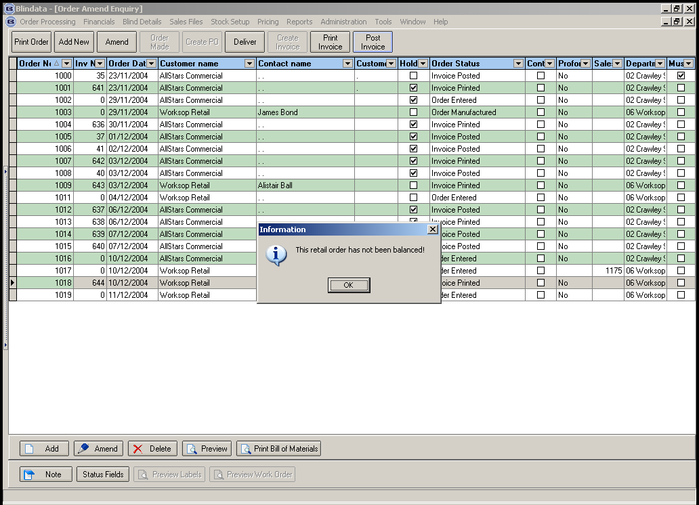

We do not need this message anymore and should allow a retail order that has not been balanced to be posted to Sage Line 50.

This means that the user must still be able to enter receipts for orders with status = invoice posted. This should be done in Orders > Receipts, but we will need to adjust the filter on order numbers to allow for these records.

61. Order Processing > Orders

It is now not possible to delete an order that has a status = invoice posted.

62. Financials > Post Invoices to Sage

The start and end dates now default to the first invoice date and last invoice date of the records that appear on the screen.

63. Wood requirement report
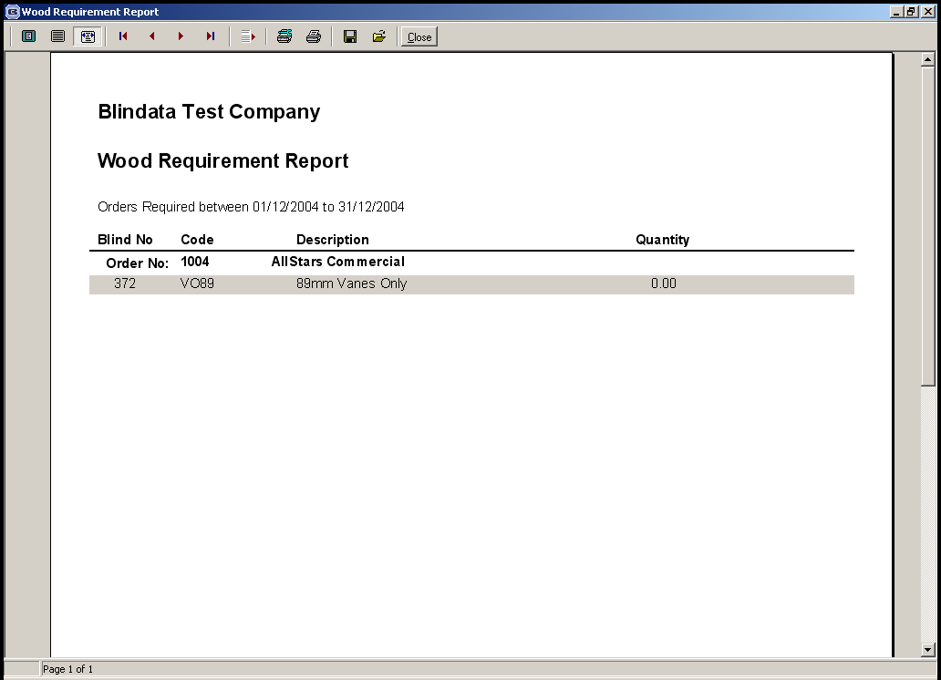

This is a new report that shows the amount of wood slat, valance and bottom bars required to fulfil orders.

64. Order Processing > Totals of Orders Outstanding

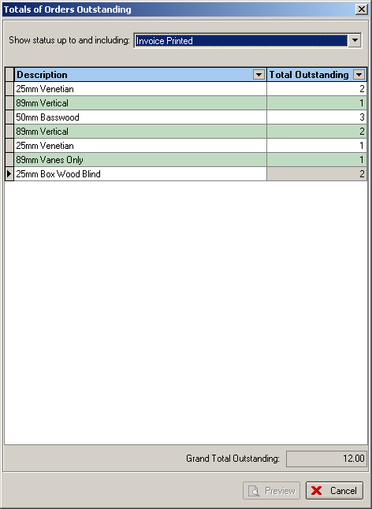

The above form displays outstanding orders, by blind type.

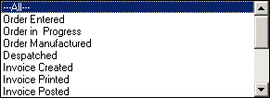

The above status descriptions are the only ones that are available.

65. Order Processing > Orders

When a fabric is entered in a detail line, the program now looks in Stock Items > Default Options to see if there are any records. If there are, a check should then be made to see if any of these default options match the blind type and link options for that detail line. If so, they should replace the existing default option.

Example: if we create a default option against record TUR0037 (25mm Slat T0001), it should then appear as a default option when the detail line is entered. A procedure should be written so these default options are selected after a fabric or an option is updated in a detail line.
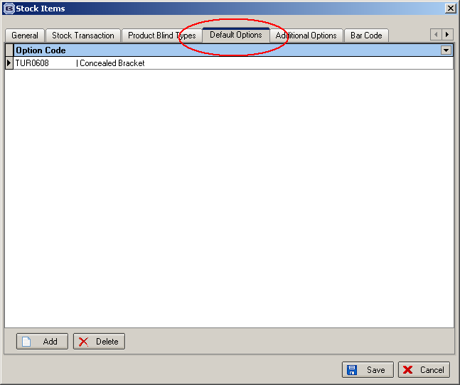

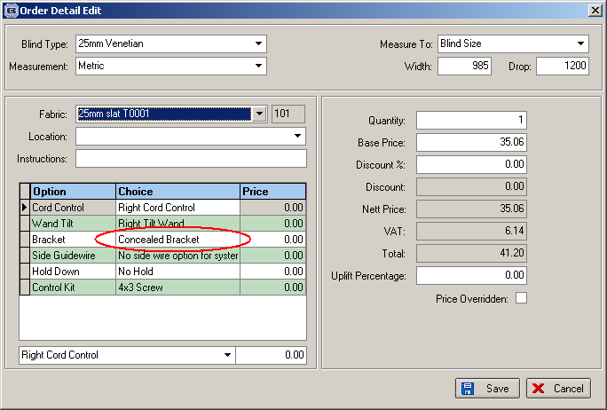

66. Blind Details > Blind Type Setup

We now display the product description here as well.

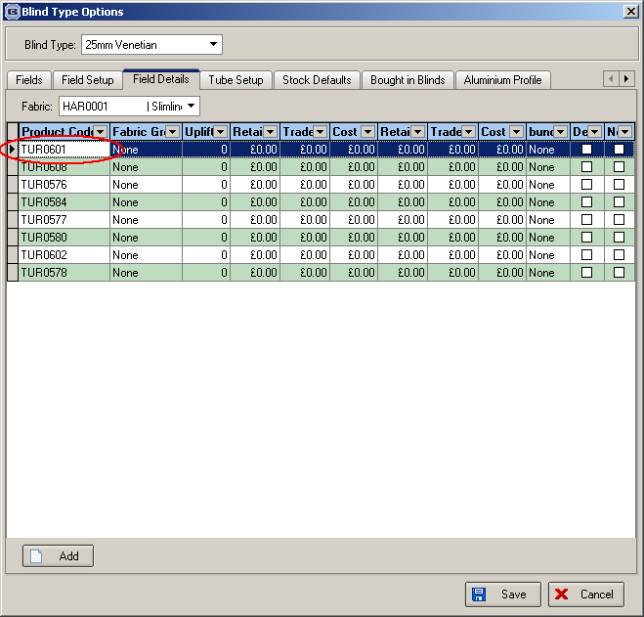

67. Update Customer Credit and ‘on stop’

The system checks data exported from Sage Line 100 and then updates customer records in Blindata. There are two stages to this:

The purpose of this exercise is to import two amounts into Blindata:
- The current customer balance and the credit limit from the Sage Line 100 sales ledger customer accounts.
- The outstanding orders on the Sage Line 100 sales order processing system.

Therefore they export these two files out of Sage. The first file, CREDIT-CHECK.xls contains the credit limit in field 3 and the customer balance in field 5. This information should overwrite the existing data in the fields in ‘credit limit’ and ‘Sage customer balance’ in the customer record in Blindata. The first field in the file is the Sage account reference field.

The second file contains a list of transactions from Sage relating to outstanding orders. They should be grouped by the first field (Sage account reference) and then the sum of the third field should be updated to ‘Sage order totals’ in the customer records in Blindata.

68. Order Processing > Orders

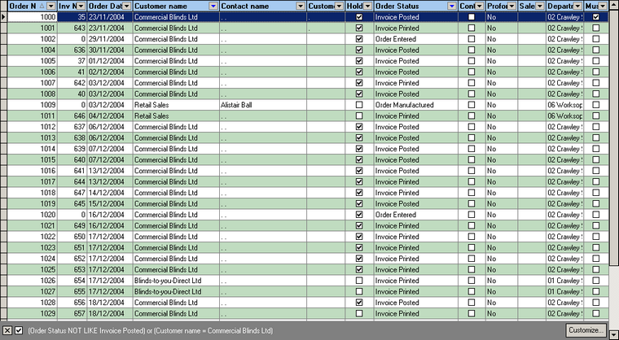

The default filter on this screen is now set to ‘Order Status NOT LIKE Invoice Posted’.

69. Order Processing > Orders > Bill of Materials
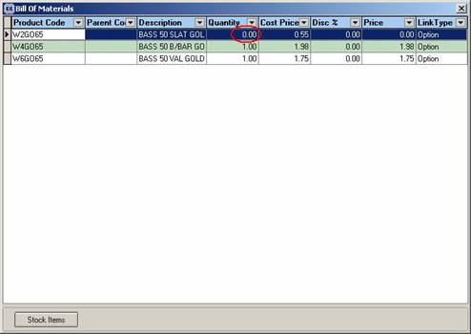
The slats were not being calculated properly for wood blinds. We have introduced a new calculator field to

70. Administration > Restore Database

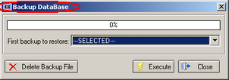

The above caption now says ‘Restore Database’.

71. Order Processing > Orders > Works Order – Label 1

Blind types were not being read correctly eg. 4 louvres, 6 wood venetians and 5 blackouts should be 4L, 6W, 5BO but it was reading 4L,6V.

At the moment the letters are being picked up from the blind identifier table. We have created two more blind identifiers, B = Blackout and W = Wood Venetian. Blind Details > Cord Spacing now allows for blind identifier = W.

72. Order Processing > Orders > Works Order – Label 1

We now display trim amounts for box blinds and also the number of slats to add or remove from the blind.

The trim amount is calculated by taking the manufacturing size of the blind and subtracting it from the width of the box blind that is being used, and then dividing by 2.

Example: man. width of blind is 1380. Box blind width used is 1500 (found in Box Blinds table). Therefore trim amount = (1500 – 1380)/2 = 60. This should be displayed on ‘works order – label 1’ in place of cord spacing (which isn’t needed for box blinds).

Calculation for working out the number of slats to add or remove.

Box blinds are manufactured externally. They are then adjusted to fit the exact sizes of sales orders. This means trimming either side (see above) to get the correct width, then adding or removing slats from the blind to get the correct drop. There is a slight complication with the drop, however. Slats will get added or removed depending on what size of box blinds are in stock and the number of spare slats there are (spare slats get created because they have been removed from blinds when the drop is too big). This means the client must be able to adjust the point at which they decide whether slats get added or removed from the blind.

Solution

We create a new table (to be maintained in Administration > System Tables) called Box Blind Slat parameters. It should have the following layout:

Field Name | Type/Description
Id | Autonumber
Blind type id | References Blind Type table (only box blinds)
Slat divider | Number (eg 23.6, 43.6)
Lowest drop | Integer
Highest drop | Integer
Add_remove point | Integer

When a detail line is entered, the number of slats to add or remove should be calculated by the following algorithm:

Identify record in ‘Box Blind Slat Parameter’ table that equals blind type and where ‘man drop’ is between lowest drop and highest drop.

Number of slats to add = ((Man drop – Add_remove point)/ Slat Divider) rounded up to next whole number.

If the result is a minus figure, then this means that slats should be removed.

We need to store this field in the order detail line and then display it on the works order label if box blind = true.

73. Order Processing > Orders

‘Order made’ has been taken off the order entry screen, only needed on the order enquiry screen for the factory.

Deliver, create invoice and print invoice is not required on the order entry screen.

If ‘Use Sage Line 100’ is set to True in Parameters, we could grey out the ‘Order Made’, ‘Deliver’, ‘Create Invoice’ and ‘Print Invoice’ buttons on the order amend enquiry screen.

74. Order Processing > Quotations

Updating quotes should be automatic once you select create order at present you need to select each separate line. The following boxes default to selected when you go to create orders:

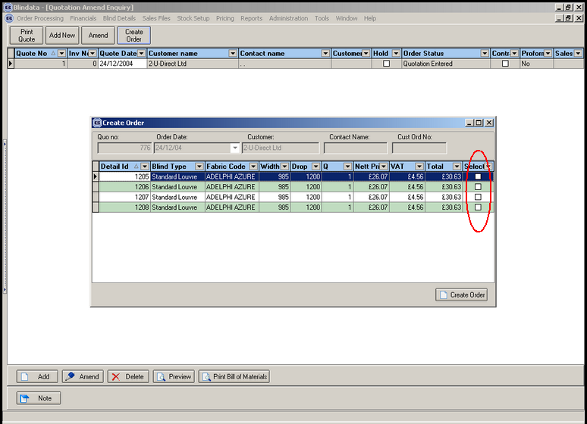

75. Order Processing > Orders > Bill of Materials

If the blind identifier in the blind type record has been changed to W (for Wood), the bill of materials no longer works for calculator = Slats. It should work in exactly the same way as if the blind identifier = Venetian.

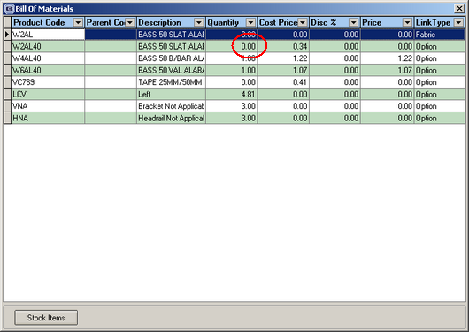

76. Order Processing > Orders

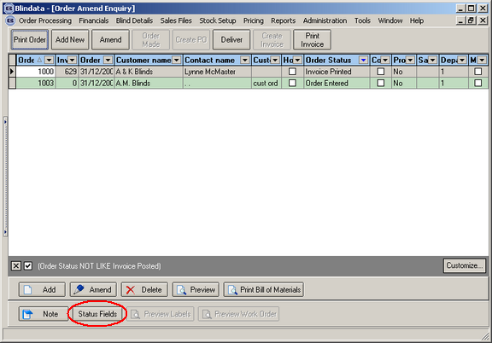

The button ‘Status Fields’ is only shown if the user has access rights to Administration > Users.

77. Carriage Calculations

Carriage is now calculated at depending on where the client is based. Therefore carriage amounts are held in the area table. The amount of carriage charged can also be dependent on the value of an order or orders. At the moment, if the nett value of the order (or orders) is over £500, carriage is free.

A new amount field has been added to the area table.

A new parameter has been added to the Parameters table: ‘Carriage free over:’

A new routine has been written to calculate carriage for orders. This routine examines all orders that have a status of ‘Invoice Created’. It should then group the orders by customer. If the sum of the nett amount (grouped by customer) exceeds the ‘Carriage free over’ amount in the parameters table, nothing is done. If the amount is lower then a carriage detail line should be added to the first invoice in the group. The total for that invoice should then be recalculated.

78. Administration > System Tables > Receipt Description

There is a new table for holding receipt descriptions. This is required for entering receipts

