Blindata Release Note 10.7.3 

1 October 2021

Bug Fixes and Enhancements

The following bugs were recorded in www.support.blindata.co.uk and have been resolved.

14671. Orders > Receipts
14677. Quotation / Order Entry > Save & Next
14679. Quotation > Submit
14699. PO's Printing over two pages unnecessarily
14740. Customers > Amend > Blind Type Sync
14746. Unable to print work order
14749. PP-Record-In-Use-Hourglass
14760. Tracking Number

New Work and Customer Requests

13744. Order Processing > Quotations

The Square foot information for in the Totals tab of an order now appears in quotes.

13850. Out Of Stock Functionality

When an order is entered and there is not enough stock, the warning message has been improved to this (an example).

There is not enough of the following stock to manufacture the order:

R8220 Fabric Locking Tape 225mm x 7mm

Purchase Order 999901 raised for 100m on 01/05/21 . Due in date of 28/05/21
Purchase Order 999902 raised for 100m on 03/06/21. Due in date of 06/07/21
Sales Order 123400 entered at 09:00 on 01/05/21 by User A for 100m (Related to PO 999901).
Sales Order 123456 entered at 12:34 on 04/05/21 by User A for 40m. (Related to PO 999902).
Sales Order 123457 entered at 12:34 on 15/06/21 by User B for 100m. (‘Out of Stock).

R9999 Fabric 9999

Etc.

13851. Order Processing > Orders > Context Menu

There is a new choice on the context menu called ‘Out Of Stock Details’. The following (an example) is then displayed.

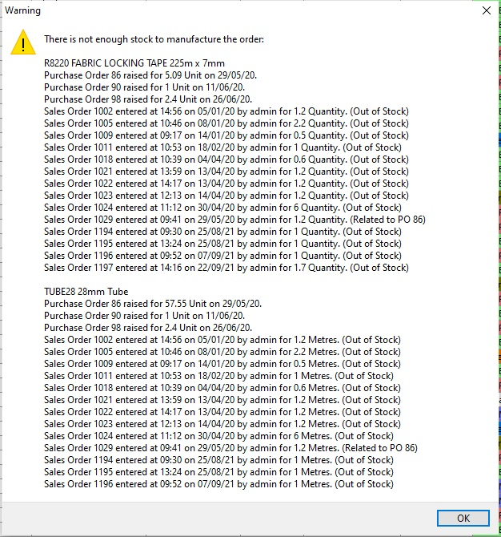

14284. Order Processing > Production List

The is a new report in this form called ‘Production List Summary 10 Days’.

14590. Order Processing > Orders

In the option section of an order detail entry, there is a new column choice called ‘OPL’ (option price lock). If this is set to true, then the option price is locked if the customer is change or anything else in the order detail line is changed.

14705. Acknowledgement - Bespoke 79

The ‘Instructions’ field on this report has been increased in size.

14756. Archive Filtered CMR Records

There is now an option to set a permission for archiving filtered contact management records.

