Blindata Release Note 10.5.5 

28 May 2021

Bug Fixes and Enhancements

The following bugs were recorded in www.support.blindata.co.uk and have been resolved.

13615. Blind Process Scan
13644. Daily status report. Issue with file format and extension
13654. Contact Record Type
13684. Duplicates in table Fabric Roll Width

New Work and Customer Requests

12548. Order Processing > Orders

If an order is entered, and the 'Entry Type' is changed to 'Invoice', the following question is asked:

If the answer to this is 'No', then the 'On Sales Order' and 'Stock In Hand' figures in the relevant stock item BOM records is reduced by the quantity.

13446. Online Ordering > Valance Width

Blind Types

If there is an 'Enter Valance Size' field in a blind type record, then there is also an 'Enter Online Valance Size' flag that defaults to false. If false, the 'Valance Size' is not shown in the online order entry field, if true it is shown.

13466. Invoice - Bespoke 2

At the moment if there is a multi blind order the invoice does not show the overall blind - it only shows the 3 individual blinds. If 'Multi Blind Pricing' is set to true, then ONLY the overall detail line is shown (because it contains the price). If 'Multi Blind Pricing' is false then the existing layout is correct.

13481. Online Ordering > Order Column Visibility

There is a new flag for 'Actual Total' in Parameters > Online. If true, then the 'Actual Total' column will be displayed in online orders.

13525. Online Ordering > Install Height

Blind Types > Parameters

There are two new fields 'Min Online Install Height' and 'Max Online Install Height', which both default to 0. In the online order entry if these are 0 then any install height can be entered. If they are not 0, then the online install height must be between the 'Min Online Install Height' and 'Max Online Install Height'.

13585. Online Ordering > Special Instructions

There is a new system table called 'Special Instructions Online', which has fields for 'Blind Type' and 'Special Instructions'. The first field looks up blind type records, the second is a 100 character text field.

It is now possible to save a record with only special instructions text filled.

Parameters > Online

There is a new parameter in the Online > General section called 'Use Spec Ins Lookup', which defaults to false. If true, then special instructions are selected from the new system table. If there is no blind type in the record, then it is available for any blind type, otherwise only for the relevant blind type.

13588. Parameters > Automated Tasks > Send Order Status File

This file is now created in a csv format, not Excel.

13618. www.getaddress.io

There is a new method of doing a postcode search for UK addresses called getaddress.io which is less expensive (£12 per month for 2000 searches per day or £3.00 per month for 50 searches per day) than postcodeanywhere.co.uk (4.6p per search).

A key can be obtained from get address.io and saved in Administration > Parameters > Connection Settings.

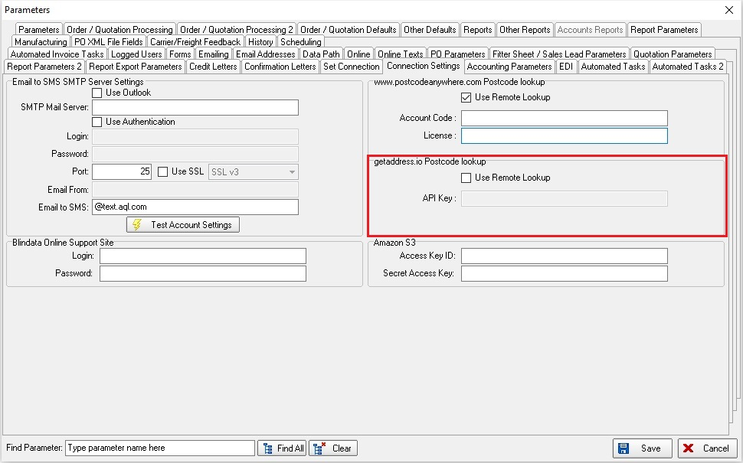

13627. Quotation – Bespoke 73

Special instructions now print for each line in the detail section,

