Blindata Release Note 10.4.6 

26 March 2021

Bug Fixes and Enhancements

The following bugs were recorded in www.support.blindata.co.uk and have been resolved.

12735. Order Processing > Fabric Summary
13061. Issue adding Cutting Option
13063. Fitter Sheet\Sales Leads
13089. Office 365 email
13094. SMTP Configuration
13100. Pattern Repeat
13138. Order Processing > Orders

New Work and Customer Requests

12457. Manufacturer Label - 4x1

There is a new label report called ‘Manufacturer Label – 4 x 1’. There is a new column named 'Man. Label Printer' in 'Blind Details > Blind Types > Man. Process Types' table for choosing the available printer to print the manufacturer label report.

Also, there is now a 'Man. Label Printer' choice in 'Administration > Users > Amend > Printers' tab. Blindata now checks the user printer settings and if it is empty uses the printer settings from the new column.

12749. Works Order - Bespoke 67

There is now more room for the serial id barcode to print.

12851. Administration > Parameters > Automated Tasks

A new flag called 'Send Amendment CSV File' has been added to Blindata > Administration > Parameters > Automated Tasks tab. This flag defaults to false; if set to true, then the
'CSV Export Time' field is enabled.
A new flag called 'Send Amendment CSV File' has been added to the Sales Files > Customers > Amend > FTP Settings tab. This enables this box:

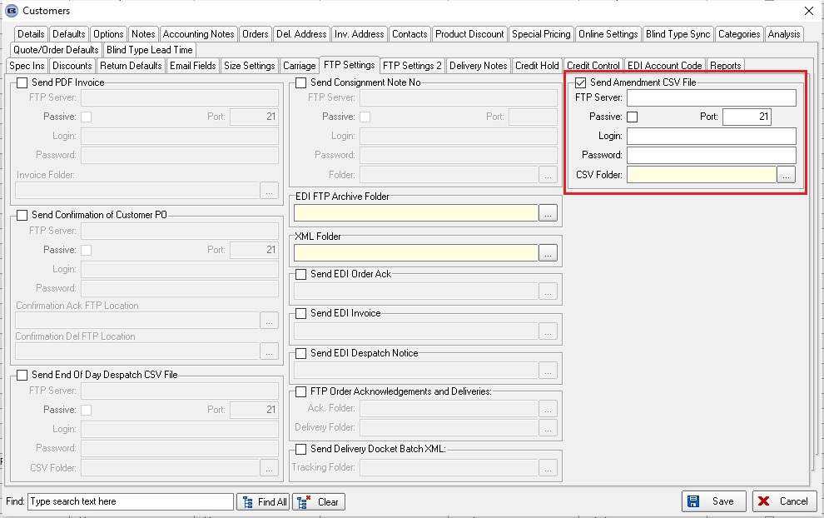

The box contains the following fields:

FTP Server Settings (FTP Server, Port, Login, Password, Passive)
FTP Folder (where CSV file will be exported).

Blindata will check Administration > Parameters > Automated Tasks > Send Amendment CSV File > CSV Export Time and will then upload the CSV file to Custome r> FTP Settings > Send Amendment CSV File > FTP Folder at the appropriate time.

12974. Purchase Order Bought In - 8.5 x 11

The instructions field has been made larger on this report.

13000. Stock Items / Detail Line Entry

There is a new field in Stock Items > Defaults tab called 'Manufacturing Location'. This looks up the 'Manufacturing Location' table in System Tables.

In order detail line entry, if any options have a manufacturing location in them, then it is saved in the order detail line record. If more than one option has a non null manufacturing location, then the one with the highest sequence number in the option (from Blind Types > Option Setup) is saved.

13007. Order Processing > Delivery Docket Batch Print > Despatch Manifest Invoice

There is a new report available here which prints out a despatch invoice which contains business to business pricing.

13008. Reports > Receipts By Date

There is now an option to print this report by blind identifier.

13141. Blind Details > Blind Types

There is a new tab in the blind type record called 'Cost Price Markup' that is only required if the blind identifier = Online.

This new tab has two fields - 'Price Table' and 'Mark Up %'.

When an order detail line is entered for a blind type that is a web service blind i.e., the blind identifier = Online, the base price is calculated as the cost price (in the detail line) * Mark Up % / 100.

