Blindata Release Note 10.3.9 

5 February 2021

Bug Fixes and Enhancements

The following bugs were recorded in www.support.blindata.co.uk and have been resolved.

12070. consignment number update multiple times
12605. Order Processing > Orders > Totals Tab
12634. Out of Stock Notification Question
12647. Remake / Repair / Redespatch

New Work and Customer Requests

8950. Peachtree Sage 50 v28 (2021)

The integration to Peachtree Sage 50 v28 (2021) has been added.

12463. Sales Files > Customers > Incoterms

There is now a new field for ‘Incoterms’ in the customer record. 'Incoterms' is also now a choice in Sales Files > Customer Update'

This is now used as the default value when an order is entered manually only or if an EDI order is imported.

12468. Invoice - Bespoke 15

This invoice layout is now available in Parameters > Report Export Parameters.

12488. Order Processing > Archive Enquiry

The 'Empty Invoice Date' flag now defaults to being switched on.

12503. Order Processing > Orders > Appointments

The logic applied to the 'Fitter Postcode Day' set up in System Tables has been altered. When a fitting appointment is created, it now finds the next available day and fitter according to the records set up in 'Fitter Postcode Day'. As soon as 'Fitter Sheet' is selected in 'Add Appointments', it now fills the date and fitter with the next available day according to the 'Fitter Postcode Day' set up. It ignores a day if the diary is already filled for that date.

This functionality has been applied in the diary as well as in order amend enquiry.

12522. New Invoice Fields (Brexit related)

We need to add the following information to some invoices.

There is a new 'System Table' called 'Reason of Export', which contains one field called 'Reason of Export'.

There is a new 'System Table' called 'Packaging Type' which contains one field called 'Description'.

There is a new 'System Table' called 'Mode Of Transport' which contains one field called 'Description'.

These three tables are now available via new fields in the Totals tab of the order.

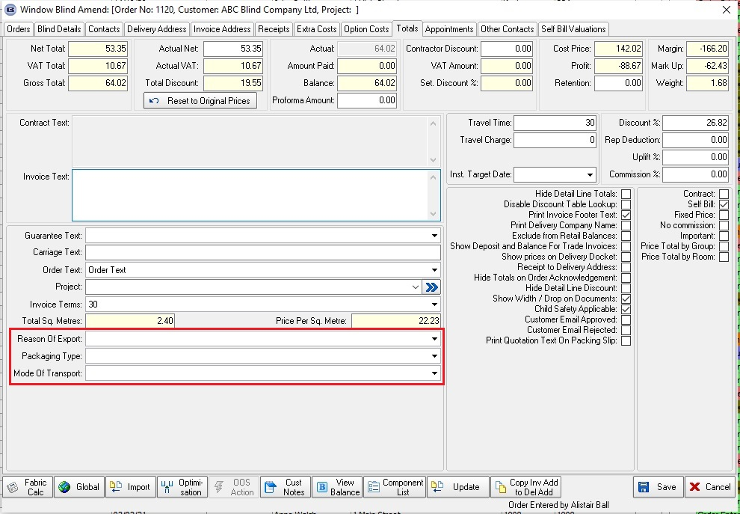

The invoice layout Invoice – Laser Print (Letterhead Logo) has been adjusted to accommodate these fields.

12584. Administration > Users

There is a new flag in the Users > User Information tab called 'Login Direct To Diary' which defaults to false. If this is set to true, when the user logs in, Blindata goes straight to the Order Processing > Fitters Sheet / Sales Lead form.

12585. Parameters > Menu Display Parameter

At the moment if a user does not have permission to go into a menu option, that menu option is greyed out. There is a new parameter called 'Hide Menu Options If No Permission' which defaults to false.

If true, if a user does not have permission for a menu option, it is hidden instead of greyed out.

