Blindata Release Note 10.4.1 

19 February 2021

Bug Fixes and Enhancements

The following bugs were recorded in www.support.blindata.co.uk and have been resolved.

12717. How show PO receiving detail?
12744. Installation Height to show on Worksheets
12748. Order Processing > Orders
12767. 'Select Cost Price from Table' functionality
12771. Purchase Order Spelling Error
12772. Works Order Bespoke 70 & 70 A cut size barcode should be in decimal format
12773. Dispatch label bespoke 70A - formatting issue and "Count for labels" window does not open

New Work and Customer Requests

8304. Order Processing > Order Enquiry

The ‘Fitting Date’ field is now a column choice in this form.

12582. Order Processing > Orders > Deposit Invoice Creation

For customers using Blindata Accounting, there is new functionality to allow users to create and post invoices at the receipt entry stage. The balance invoice will then be created at the normal ‘Create Invoice’ stage instead of an invoice for the full amount.

There is a new flag in Sales Files > Customers > Options tab called ‘Create Receipt Invoice’. This flag can be set up for multiple filtered records in Sales Files > Customer Update.

The benefit of setting up this flag is that the new ‘Create Invoice’ flag in the receipt entry will default to true. Once the invoice / receipt records have been posted, the ‘Inv Posted’ flag held against the receipt record will be set to true.

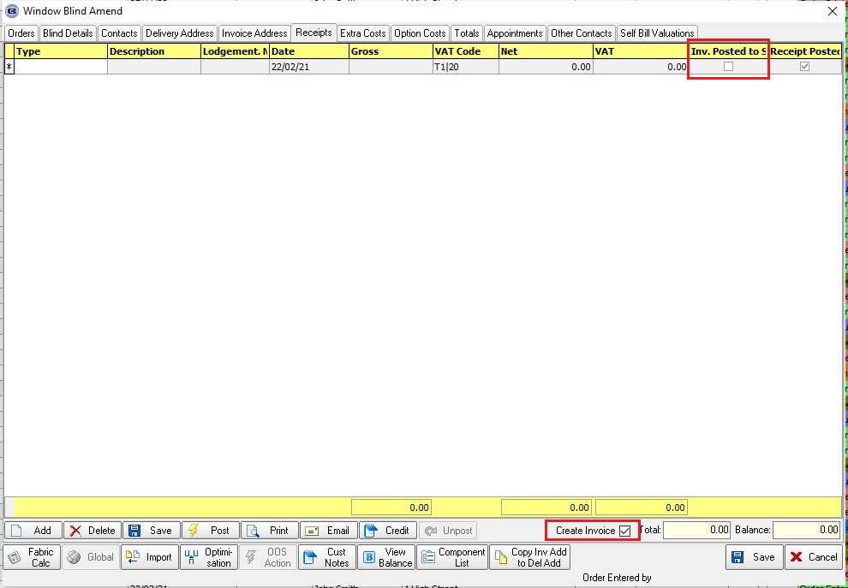

If this flag is set to true, then it will be possible to create, print and post an invoice in the Receipt entry.

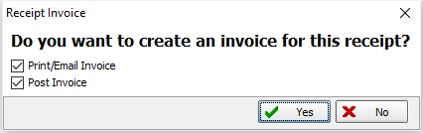

When this has been done, the invoice and receipt transactions will be posted to the sales ledger and allocated against one another. An invoice will be printed/emailed for the deposit amount of the order. The invoice number will be saved in a new Deposit Invoice Number’ in the order record. This field is a column choice in the ‘Order Amend Enquiry’ form.

The order will then be processed as normal. At the invoice print/email stage, a second invoice will be raised for the order, but only for the balance amount of the order. When this is posted to the sales ledger, it will only post the balance amount. A new invoice number will be created for this order as previously.

12620. Works Order Portrait

There is a new flag in Parameters > Report Parameters > Works Order and Label called 'Exclude Bought In From Codes', which defaults to false. If true, then the codes for bought in blinds should not printed on ‘Works Order Portrait’.

12645. Works Order Portrait

If an order is for a Remake or a Repair this now prints on this works orders in bold capitals. ie REMAKE or REPAIR.

12646. Acknowledgement - Laser Print (Letterhead Logo)

If the order is a remake or repair, it now prints REMAKE or REPAIR in the header section.

12795. PO XML Transfer File 2

The rule 'if Install Height = 0 (i.e. INST_HEIGHT_CM = 0.0) then BLI_CONTROLS_LENGTH tag will not be included to XML' has been removed.
The rule 'If Chain Length = 0 then BLI_CONTROLS_LENGTH tag will not be included to XML' has been added.
The rule 'If INST_HEIGHT_CM > 0 then the BLI_CONTROLS_LENGTH attribute is excluded has been added.

