Blindata Release Note 10.4.4 

12 March 2021

Bug Fixes and Enhancements

The following bugs were recorded in www.support.blindata.co.uk and have been resolved.

12933. Border fabric not showing in the options of the works order
12946. Velux Window Code not showing on works order as it does in the quote
12961. Re: Feature 12204 Bug
12986. cancelled order appearing on Project Profitability by BOM Group

New Work and Customer Requests

12278. Reports > System Reports > Outstanding Manufacturing Report

There are now options to select records for this report by customer and delivery day.

12609. Administration > Import From Excel > Actual Fitter Time

There is now functionality to import Fitter (Installer) times from a spreadsheet in Import From Excel > Import Fitter Times.

The spreadsheet contains the following fields.

Order Number
Appointment Type
Date
Employee Name
Start time
End time
Notes

12623. System Tables > Carrier File Layout

New functionality has been added to the carrier file layouts so detail lines can be included in a XML file layout.

When XML node is being added, it can be specified as Order or Order Detail level.

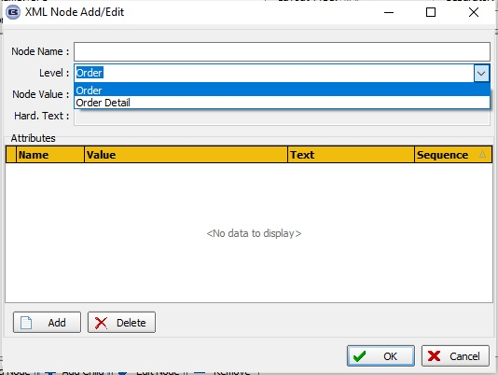

12988. Order Processing > Order Enquiry > Order Process Scan

A change has been made to the ‘Order Process Scan’ so the process can be selected after an order has been scanned.

