Blindata Release Note 10.2.3 

16 October 2020

Bug Fixes and Enhancements

The following bugs were recorded in www.support.blindata.co.uk and have been resolved.

11630. PO XML Import
11667. Receipt Details Showing As "online" in respect of Arena EDI Blinds
11671. EDI dispatch notice needs to go out before invoice EDI file
11671. EDI dispatch notice needs to go out before invoice EDI file
11703. Blind type codes for Arena EDI blinds are not pulling through to fitters sheet correctly
11705. overwrating the invoice + Blindata Update
11719. Blind Detail > Duplicate
New Work and Customer Requests

11308. Order Processing > Order Enquiry > Process Misc Transactions

There is a new 'Process Misc. Transactions' button on the 'Order Processing > Order Enquiry' form. The button visibility and permissions are the same for this as for the 'Process Transactions' button.

11513. Drop Ship By Customer and Blind Type

There is a new system table called Drop Ship By Customer and Blind Type. If there is a matching record in here then the order is flagged as Direct Delivery By Supplier.

11535. Order Processing > Orders > Web Service Blind Type

Foe web service blind types, the ‘Measurement’ is now being taken from the customer record in the supplier database.

11536. Order Processing > Orders > Web Service Blind Type

The 'Save & Next' in the order detail line now behaves in the same way for a web service blind type as it does for a blind type held in the local database.

11537. Order Processing > Orders > Web Service Blind Type

The Group no./ Room no./ Batch no. boxes now appear in the bottom right hand corner of the form when choosing/entering a web service blind.

11542. Administration > Parameters > Automated Tasks > Enable PO XML Import

The Archive and Broken folder locations can now save to a ftp location.

11543. System Tables > Venetian Slats > Pleated Charts

There is a new field in the 'Product Blind Type' tab of the stock record called 'Pleat Table'. This only appears if the stock record has blind identifier = Pleated and link option = Fabric.

If this field is filled, then it will select the number of pleats from this pleat table.

11552. Quotation - Bespoke 31

This quotation layout now shows the relevant Option Choice discount (or 0% if none) in the Discount column (as per Invoice - Bespoke 31).

11563. Reports > Sales Analysis

There is now a 'Bought In' flag alongside the Remakes, Repairs, Redespatches and Misc. Sales flags. This means that Show Only or Exclude any Bought In blinds can be applied to the sales analysis reports.

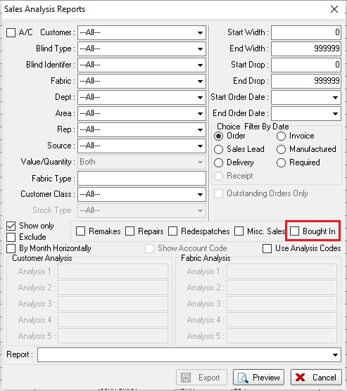

11622. Reports > Sales Lead Status Report

There are now totals for all reps combined at the bottom of the report.

11624. Reports > Sales Lead Status Report

There is now an option to not group by rep and just show amounts and totals by date. This criteria is called 'Group By Rep' which defaults to true, and is displayed above the 'Fitter/Rep' criteria. If the new criteria is unticked, then the 'Fitter/Rep' choice is only 'All'.

11645. Order Processing > Orders

The total for the ‘Cost Price’ column is displayed when this column is selected and the user has permission.

11655. EDI Import

The following workflow now applies to retail.blindata.co.uk.

A sales lead is entered in the desktop system and then synchronised to retail.blindata.co.uk.
The sales lead is converted to an order in retail.blindata.co.uk and submitted.
The EDI order is then imported to the desktop system as an order, and the order source and sales lead id updated in the order to the information that was in the desktop sales lead.
When the order is imported to the desktop system, the sales lead in the desktop system status is now changed to 'Changed To Order'. This is required so the 'Sales Lead Status Report' works properly.

11661. Transfer File 2 XML Files

If an order detail line has been entered for a web service blind, the ‘Transfer File 2’ rules are now applied to the XML file

11682. Delivery Docket Batch XML File

This file now includes fields for 'Number Of Packages', 'Weight', 'Consignment Note No', and 'Dimensions'.

11687. Order Enquiry > Blind Process Scan

If all processes are scanned for a blind, then the status of that blind will change automatically to ‘Blind Manufactured’, regardless of whether ‘Use Employee Barcode’ is set to true or false.

11713. Order Processing > Order Enquiry

There is now a column choice for ‘Category’. This is the category field held against either the blind type record (for a blind detail line) or the stock record (for a component detail line).

