Blindata Release Note 10.0.7 

26 June 2020

Bug Fixes and Enhancements

The following items were recorded in www.support.blindata.co.uk and have been resolved.

10646. Problem importing orders
10657. Roll Width Manual change not changing the price, fabric or widths
10668. Blindata/SAGE Link
10670. History
10676. PP-Response-Time
10677. PP-Archiving-Error
10678. Blind Details > Blind Types > Allusion Louvres Only
10683. Manufacturing Survey / Survey sheet
10687. Purchase order Enquiry
10692. Order Processing > Orders
10693. Amend history
10697. Second part of postcodes not fulling through to diary & fitters sheet

New Work and Customer Requests
5516. Pricing > Velux Price Table

There is now a ‘Copy To Clipboard’ option in the context menu.

10302. Order Amend Enquiry > Batch Status Field

When multiple records are changed to order status ‘Despatched’, the despatch date is saved as the current date.

10539. Works Order – Bespoke 37A

The page number is reset to 1 at the start of each order when the report is run from ‘Production Documentation’.

10598. Blind Details > Blind Type > Duplicate

When a blind type is duplicated there is now an opportunity to select which related records get copied as well.
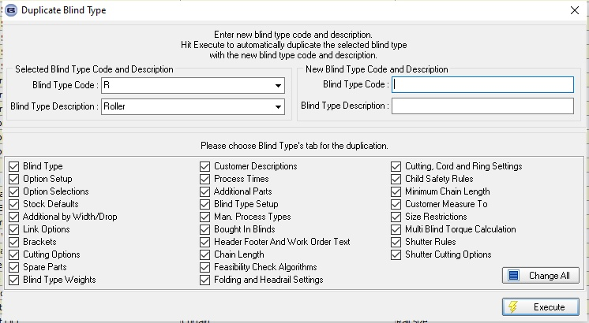

10600. Cutting Sizes and Aeronaut File

Whenever an option is changed by using the ‘Global’ functionality or if the BOM is recalculated, it now updates the cutting sizes in Window Blind Amend > Cutting Sizes and those in the Aeronaut file.

10638. Parameters > Mandatory Area Field

There is a new parameter called 'Mandatory Area Required' in Parameters > Fitters Sheet / Sales Lead tab, which defaults to false. If true, the area must be entered in the sales lead.

10643. Order Processing > Orders > Totals

There was a requirement for a restriction in Order Processing > Orders > Totals > Actual Price so that the pricing cannot be altered after status 'Order Manufactured'. There is a new user permission for this called 'Allow Actual Price Edit After Manuf' which defaults to false.

10656. Border Make Price

At the moment, the 'Make price' is held against the blind type record, and is applied regardless of who the customer is.

This has been replaced by a 'Make Price' by 'Price Table' which is held in a new tab in the blind type record. There are two fields in this tab - 'Price Table' and 'Make Price'. The make price will then be found by referring to the price table held against the customer.

10690. Order Processing > Orders > Options

The Roll width (RW) and Pattern Repeat (PR) that are in the option section now display in centimetres when 'If Metric Use Centimetres' is set to true.

10713. Feature. Pricing > Option Price Enquiry
We can set up an option price to be a formula (1), but it will only work if a price of 1.00 is set up in (2). If there is no underlying price record ie (2), then it is assumed that the price is always 1 and so only the formula will determine the price.

