Blindata Release Note 9.9.8 

24 April 2020

Bug Fixes and Enhancements

The following bugs were recorded in www.support.blindata.co.uk and have been resolved.

9988. Option Pricing
10103. Widths and options not updating when changing sizes in an estimate
10147. Error While Creating a New User
10148. Items not fixed after testing ticket 10046
10150. Fabric Free type box duplicating free type entry
10166. Address Warning Message
10183. Quotations > Create Order
10188. Component List Import Error
10190. Work Order- Bespoke 37A (Tag)
10191. PP-UnitCost-Duplicated
10195. Despatch Email
10201. EDI orders cannot be revised
10219. Order Processing > Orders

New Work and Customer Requests
5804. Order Processing > Quotations

When a quotation is entered and there are BOM records created, the ‘Stock Transaction’ now identifies the quote number and the customer here. Also, the background for this field is light orange if it is a quotation.

7220. Import From Excel > Unit Of Sale

If a record already exists, then it should update the fields for Price, Default, Full Roll and Inactive.

7231. Stock Control > Stock Items

We now hold a 'Despatch Method' against the stock item. If a component order is entered and the despatch method in the stock item is not null, it is saved in the order.

7233. Order Processing > Orders

If there are entries in ‘Notes’ or ‘Notes 2’ then the relevant button turns red when a relevant record is pointed at.

10048. Quote 83 Update

The logo is now taken from the department record.
The title no longer prints on this report.

10059. Administration > Parameters

This form has been made wider and shallower so it will display fully on all screens.

10122. Acknowledgement - Bespoke 37

‘Quantity’ on this report has been replaced by ‘Unit Quantity’.

10146. Quotation – Bespoke 83 Selection Update

Quotation – Bespoke 83A’ is now a third choice in the ‘Report Selection’ form.

10152. Purchase Order CSV File to Eclipse

There is a new flag in the ‘Regular Po’ header section called ‘PO Delivery Address’. If this is set to true, then the CSV file that is emailed has a new field with ‘2’ in it. If ‘PO Delivery Address’ is left as false, this field is filled as ‘1’.

10154. Customer Quotation/Order Defaults

All of these flags are in the customer record, in a new tab, so that defaults can be set by customer.

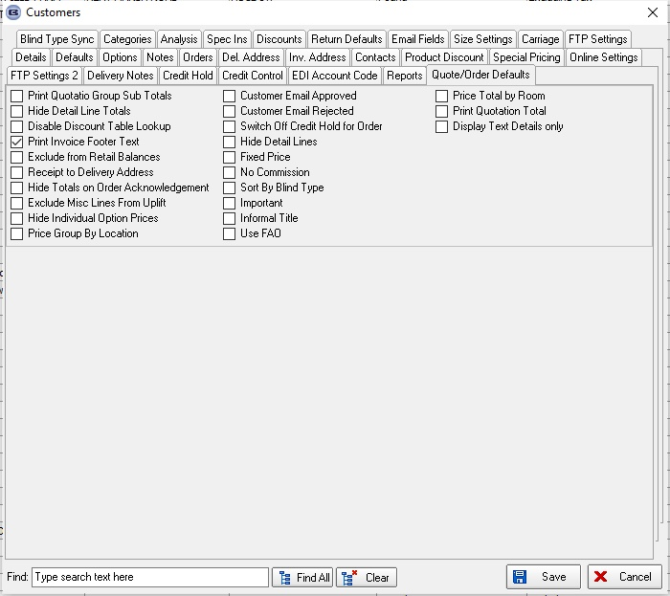

10156. Sales Files > Customer Update

There are now field choices for all of the fields in the new Quote/ Order Defaults in Sales Files > Customers.

10185. Acknowledgement - Bespoke 73

If the 'Install Height' is entered in centimetres, it now prints in centimetres.

10187. Order Processing > Quotations

The 'Fabric Summary' button that was created for the 'Order Amend Enquiry' form is also now displayed in the 'Quotation Enquiry' form.

