Blindata Release Note 5.9.7 

2 July 2012

Bug Fixes and Enhancements

3867. Sales Files > Customers > CSV Order Import

There were still two problems with the import.

- The address that is imported to the delivery address is now the second address in the record, not the first one.
- The comment field does import into the ‘Special Instructions’ field in the detail line. However it was also importing the description, which is not required and so has been taken out.

3868. Picking List

If there are special instructions in a detail line, they now print out on the detail line. The detail line is shrinkable (no space if there are no special instructions).

3869. Order Processing > Orders

If you entered a sales order and put one detail line in and save the detail line, the ‘On Sales Order’ field in the stock record is updated. But if you then cancelled the order before it had been saved, the ‘On Sales order’ figure was not updated (even though the detail line had now been removed). This has been fixed.

3870. Purchase Order Regular – Bespoke 31

We now allow for up to 17 characters to print in the product code column (could all be upper case characters). This has been done to cater for long supplier part numbers.

3873. Pricing > Price Table Enquiry

The ‘Selected Price Uplift’ was not working properly (temporarily). If you choose ‘Copy to New’, it created a blank price table. This has been fixed.

New Work and Customer Requests

2608. Works Order A4 Individual

The barcode on this report has been moved up, as indicated below.

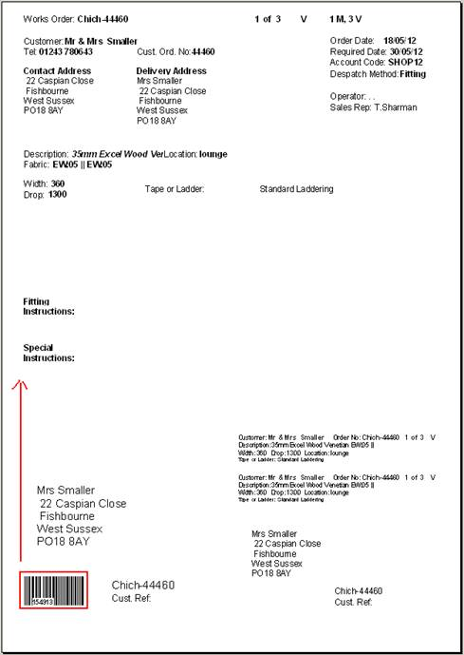

2686. Financials > Create Invoices

We have had occasional performance issues with the creation of invoices routine. Timeout errors would sometimes occur and on the odd occasion the invoice number in the Order record was different from the invoice number in OrderDetail. We have also had a number of cases where two orders have ended up on the same invoice.

These problems only started to happen after we did the development item to have multiple invoices per order. This was done after a request by a customer. We now think this was a mistake. The reason we made the change was to allow customers to part despatch an order and then only invoice the lines that had been despatched. It was also done for ‘Applications’, which aren’t actually being used by anyone.

As we now have the functionality to ‘split’ orders, we have changed back to only holding the invoice number against the Order record. The ‘Create Invoice’ routine has been changed along with all the invoice reports.

2727. Reports > System Reports > All Discounts Report

We now show the product code on this report.

2732. Administration > Company Details > Email Text

It is now possible to have separate email text for proformas. Previously the text was the same as for quotations, so we have created a new field called ‘Proforma Email Text’ where the message text can be stored.

Also previously there was only have one option to ‘Email Straight Away’ in Parameters. We now hold a flag against each one of these report choices to say if the pdf should be emailed straight away. These new flags default to ‘Email Straight Away’ that is set up in the ‘Set Connection’ tab.

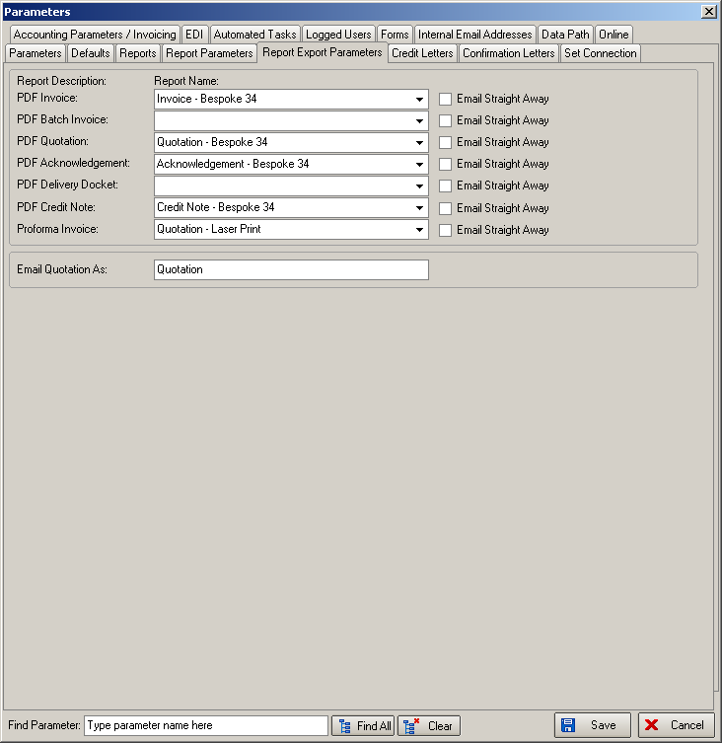

2736. Acknowledgement – Schedule Date
There is now a flag on the blind type card called ‘Lead Time Text’. When this is flagged the acknowledgment displays the lead time text from the Blind Details > Lead Time Text, otherwise if this flag is left blank, then the acknowledgment remains the same as now showing the schedule date or promised date.

2738. Works Order Label 1

The Valance measurements on works order have been moved to the left a little to avoid overwriting options.

2739. EDI Enquiry

On the EDI Enquiry screen when orders are imported automatically the popup message “Please make sure the e-mail address is specified in the Customers profile” appears and holds up the automated importing process. This message has been changed, so that it does not pop up on the screen. Instead of a pop alert message this has been set so it does not send an email.

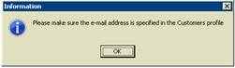

2740. Connection Lost

If the network connection to the server is lost for a split second, Blindata displays connection errors and it is not possible to log out. The only solution was to kill the blindata.exe in Task Manager. Blindata will now close with the red ‘X’ in the corner even with no network connection.

