Blindata Release Note 5.9.6 

22 June 2012

Bug Fixes and Enhancements

3858. Administration > Accounting Utilities > Create/Update Customer Details from QuickBooks

Every time this routine is run, it set ‘On stop’ = true in all the customer records. It was also overwriting address as well.

We have added a flag called ‘Create New Customers Only’ for Create/Update Customer Details from QuickBooks’ which is true by default. In this case the program won’t override existing customers and just imports new customers from QuickBooks. If the flag is false, it will work as it works at the moment.

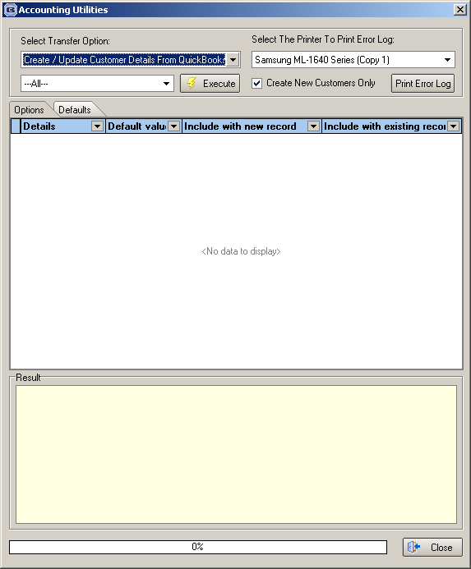

3860. Pricing > Cost Price Table Calculation

This was not working properly – it came up with 0 prices. Fixed.

3861. Purchase Order Enquiry > Regular PO > Update

If you had a fabric that has ‘Batch Numbering’ = true and ‘Enable Factory Stock’ was true in Parameters, when the fabric was delivered, there is the choice to tick ‘Factory Stock In Hand’. If this is ticked, then there is no need to record a batch number for the fabric, so we have removed the validation on ‘Enter Batch Number’ if this is true.

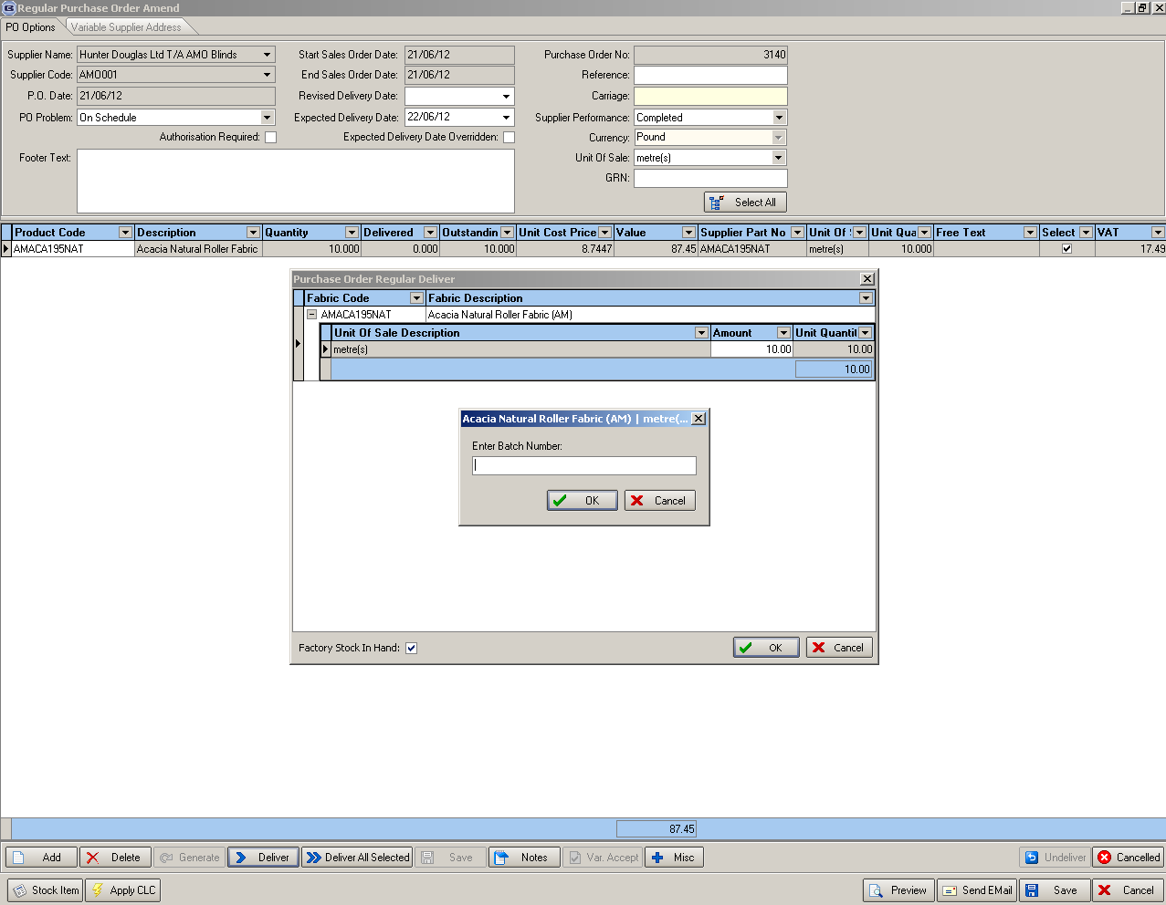

3862. Order Processing > Orders > Bill Of Materials

If you set up a formula, it was not working out a quantity in the bill of materials. Fixed.

3866. Sales Files > Customers > Preview Labels

When you click on the button to preview labels, it defaults to this form. If the contact name is left blank, it will print out the contact name from the customer record on the label.

The contact name now defaults to the customer company name in this form.

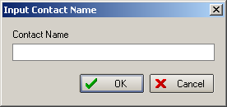

New Work and Customer Requests

2700. Administration > Import From Excel > Blind Type Dataset

We now have a validation routine on this import to make sure there are no duplicate stock codes. If there is a duplicate stock code, then it is reported in the log and the record is not imported.

2701. Administration > Import From Excel > Customer Update

There is a new import spreadsheet option for customers that works in a similar way to the ‘Stock Update’ choice. This choice is called ‘Customer Update’ and has a first column of ‘Account Code’, then column choices for all the fields that are currently in the customer import spreadsheet, plus all the email fields.

2713. Purchase Order Enquiry > Due Delivery Date

We now hold a due date and expected delivery date against regular PO detail lines. If the expected delivery date is entered here, it updates the stock record. Also if there is an expected delivery date in the stock record, it is updated in the PO detail line.

2730. Stock Setup > Stock items

There is a new field in the ‘Characteristics’ tab of the stock record called ‘Notes’. If this is not null, and a fabric is entered in the blind detail line entry, the ‘Notes’ appear in a pop up window.

2731. Quotation – Bespoke 34 / Quotation – Laser Print

If ‘Print Fabric Code’ is set to true in Report Parameters, the stock code prints on these reports for fabrics in blind details and for all components.

2733. Delivery Docket – Laser Print 8.5 x 11

For delivery dockets with components only, we now print the quantity and have the column headed as ‘Boxes’.

