Blindata Release Note 5.9.5 

15 June 2012

Bug Fixes and Enhancements

3855. Quotation – Bespoke 34

‘Enquiry’ is now spelt correctly.

3857. Works Order – Bespoke 42

Removed 2nd top field for rollers
‘Plain’ is now be ‘Composition’ from stock record
Removed Tube Cut, Tube Diameter and Control Finish Drop from bottom section
Middle section – is now cloth width, entered blind drop for roller blinds
Location now appears in top section as per spec
Special instructions now appear in the middle section box
Venetian middle section – sizes are blind size (man size)
Cord spacing is now in bottom section
Verticals – included no. of louvers, total fabric, no of brackets, cutting sizes
Miscellaneous works order required

New Work and Customer Requests

2708. Works Order – Bespoke 31

There is now a colour choice held against carriage type. This report will print carriage type as that colour.

2710. Archive Enquiry > Email Invoice

If an email address is wrong in an order and it has already been posted, then if the invoice has to be emailed again, it will go to the wrong address again. Therefore we have introduced an option to select an email address from the customer record invoice email address, and change it if necessary.

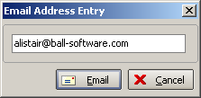

2711. Reports > Stock Valuation Report

If ‘Sort By’ stock code is chosen, there is now a choice of start and end stock code.

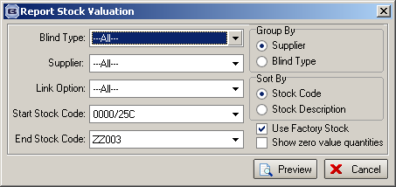

2712. Purchase Order Enquiry > Update

We now display the net total for a detail line in the Update > Create Invoice form.

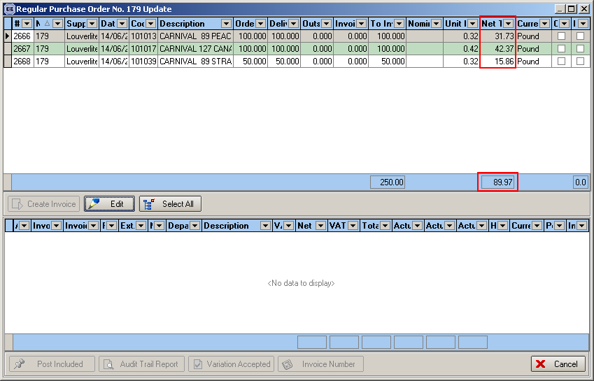

2714. Order Processing > Orders > Up/Down Arrows

The up/down arrows now work after the ‘Order Entered’ stage.

2720. Stock Take Entry > Import

If records are imported that have the ‘batch number’ column filled, then the following rules now apply.

The record imports to the batch number table, and the ‘Stock in Hand’ figure in the stock record is the sum of the last record entered for each batch number.

The record will not be imported if ‘Batch Numbering’ is true for the stock record and there is no batch number in the import file column.

The record will not be imported if there is a batch number but ‘Batch Numbering’ is not set to true in the stock record.

We have also checked the ‘Stock Take Report’ and ‘Stock Valuation’ report to make sure they produce the correct figures.

2725. Sales Analysis by Product

Previously for the ‘unit quantity’ we had a routine that puts in 1 for each order detail line. We have changed this for this report (and the report in dev 2726) to show the actual unit quantity.

2726. Sales Analysis by Product Quantity by Month

There is a new report called ‘Sales Analysis by Product Quantity by Month’. This is the same style of report as ‘Sales Analysis by Product by Month’ but shows the unit quantity and not the value. The unit quantity is the actual quantity, not ‘1’ for each detail line.

2728. Administration > Price Tables

Previously price tables could only be imported if they were not already in the system. There is now an option to overwrite the existing price tables.

2729. Regular PO EDI Transfer

We have created a new flag for automatically sending the regular PO EDI file and also have a separate ftp location held in the supplier record. This means that regular EDI files will only be transmitted immediately if this new flag is switched on.

The new flag is in Parameters > EDI and is called ‘Automatically Send Regular Fil’.

In ‘Suppliers’ the existing ‘FTP Catalog’ is now called ‘Bought In FTP’ and the new one is called ‘Regular FTP’.

