Blindata Release Note 5.9.4 

7 June 2012

Bug Fixes and Enhancements

3848. Create Invoices > Carriage Charge

There was a problem if there were two or more orders for the same customer and the Carriage Charge Per Order and Batch Invoice flags were unticked in the customer record. Fixed

3849. Financials > Invoice Print and Post > Create EDI Invoices

We have changed the content of this file slightly again.

1 = Quantity (from detail line)
2 = Unit net price
3 = Net price of detail line.

This file gets passed into a third party system and sent to the customer. It is validated when it goes through this system, so 1 * 2 = 3 must always be true.

3850. Order Processing > Orders

‘Split Order’ now works for an order which only has component lines.

3851. Invoice – Laser Print (Letterhead Logo) 8.5 x 11

If there are more decimal places in the ‘Unit Price’, they are now displayed.

3852. Stock Items

If the date is set up as US format, then some of the date fields were not displaying correctly. Fixed.

3853. Order Processing > Orders

If ‘WIP Required for Components’ is switched on, then it is no longer possible to do ‘Order Made’ whilst the order is still at ‘Order Entered’ or ‘Order Printed’ stage. The button is now greyed out.

This is because if ‘Update Stock at WIP Stage’ is also switched on, and the WIP stage is missed out, the stock is then incorrect.

New Work and Customer Requests

2705. Price Table Enquiry > Export to Excel

Price tables will only be exported if blind type ‘Export Blind Type Dataset’ = true.

2707. Carriage Review

We now have a new option called ‘Carriage Surcharge’ so we can identify the difference between ‘Carriage’ and ‘Carriage Surcharge’.

We have also rearranged the carriage flags in the customer record.

‘FOC Carriage’, ‘Carriage Charge Per Order’ and ‘Auto Add Carriage at Order Entry’ should all be held together.

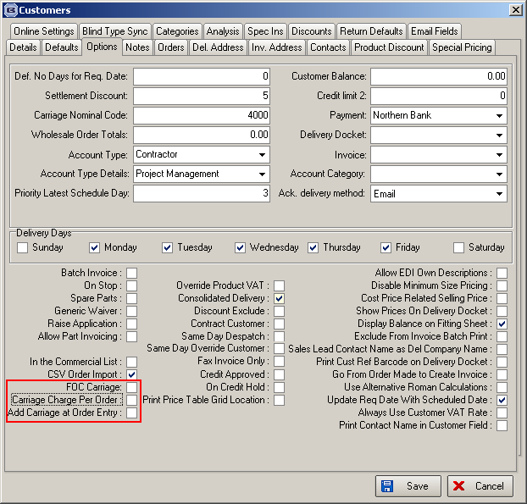

2709. Blind Types > Blinds Per Carrier (Tuffnells)

We have made a change to the way the number of parcels is calculated for Vertical blinds in Tuffnells delivery.

There is a new field in the blind type record called ‘Parcel Multiplier’, which defaults to 1.

The formula for calculating the no of parcels is now ((no of blinds / Blinds Per Carrier Package) * Parcel Multiplier). (1 in all cases except verticals which will be 2).

2715. Help > Support Log

We are in the process of implementing an online support database. which needs to be accessed directly from Blindata. This means we need to pass a username and password through to the online site from Blindata Desktop.

There are two possible solutions here –

- Only allow one user per customer to enter support log items. The username and password should be held in Parameters > set Connection.
- If multiple users at a customer site want to have access, then we need to hold the support log username and password against the user. The problem here is that we may want one user at a customer to see all the support logs for that customer.

We have implemented option 1 for now but will review this.

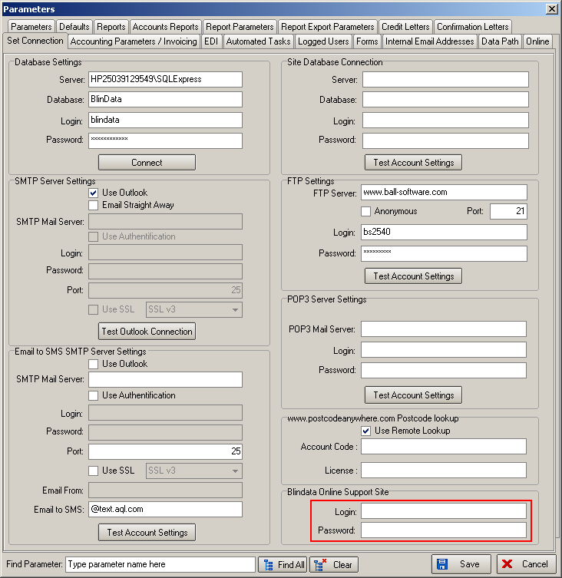

2716. Blind Types > Link Options

There is now a choice at the bottom to ‘Add All’.

2717. Order Enquiry > Blind Process Scan

We have made a couple of changes to the way this works. Firstly, the scanning is dependent on the shop floor scanning system being switched on. If it is switched on, then the barcode will be the serial id, if not it will be the blind id. To test manually (without using a scanner), put E for employee and P for process and then enter the blind id / serial id manually.

When the scan is done, the employee and process descriptions will now appear in the scanned message box.

Solution

We need to switch on ‘Enable Serial No Shop Floor System’ in Parameters. This is necessary be cause the process transactions are held with the serial id.

We have changed ‘Label Print – Bespoke 33A’ so it will print the barcode as the serial id if there is a serial detail line. Also we should print ‘PROCESS’ (in red) below the barcode if the barcode is the serial id. If there is no serial detail line, then the report stays the same.

In Order Enquiry > Blind Process Scan, if ‘Use Employee Scan’ is switched on, only the scan field will be seen. The ‘Employee’ and ‘Process’ lookups will be hidden.

The 3 scans can be done in any order – once they are all done, the message box will say ‘Process Scan completed’.

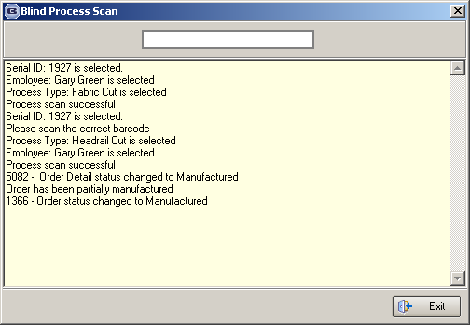

2718. Stock Take Report

There is now an option to not show zero amount items.

2721. Order Enquiry

‘Stock Code’ is now a column option on this form. This is the stock code that relates to the fabric description.

2722. Stock Take Entry

It is now possible to enter a decimal place for the quantity.

2724. Administration > Maintenance > Recalc SO/PO

We are now able to recalculate the ‘On Sales Order’ and ‘On Purchase Order’ figures based on the stock transactions table (StockTransaction) and the Po transaction table (PurchaseOrderTransaction).

Recalculate On Sales Order

This looks at the stock transactions that have an issue date but not a receipt date, groups them by stock code, and then the sum of the quantity is updated to the ‘On Sales Order’ field in the Fabrics table.

Recalculate On Purchase Order

This looks at the PO transactions and sums the (quantity ordered – quantity received) amount for each stock item and updates the ‘On Purchase Order’ field in the fabrics table.

