Blindata Release Note 5.9.2 

25 May 2012

Bug Fixes and Enhancements

3828. Order Processing > Post Invoice

a problem occurred if the parameters were set up so the order number and invoice number should post to Sage.

The order number and invoice number is now getting posted to the Sage Ref field. It was posting the cust ord no and invoice number, which was incorrect.

3829. Order Processing > Post Invoices

We discovered an issue when posting data to the ‘Detail’ field in Sage transactions, which we could not overcome, as it is a Sage SDK problem. As an alternative we have introduced a new parameter that will allow the user to update ‘Order No / Invoice No / Contact Last Name’ to Sage. This will work for both invoices and receipts.

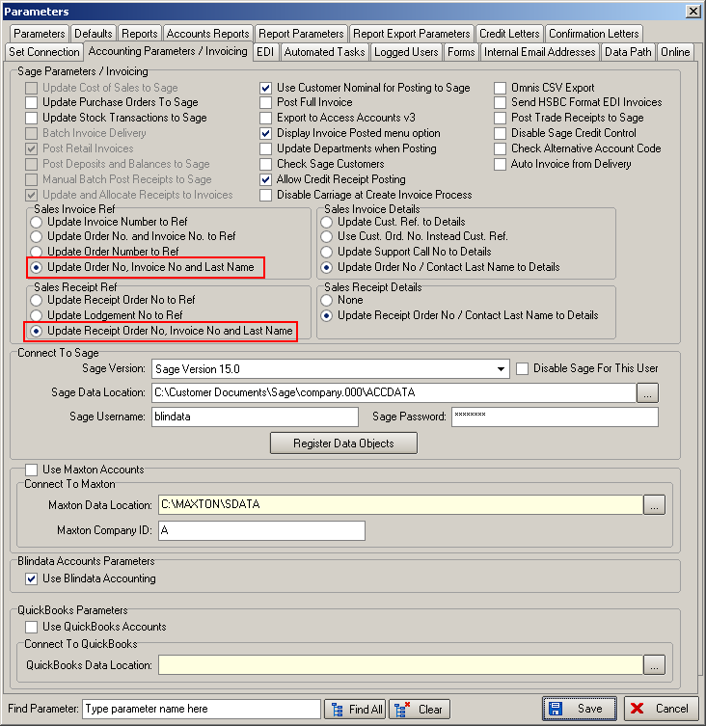

3830. Financials > Invoice Print And Post > Create EDI Invoices

When the EDI file is created, we previously set the quantity to always be 1. The file has now reverted to the way it was before v5.4.2.

3831. Quotation – Bespoke 34

The boxes at the bottom of the form have been tidied up for the print and pdf versions of this report.

3832. Order Processing > Orders

There is now a column choice for ‘After Latest Schedule Day’.

3835. Production Documentation > Label Print – Bespoke 33A

The wrong processes were appearing if this report was run from ‘Production Documentation’. Fixed.

3836. Label Print – Bespoke 8

More of the special instructions text now appear on this label, as it is was previously being cut off.

New Work and Customer Requests

2619. Sales Files > Customers

It is now possible to specify a latest schedule day for priority orders. This is required to identify priority customers that have orders that have gone past an agreed promised number of delivery days from order date.

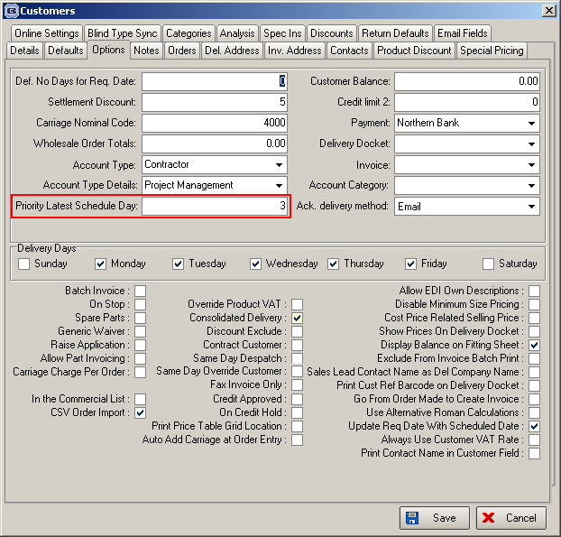

If the number of days between the order date and the scheduled date exceeds the ‘Priority Latest Scheduled Date’, a new flag (called ‘After Latest Schedule Day’) is set to true. This flag can be selected as a column choice in the Order Amend Enquiry form.

2661. Stock Take – Batch Numbers

There is functionality in Blindata to hold batch numbers against stock items. This is enabled if ‘Batch Numbering’ is switched on in the stock record.

When stock records are exported, it is now possible to export batches, then to import them as well as part of the stock take process. This is required so that the batch total and the stock in hand figures are the same.

The following changes have made to the system

Reports > System Reports > Stock Take Report

We now export the batch amounts as well as the ‘Stock In Hand’ figure. These are a subgroup of the stock record.

Stock Setup > Stock Take Entry > Import

We have made some changes to the import file. There are additional columns for ‘Unit Of Sale’ and ‘Batch Number’.

Previously when the stock was imported, it did not take account of ‘Unit Of Sale’ or batch numbers. We have introduced two new columns for them. Also, there are now column headers in the import spreadsheet, as follows:

Stock code
Stock description
Warehouse stock
Factory stock
Unit Of Sale
Batch Number

If there is no ‘Unit Of Sale’ filed filled in, then it will be assumed that the amount (‘Warehouse Stock’ or ‘Factory Stock’) is a unit amount.

If the batch number is filled in (need to check that the stock record has ‘Batch Numbering’ switched on), then the existing batch record(s) for that item will be removed, the stock in hand zeroised and the new ones added to the batch number table and the stock in hand added to (it has to be added to because there may be more than one batch number record).

Stock Setup > Stock Take Entry > Manual

It is now possible to enter ‘Unit Of Sale’ and ‘Batch Number’ in here if necessary. If ‘Unit Of Sale’ is left blank, then units will be assumed. If ‘Batch Number’ is left blank, then the batch number record will not be updated. If it is not blank, then the amount will be added to the stock in hand instead of overwriting it.

2662. Order Processing > Orders

The customer default option for fabric is now working slightly differently. A default option for a fabric that is held against a customer in System Tables > Customer Default Options is now only selected after the fabric is entered.

2663. Scheduling – Remaining Time

As well as seeing what has been scheduled for the next few days, it is also now possible see how much remaining manufacturing time has to be completed in the current day. This is visible in the Scheduling form.

Not all customers may want this so there is a new parameter called ‘View Remaining Man. Time’ in Administration > Parameters.

If this parameter is switched on, a new column will be visible in Scheduling called ‘Remaining’ which will get reduced as the day goes on. The reduction will take place when the blind is scanned as made.

This means when the blind is scheduled, we also update the new column. Then when the blind is manufactured, the number of minutes is deducted from the new column.

This has been done for normal and priority scheduling, and also works for ‘Blind Made Scan’, ‘Order Made Scan’ and ‘Blind Process Scan’.

2687. Export Order Report

In the top left hand side on the order paperwork the wording “MARINE SUNBLIND SPECIALIST” has been changed on all documents to just “SUNBLIND SPECIALIST”.

2688. PO Transfer File 2 History

When creating an EDI transaction for transfer file 2 there is now a note of the event in the record’s history. It is also recorded in the EDI transaction log. In other words they are recorded in the same way as they are for the normal bought in EDI file transfer.

2689. Arena Option Setup

There is a new method to alter the XML file that is created for Transfer File 2.

We now hold a table that has option choices, and then characteristics that are excluded. This is a ‘System Table’ called ‘Options / Characteristics Rules’. It holds ‘Blind Type’, ‘Option Name’, ‘Option Choice’, ‘Excluded Characteristic’.

When the transfer file 2 is created, it looks at this table to see what should be excluded.

2690. Invoice – Bespoke 41 (print and pdf)

‘Cust Ord No’ now prints in the header section on this invoice.

2694. Sales Files > Customers

If ‘postcode / ZIP’ = ‘USA ZIP Code’, the validation has been removed on address line 2 ie it is now possible to save this as a null field.

2695. Invoice – Laser Print (Letterhead Logo) 8.5 x 11

If there is a consignment note number held against the order, it now appears on the invoice, level with ‘Net Price’ in the footer.

