Blindata Release Note 5.9.3 

2 June 2012

Bug Fixes and Enhancements

3837. Order Processing > Orders > Print Invoice

There was a problem printing invoices that were imported from csv files. Fixed.

3838. Administration > Maintenance

When clearing down ‘Orders’, the ‘on sales order’ figure in the stock records is now zeroised.

Also when clearing down ‘Purchase Orders’, the ‘on purchase order’ figure in the stock records is zeroised,

3839. Stock Items

When ‘Duplicate’ is used, the stock amounts (stock in hand, on sales order, on purchase order) in the new records are all set to 0.

3841. Works Order – Bespoke 31

The no of vanes now prints for blind identifier = ‘Vanes Only’.

3842. Label Print – Bespoke 33A

1 L89, 1 VO127, 1 VO89 was being chopped off by ‘1 of 3’ field.

The fabric description now print on the lower right label if there is a customer fabric description on the main label and the process names are ‘Roller Fabric Cut’ and ‘Louvres Cut’.

3843. Order Processing > Orders

For vanes only, if you enter a 127mm Vanes Only, then enter drop and no of vanes, if you change the blind type to 89mm Vanes only, the no of vanes did not change. Fixed.

3844. Sales Analysis by Blind Type (Weekly)

When this report was sent to Cute PDF Writer, you sometimes got a floating point overflow message – fixed.

New Work and Customer Requests

2366. Reports > System Reports > Bought In Blind Check List

A report has been created that prints a list of all sales orders that have bought in blinds in them.

It is for all outstanding sales orders and shows, in sales order number order:

Sales Order Number, Order Date, Customer, Required Date, Blind Type, no. of blinds, PO Date, Expected Delivery Date, Revised Delivery Date.

2634. Sales Analysis by Product by Month

There is a new report called ‘Sales Analysis by Product by Month’ that shows only miscellaneous sales. This prints out data across 12 months (in the same style as ‘Sales Analysis by Blind Type by Month’).

2665. Administration > System Tables > Carriage Type

It is now possible to hold an amount against the carriage type record. For example, a pre 10.30 delivery may have a carriage surcharge, and this can be held here.

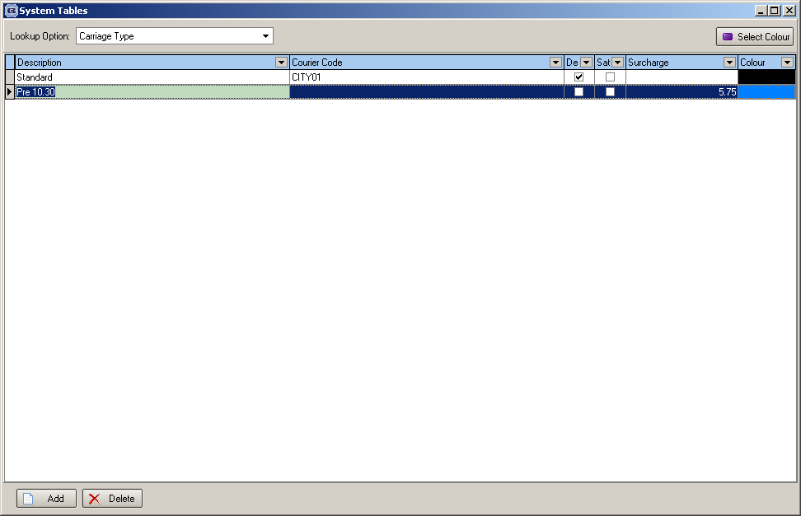

When the order is saved, if the carriage surcharge held against the carriage type record is > 0, then a carriage detail line is added to the order.

Please note for this to work there needs to be a stock record with link option = ‘Carriage Surcharge’ set up.

2697. Works Order – Bespoke 42

There is a new works order report called ‘Works Order – Bespoke 42.

2698. Reports > Financial Reports > Gross Profit by Order by Blind Type

There is a new report, similar to the Gross Profit By Order Report, called ‘Gross Profit by Order by Blind Type’.

It is split by Rep, by Order and also by Blind Type.

It is possible to choose how this information is grouped - by Rep or by Customer, and also to choose which blind types.

2699. Stock Setup > Stock Items

We now hold the following extra fields against the stock record. These are displayed in the ‘Characteristics’ tab in ‘Stock Items’.

They are all text fields except where identified.

Collection (30 Characters)
PVC Free (Y/N)
Composition (30 Char)
Backing (10 Char)
Weight g/m2 (Number 2dp)
Fire Resistant (Y/N)
Green (20 Char)
Antimcrobial (Y/N)
Tariff Item No (20 Char)
Tariff Rate (Number 2dp)

There are also column choices for these fields in Stock Enquiry.

It is also possible to import these fields in Import From Excel > Stock Updates.

2702. Docuware Export

We have created a button to export the Docuware file manually. The button is in the ‘Archive Enquiry’ form and will send the file to the location that is held in the Parameters table.

2703. Sales Files > Customers > CSV Order Import

We have made two further changes to the csv order import.

- There are sometimes notes held in the detail lines – these can now be imported into the ‘Special Instructions’ field in the order detail line.
- There are also sometimes carriage charge detail lines – these are added as carriage charge detail lines – they can be identified because they have the text ‘CARRIAGE CHARGE’ in them.

