Blindata Release Note 5.9.1 

21 May 2012

Bug Fixes and Enhancements

3815. Invoice – Bespoke 41

The net price figure was incorrect – it is actually showing the unit price. It is now the net price after discount has been deducted.

3816. Quotation – Bespoke 34

If there were five blinds on a page, it split the last blind up onto a second page. Detail lines are no longer split over pages.

3820. Sales Files > Customers > Import CSV File

When the file is imported, it puts the delivery address into the invoice address in the order. The invoice address is now invoice address that is held in the customer record.

Also, the store number now goes into the delivery address first line.

3821. Invoice – Bespoke 41

The delivery address is now included on this invoice.

3822. Label Print – Bespoke 33A

The blind id has been removed from the lower right label and the fabric description now starts from where the blind id was.

3823. Financials > Post Receipts

- The columns have been changed; the ID is not required and has been replaced by ‘Order No’ (ie order_id in Orders) and the second column is now ‘Invoice No’.
- The receipt date is now being filled in properly.

New Work and Customer Requests

2658. Acknowledgement – Bespoke 17a

For certain departments, ‘Square Metre Price’ can now be shown on this acknowledgement instead of ‘Unit Blind Price’. There is a new parameter in the department form called ‘Print Square Metre Price’.

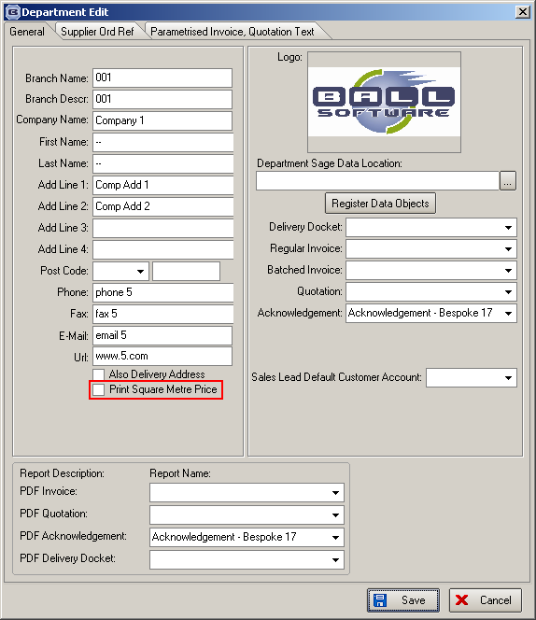

2659. Export Data

There is a new export option for ‘Unit Costs’ in Administration > Export Data. This exports stock code, unit of sales, cost price.

2664. Tuffnells csv File Creation

This item relates only to customers that use the Tuffnells csv carrier file functionality. As well as generating a csv file when orders are despatched, there is now functionality to send the file out to the Tuffnells system before the orders reach the despatch order status. The plan is that every morning a routine will be run that creates Tuffnells csv files for the orders that have a required date = current date (and have not yet been invoiced).

At the moment the number of boxes can be entered at the despatch stage, but we can now automate this according to the following criteria.

The following method is now used to calculate the number of packages/boxes that are sent. Blinds (in cardboard packaging) can be strapped together, up to a limit for each blind. This limit can be held in the blind type record eg if the limit is 3 for 25mm Venetian and there are 7 blinds in the order, the number of packages will be calculated as 3 (2.33 rounded up to the next whole number). There is a new field in the blind type record called ‘Blinds Per Carrier Package’ to handle this.

We also hold the weight per blind which will also go into the Tuffnell csv file. There ia another new field in the blind type record called ‘Average Weight’.

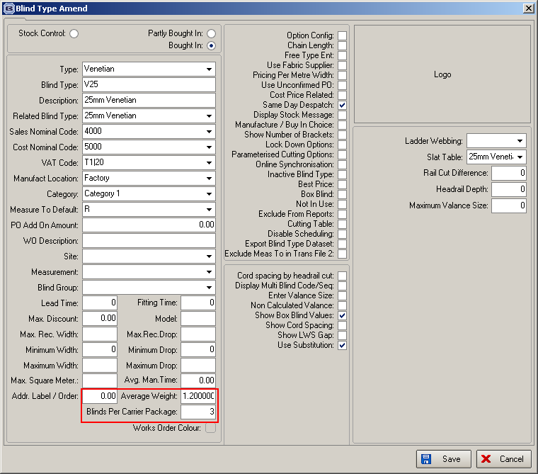

There is a new routine that sends csv files for all orders with required date = current date and relevant delivery method to the Tuffnells system. This can be run from a new button at the bottom of the Order Processing > Order Enquiry form called ‘Export Carrier CSV Files’. This button has it’s own flag in Advanced Permissions.

When this routine is run, the csv files are merged together into one file, and the Tuffnells system will import this. Therefore when this routine is done, it only creates one csv file.

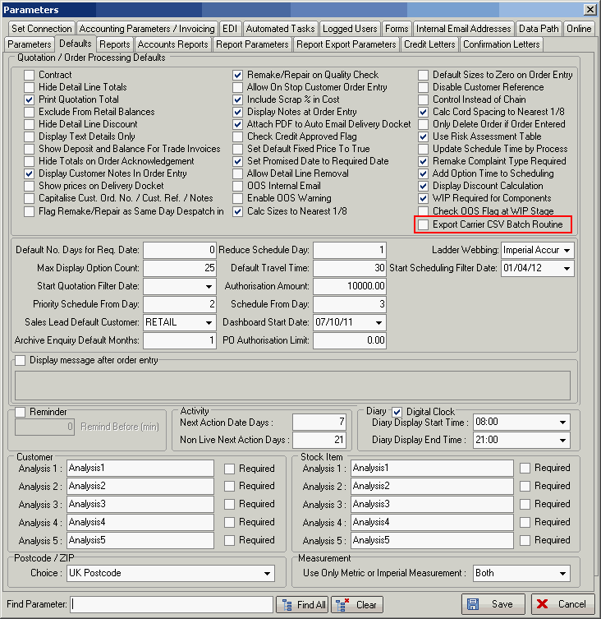

2682. Order Processing > Orders > OOS

We have a customer who does not want it possible to process through an order that has a component detail line that is flagged as ‘Out Of Stock’.

Therefore there is a new parameter for this called ‘Check OOS Flag at WIP/Man Stage’. This defaults to false. If it is set to true, then one of two things can happen.

If this new flag is set to true and ‘Update Stock at WIP Stage’ = true, then when the user tries to change the order to ‘Work In Progress’, as well as the message about out of stock appearing, it says ‘This order cannot be changed to ‘Work In Progress’.

If this new flag is set to true and ‘Update Stock at WIP Stage’ = false, then when the user tries to change the order to ‘Order Made, as well as the message about out of stock appearing, it says ‘This order cannot be changed to ‘Order Made’ because it is flagged as ‘Out Of Stock’. This also applies to the various ‘Blind Made’, ‘Order Made’ buttons in Order Enquiry.

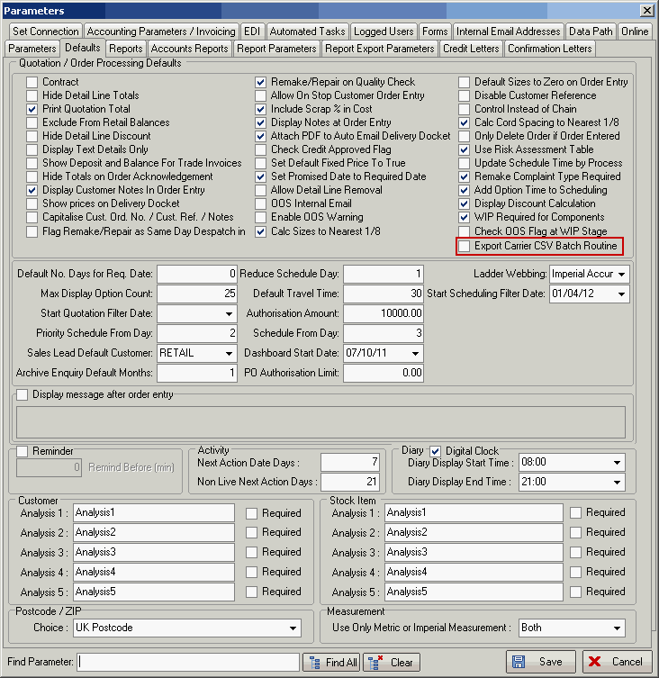

2684. Stock Items > Cost Price By Quantity

We now hold the price to four decimal places in this form.

2685. Order Processing > Total Of Orders Outstanding

There are two export spreadsheets here:

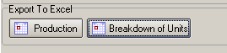

These worked ok until we added in the ‘Manufacturing Time’ in the stock record. This resulted in the times not being picked up in the spreadsheet. We have resolved this by holding the ‘Process Type’ against the stock record as well. This means that when the spreadsheets are created the manufacturing time held against the option (stock record) will be put in the correct process type.

