Blindata Release Note 5.9.0 

14 May 2012

Bug Fixes and Enhancements

3783. Purchase Order Enquiry > Generate Regular PO

When ‘Stock in Hand’ minus ‘On Sales Order’ falls below ‘Re-order Level’ a stock order is generated to bring the stock in hand amount back above the ‘Suggested Order Level’ in multiples of the ‘Minimum Order Level’. Previously this was only being generated so it was over the ‘Suggested Order Level’.

3810. Label Print – Bespoke 40

We have moved everything to start 15mm from left hand edge.

3811. Works Order – Bespoke 40

On second and subsequent pages for the same blind type the column headings were not being printed. Fixed.

3812. Order Processing > Orders

If ‘Enable WIP Status’ is switched on, and there is an order which only has component detail lines in it, it is now possible to go straight from ‘Order Printed’ to ‘Order Made’ with out doing ‘Work In Progress’ first.

We have introduced a parameter to force the use of the ‘Work In Progress’ stage, called ‘WIP Required for Components’.

New Work and Customer Requests

2667. Rollout Production Planning Report

This report now prints out by blind group (from the blind type record) instead of category.

2670. Order Processing > Orders

There is a new parameter in Administration > Parameters called ‘Display Discount Calculation’. If this is switched on, when an order detail line is entered, the way the discount is calculated can be displayed by putting the cursor over the ‘Discount %’ or ‘Discount’ field in the order detail line.

A pop up window will appear showin base price, option prices, discount order, description and %, whether accumulative or not and the net price.

For example:

Base Price = 100.00
Options (discount applicable) = 10.00
Options (non discount) = 5.00
Customer discount (accumulative) 15%
Customer blind type discount (accumulative) 5%
Net Price = 93.825 rounded to 93.82

2673. Quotation / Proforma Printing

We have had a request to print different layouts for quotations and proforma invoices. This means we now hold a new report choice in Parameters > Reports and also in Report Export Parameters.

When ‘Print Quote’ is selected, the report selected is now dependent on whether ‘Proforma’ is set to ‘Yes’ or ‘No’. If ‘Yes’, then it should print the ‘Proforma Invoice’ report, if ‘No’ then the ‘Quotation’ report. The same rules apply to emailing the quote/proforma – it looks at the relevant ‘Report Export Parameter’ report choice.

2674. Invoice – Bespoke 30

This report has now been enabled for email invoicing, and will handle batch invoicing. It has been changed slightly to include extra field descriptions and borders.

2676. Scheduling (Option Minutes)

It is now possible to schedule extra time for specific options when entering a blind. For example, if there is an option in a blind type called ‘Sewn In Weights’, these take a long time to do and so extra minutes are required.

Therefore we now hold a field in the stock record called ‘Manufacturing Time’. This defaults to zero. When scheduling minutes are calculated, they should look at the options chosen in the order detail line and add these to the scheduled time for the order detail line. Because this has the potential to use a lot of resource, there is a new parameter to switch on this functionality.

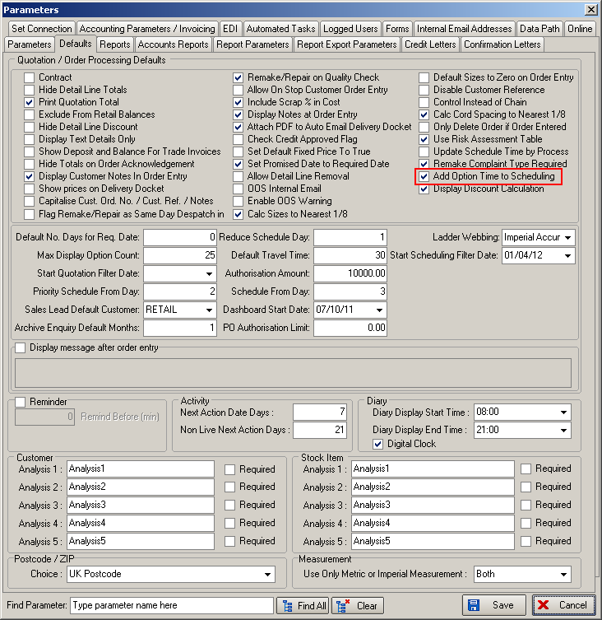

2677. Label Print – Bespoke 33A

The fabric description here (from the stock record – not the customer fabric description) is now shown on the lower right hand label.

2678. Acknowledgement – Laser Print 8.5 x 11

The logo and company name can now be taken from the ‘Department’ record. If the logo is blank, then the logo and company name still comes from ‘Company Details’, other wise it uses the department fields.

2679. Delivery Docket – Laser Print 8.5 x 11

The logo can now be taken from the ‘Department’ record. See notes in 2678 (see condition to apply).

2680. PO Bought In Transfer XML File 2

It is now possible to exclude the ‘Measure To’ field in the characteristics for some blind types when ‘Transfer File 2’ XML file is created.

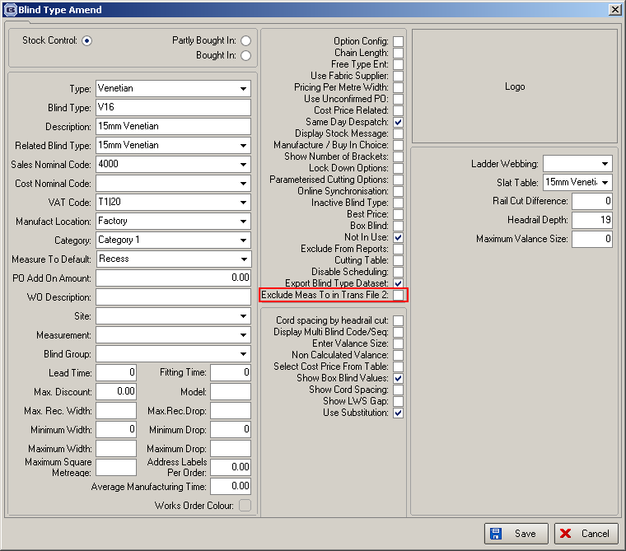

For example,

BLI_EXACT_RECESS is not a required characteristic on perfect fit product so no characteristic or value should be sent for VP2 products. All perfect fits are made to exact widths and drops ( glass size is measured ).

We have also excluded an option characteristic dependent on another option being chosen.

ROM_CLEAT_COLOUR = CH was sent on deluxe roman. A cleat can only be supplied on a standard roman so ROM_CLEAT_COLOUR characteristic should not be included as an option when deluxe is selected as the headrail type.

This is a more complicated change, so we decided just to hardcode it for now. For a ‘File Transfer 2’ file, if option ‘Roman Rail Type’ = Deluxe (ie characteristic ROM_RAIL_TYPE = D), then the characteristic ROM_CLEAT_COLOUR is excluded from the XML file completely.

2681. Order Processing > Works Order Print

If ‘Works Order – Bespoke 41’ is used and ‘Utilise Picking List’ is switched on, a picking list will now print out for a miscellaneous order.

2683. Invoice – Bespoke 41

The detail line has been changed here to have columns for Quantity, Unit Price, Discount %, Net. The Unit price is split into ‘base price’ with ‘options price’ below it.

This has been done in the print and email versions.

